10-Year Telecommunications Plan

DRAFT

Prepared for the State of Vermont
May 2021

Contents
1 Executive Summary 1
1.1 Summary of Project Scope and Tasks 3
1.2 Summary of Findings 3
1.3 Summary of Recommendations 5
2 Telecommunications Challenges and Needs in Vermont 8
2.1 Challenges Identified by State Agencies 8
2.2 Residential Needs 10
2.2.1 Key Findings 11
2.2.2 Internet Service Features and Uses 13
2.2.3 PEG TV Content 14
2.3 Public Comment 14
2.3.1 Broadband Policy 14
2.3.2 Cell Service (Mobile Voice and Data Service) and Public Safety 15
2.3.3 Public Access Television 16
2.4 Business Needs 16
2.5 Public Safety / Emergency Communications Initiatives and Requirements 18
2.5.1 Department of Homeland Security Statewide Communications Interoperability Plan (SCIP) 19
2.5.2 Vermont Radio Technology Services 21
2.5.3 Vermont Enhanced 911 Board and Next Generation 911 (NG911) 22
2.5.4 U.S. Department of Commerce FirstNet Initiative 26
3 Identified Broadband Gaps in Vermont: Overview of Service Based on State Broadband Mapping and Testing 29
3.1 History of Broadband in Vermont 30
3.2 Mobile Voice and Data 32
3.2.1 Drive Test Coverage Data 32
3.2.2 Radio Frequency Propagation Analysis 34
3.3 Wired Broadband Coverage 38
3.3.1 Scope of Unserved and Underserved Premises 38
3.3.2 Communications Union District Coverage 40
3.3.3 Wired Broadband Competition in Vermont 43
3.3.4 Price and Speed Comparisons With Other States 44
3.4 Survey of Other State Broadband Programs and Offices 52
4 10-Year Technology and Usage Trends 55
4.1 Broadband Market and Technology Trends 55
4.1.1 Fiber Broadband Deployment Trends 55
4.1.2 Fiber Broadband Deployment Methods 55
4.1.3 Wireless Network Deployment Trends 56
4.1.4 Cable Industry Trends 57
4.1.5 Emerging Technologies 58
4.2 Broadband Use Trends 60
4.2.1 Remote Work 61
4.2.2 Population Changes 62
4.2.3 Education 62
4.2.4 Telehealth 63
4.2.5 Transportation 65
4.2.6 Shift in Consumer Habits Driving Data Consumption 66
4.3 Incentive Regulation Plan for Consolidated Communications, Inc. 66
5 Technology Assessment and Recommendation for Fiber for Unserved Areas 68
5.1 Fiber Is the Most Capable, Scalable Broadband Technology 68
5.2 Fiber-to-the-Premises in Currently Unserved Areas Will Make Mobile Deployment Easier 69
5.2.1 Overview of Mobile Carriers’ Need for Fiber 69
5.2.2 Overview of Fiber’s Benefit to Expansion of Cellular and Public Safety Service in Vermont 70
5.3 Cable Broadband Is Upgradeable with Fiber and Electronics 73
5.3.1 Cable System Upgrades Could Take Different Forms 74
5.3.2 Upgrading a Cable System Will Cost an Estimated $1,000 to $2,000 per Passing 75
5.4 Fixed Wireless Has Strengths in Some Use Cases—But Is Not a Viable Solution on Its Own for the State’s Broadband Gaps 77
5.4.1 Fixed Wireless Has Advantages in Terms of Deployment Speed and Capital Cost 77
5.4.2 Fixed Wireless Is Effective as a Broadband Solution for Limited Use Cases 80
5.4.3 Fixed Wireless Is More Costly Than Fiber in the Long Run 80
5.4.4 Fixed Wireless Cannot Comprehensively Address the 100/100 Plus Scalability Standard 82
6 Infrastructure Design and Costs for Unserved Areas 84
6.1 FTTP Service Area Definition 86
6.2 Design Objectives and Key Attributes 91
6.3 FTTP Network Deployment Costs 94
6.3.1 Deployment Scenarios 97
6.3.2 Central Network Electronics Costs 98
6.3.3 Core Electronics 99
6.3.4 Distribution Electronics 100
6.3.5 Customer Premises Equipment and Service Drop Installation (Per Subscriber Costs) 100
6.4 Operating Costs 102
7 Possible Structures for State Broadband Funding Program to Address Unserved Areas 104
7.1 Context for the Recommendations 104
7.2 Distribution According to Governor Scott’s Recommendation via H.360 Legislation 106
7.3 Suggested Grant Program Refinements 107
7.3.1 Obligation to Cover All Unserved and Underserved Addresses 107
7.3.2 Refinement of H.360 §8086 Funding Priorities 108
7.3.3 Recommendation for a Phased Application Process 109
7.4 Alternate Strategy: Aggregated Procurement Option 112
8 Recommended Resources and Support for State Program to Address Unserved Areas 114
8.1 Expected CUD Expenses 114
8.2 Structure of State Support for CUDs 116
9 Framework of Business Models and Negotiation Opportunities for CUDs 117
9.1 Potential Business Models 117
9.1.1 Public Operation With In-House Staff 118
9.1.2 Vendor-Based, Fee-for-Service Network Operations 119
9.1.3 Public-Private Partnership 119
9.1.4 Private Network Extended with Public Support 121
9.1.5 Open Access 122
9.2 Lease Agreement Structures 122
10 Addressing Demand-Side Broadband Issues 124
11 Recommendations to Improve and Expand Mobile Service 127
11.1 Request for Proposal Strategy 128
11.2 Update Mobile Voice and Data Service Maps 129
11.3 Possibility of Collaboration with Green Mountain Power 129
12 Recommendation to Support Public Safety Communications 130
12.1 Applications 130
12.1.1 Push-to-Talk and Other Public Safety Applications 130
12.1.2 Other Public Safety Broadband Networks 130
12.1.3 Leveraging 5G in Public Safety 130
12.2 Spectrum 131
12.2.1 Current Public Safety Spectrum 131
12.2.2 Additional Future Spectrum Possibilities 132
12.3 Funding Opportunities 133
12.3.1 FEMA Funding Programs 134
12.3.2 NG911 Funding 135
12.4 Continuous Emergency Access Regulations 136
13 Recommendation to Support PEG 137
14 Legal Analysis 140
14.1 Open Access 140
14.1.1 Overview 140
14.1.2 Federal Law 141
14.1.3 Vermont Law 144
14.2 Net Neutrality 145
14.2.1 Overview 145
14.2.2 An Abbreviated History of Network Neutrality 146
14.2.3 California Net Neutrality Litigation 149
14.2.4 Vermont 150
14.2.5 Vermont’s Near-Term Options. 150
14.3 Easements 152
14.3.1 Overview 152
14.3.2 Use of Electric Easements for Communications Purposes – The Key Issues 153
14.3.3 Recent Legislative Activity in Other States 153
14.3.4 Current Situation in Vermont 155
14.3.5 Recommendation 157
14.4 Carrier of Last Resort (COLR)/Eligible Telecommunications Carrier (ETC) 157
14.4.1 Overview 157
14.4.2 Vermont 159
Appendix A: 2021 Online Residential Survey 163
Appendix B: 2021 Online Business Survey 188
Appendix C: 2021 Municipal Leaders Survey 207
Appendix D: Stakeholder Input Provided for This Plan 221
State Agencies and Departments 221
Communications Union Districts 221
Internet Service Providers 222
Utilities 222
Healthcare Sector 222
Elected Officials 222
Other Stakeholders 222
Appendix E: Alignment of Plan to Statement of Work 224

Figures
Figure 1: Department of Homeland Security SAFECOM Interoperability Continuum 20
Figure 2: FirstNet by the Numbers 26
Figure 3: Unserved Premises in Vermont (Source: Department of Public Service) 29
Figure 4: USDA Map of Funded Areas 31
Figure 5: High-Level Drive Test Routes 33
Figure 6: Vermont Wireless Coverage Map 36
Figure 7: Existing CUD Coverage (Source: Public Service Department) 42
Figure 8: In-Person vs. Video Visit No-Shows 64
Figure 9: Fiber Infrastructure in Vermont 71
Figure 10: Mobile Voice Service Gap in Orange County 72
Figure 11: Fiber Penetration in Mobile Service Gap in Orange County 73
Figure 12: Cable Broadband in a Branching Tree Design 76
Figure 13: Example Fixed Wireless Network with Antennas on a Monopole and Customer Premises 78
Figure 14: Representative Comparison of Costs for Fiber and Fixed Wireless Solutions 82
Figure 15: CUD Service Area Boundaries 87
Figure 16: Target Unserved Addresses for FTTP Deployment 88
Figure 17: High-Level FTTP Cable Plant Routes 90
Figure 18: Estimated Network Implementation Costs at Varying Take-Rates 97
Figure 19: High-Level FTTP Architecture 101
Figure 20: Use the Internet at Home 163
Figure 21: Internet Services Purchased 163
Figure 22: Communication Services Purchased 165
Figure 23: Internet Service Providers Used 166
Figure 24: Importance of Internet Service Factors in Selecting a Place to Live (Mean Ratings) 167
Figure 25: Importance of Internet Service Factors in Selecting a Place to Live 167
Figure 26: Importance of Availability of Good Cell Service Coverage in Selecting a Place to Live by Internet Service Type 168
Figure 27: Agreement with Statements About the Availability of Internet Service If You Were To Move in the Next Year (Mean Ratings) 169
Figure 28: Agreement with Statements About the Availability of Internet Service If You Were To Move in the Next Year 169
Figure 29: Importance of Aspects of Internet Connectivity (Mean Ratings) 170
Figure 30: Importance of Aspects of Internet Connectivity 171
Figure 31: Importance of Aspects of Internet Connectivity by Internet Connection Type 172
Figure 32: Average Ranking of Internet Service Aspects 173
Figure 33: Average Ranking of Internet Service Aspects by Internet Service Type 174
Figure 34: Willing to Pay ISP More for Net Neutrality 175
Figure 35: Willing to Pay ISP More for Privacy Protection 175
Figure 36: Willing to Pay ISP More for Upload/Download Symmetry 175
Figure 37: In Favor of Allowing Municipalities to Use Taxpayer-Funded Bonds to Build Broadband Infrastructure 176
Figure 38: Importance of Having More Than Once Choice of ISP 177
Figure 39: Use of Internet Connection for Various Activities 177
Figure 40: Willing to Pay Monthly Surcharge on Electric Bill to Build Broadband 178
Figure 41: Agreement with Statements About Cell Service (Mean Ratings) 179
Figure 42: Agreement with Statements About Cell Service 179
Figure 43: Average Ranking of Statements About Cell Coverage and Infrastructure 180
Figure 44: Ranking of Statements About Cell Coverage and Infrastructure 181
Figure 45: How Often Engage in Various Activities 182
Figure 46: Change in Engagement in Internet-Based Activities 183
Figure 47: Number of Household Members Online During Peak Usage Times 183
Figure 48: Reasons Decided Not to Use the ABC for Students Free Internet 184
Figure 49: How Often Watch PEG TV Content 185
Figure 50: Type of PEG Content Accessed 186
Figure 51: Medium Used to Watch PEG TV Content 186
Figure 52: Aware of Communications Union Districts 187

Tables
Table 1: Vermont Wireless Coverage – Estimated Addresses Served 37
Table 2: Mobile Voice and Data Coverage Along Driving Corridors 38
Table 3: Vermont CUD Membership (as of April 2021) 41
Table 4: Broadband Service Pricing in Vermont 46
Table 5: Xfinity/Comcast Pricing in Neighboring States 47
Table 6: Consolidated Communications Pricing in Neighboring States 47
Table 7: Charter Spectrum Pricing (National) 48
Table 8: Viasat Pricing (National) 48
Table 9: HughesNet Pricing (National) 48
Table 10: VTel Pricing (Vermont) 49
Table 11: ECFiber Pricing (Vermont) 49
Table 12:Burlington Telecom Pricing (Vermont) 49
Table 13: Waitsfield & Champlain Valley Telecom Pricing (Vermont) 50
Table 14:Granite State Communications Pricing (New Hampshire) 50
Table 15:Tamworth Wireless Cooperative Pricing (New Hampshire) 50
Table 16:Coastline Wireless Pricing (Maine) 51
Table 17:RedZone Pricing (Maine) 51
Table 18: Starry Internet Pricing (Massachusetts) 51
Table 19: NetBlazr Pricing (Massachusetts) 51
Table 20: Shrewsbury Electric and Cable Operations Pricing (Massachusetts) 52
Table 21: Thames Valley Communications Pricing (Connecticut) 52
Table 22: Miles of Cable Plant and Addresses Passed 89
Table 23: FTTP Implementation Cost Estimates 96
Table 24: FTTP Implementation Costs for Alternative Scenarios 98
Table 25: Estimated Central Network Electronics Costs (50% Take-Rate) 99
Table 26: Per Subscriber Cost Estimates 100
Table 27:Annual Fiber-to-the-Premises Technical Operating Costs 103
Table 28: Public Safety Spectrum 132

Executive Summary
The State of Vermont has commissioned its 10-Year Telecommunications Plan at a critical moment. The COVID 19 pandemic had laid bare the importance of broadband unlike any other time in history. High-speed broadband connectivity and devices are, without question, a requirement for the pursuit of an education, participation in the workforce, and access to safe and convenient healthcare services. High-speed broadband is not a luxury, but a foundational category of infrastructure that needs to extend down every Vermont road, past every business and every home.
Crucially, this planning is being done at a time when federal funding has put Vermont on a viable path to universal broadband access. The resources allocated in the American Rescue Plan Act and the Rural Digital Opportunity Fund, among others, have created an unprecedented opportunity to build connectivity to the last mile, and the possible upcoming federal infrastructure bill may add to that capacity.
The state has taken nation-leading steps over the past decade to build a foundation for achieving statewide broadband goals. The Vermont Department of Public Service’s broadband availability data is the best in the country, and the constellation of partners ready to play a part in closing broadband gaps—including Communications Union Districts (CUD), telephone companies, internet services providers (ISP), and electric utilities—are all currently working, often in collaboration, to bring high-speed internet to every home in Vermont.
As such, this 10-Year Telecommunications Plan is oriented toward recommendations that will allow the state to seize the moment to create resilient systems that provide best-in-class connectivity for Vermonters for decades. Four core values drive the analysis and recommendations:
- Using available dollars to efficiently bring broadband to every household currently lacking infrastructure capable of delivering 25/3 megabits per second (Mbps) broadband service
- Ensuring that infrastructure investments focus on long-term needs and achieving the state’s legislated goal of 100/100 Mbps minimum speeds
- Providing agency for communities to have some control over their broadband options, costs, quality of service, and other less quantifiable desires such as net neutrality
- Optimizing mechanisms for accessing the benefits of broadband, particularly among the state’s most vulnerable residents and civic institutions, through training, awareness campaigns, and subsidy—and by leveraging new and traditional institutions like the public, educational, and governmental (PEG) access stations that are reimagining their roles in an era when most Vermonters may “cut the cord”
There is an inherent tension between providing agency to communities and efficient broadband deployment. The most efficient way to use dollars in the short run could be to simply pay private providers to build fiber to the home with no conditions, thereby ensuring monopolies for broadband delivery to rural places for decades to come. At the other extreme, federal dollars could be used only to underwrite publicly owned and operated fiber infrastructure through Communications Union Districts; further, that fiber could be permanently open access for use by any carrier with requirements for net neutrality, zero data caps, and pricing limits (such that no Vermonter would pay more than $25 per month for service). The latter scenario, however, could require multiples of the funding resources available in the state.
Though that tension may never be resolved in a way that pleases everybody, it is important for it to be discussed—and for the public and the state’s decision-makers to understand the tradeoffs. As such, this Plan explores the tensions between community control and connecting more people, and seeks to optimize the balance through public private partnership concepts that reflect the reality on the ground and the state’s clear aspirations to close the broadband gap.
This Plan also addresses many other telecommunications programs and needs in detail, such as the need to expand mobile service, particularly for public safety and to meet modern communication expectations. Fortunately, the goals of deploying last-mile 100/100 Mbps service to every location in Vermont will work hand-in-hand with achieving other telecommunications goals.
The issue of broadband affordability, in both the short and long term, continues to be an important focus for the state. Though this Plan addresses the demand-side issues of telecommunications, policymakers are also encouraged to refer to the state’s Covid-19 Response Telecommunications Recovery Plan for recommendations and guidance that are still just as relevant and applicable as when that report was published.
It is also essential to convey that speed is of the essence if Vermont is going to close the broadband gap in the near term. The unprecedented federal funding for broadband across the country is encouraging but means there will be equally unprecedented demands for skilled labor and materials to build new fiber infrastructure. Implementing programs to close broadband gaps should not be rushed but should be done expeditiously.
Increased dependency on broadband means the divisions between the connected and unconnected will continue to accelerate while exponential growth in speeds required for internet-based products and services will mean that 25/3 speeds (or even 100/100) will not be remotely adequate by 2031. Vermont has a moment now to leverage the extraordinary work undertaken over the past two decades to effectively deploy this unprecedented federal capital to create future-proof telecommunications infrastructure for the next generation and beyond.

Summary of Project Scope and Tasks
This Plan addresses all aspects of the scope of work outlined by the Department of Public Service—including analysis and recommendations designed to ensure the state of Vermont is prepared for the telecommunications requirements of the next 10 years and to meet the goals the of 30 V.S.A. §202d. The Plan reflects the following tasks completed by the project team:
- Ten-Year Overview of Expected Future Requirements for Telecommunications Services (see Section 4)
- Survey of Vermont residents and business (see Section 2)
- Assessment of the current state of telecommunications infrastructure (see Section 2 and Section 3)
- Assessment of state-owned and managed telecommunications systems and related infrastructure (see Section 2, Section 5, Section 6, and Section 13)
- Assessment of opportunities for shared infrastructure (see Section 7 and Section 11)
- PEG television analysis (see Section 2 and Section 13)
- Assessment of status, coverage, and capacity of telecommunications networks and services (see Section 2 and Section 3)
- Analysis of alternative strategies to expand broadband and increase network resiliency (see Sections 5 – 9)
- Assessment of emergency communications initiatives and requirements (see Section 1, Section 2, and Section 12)
- Analysis of regulatory and legal barriers facing state action (see Section 14)
- Initiatives to advance state telecommunication policies and goals (see Sections 5 – 14)
Appendix E also maps each element of the scope of work to the relevant sections of this Plan.

Summary of Findings
The following is a summary of key findings based on surveys, stakeholder interviews, data analysis, and cost-estimation exercises.
Fiber deployment—capable of delivering 100/100 Mbps service and greater—to unserved and underserved premises remain a priority across the public and private sector.
A cost estimate based on robust engineering work indicates that serving every unserved and underserved premises with fiber-to-the-premises will cost between $362 million and $439 million. Some variation in cost is due to an uncertainty about how many unserved and underserved premises are also off-grid. In addition, the cost estimates assume certain materials and labor costs; actual costs for these elements if and when the state pursues construction will have a large effect on the total project cost.
Consumers, businesses, advocates, and state entities indicated that lack of mobile voice and data coverage on roads and at residential premises is a major area of concern.
That said, mobile voice and data deployments must fit with local aesthetic and environmental concerns to be embraced by Vermont communities. A radio frequency propagation analysis found that up to 40 percent of Vermonters may have difficulty obtaining mobile voice and data coverage at home. That said, pursuing the state’s goal of 100/100 Mbps wired service will also make expansion of mobile voice and data service easier, because fiber can be used to backhaul mobile antenna sites.
Public safety telecommunications systems in Vermont are performing well.
All six Vermont public safety answering points (PSAP) have migrated to next-generation 911 (NG911) which offers a robust, future-proof system for telecommunications transmission. Public safety communications increasingly rely on private networks or networks outside of their immediate oversight; in light of this, the Plan recommends specific applications and technical considerations regarding public safety over the next 10 years.
PEG TV stands as a bastion of localism and Access Management Organizations (AMO) are seeking stable and predictable revenue. The public value delivered by PEG in Vermont merits public support as surveys and stakeholders interviewed reiterated the importance of PEG in generating and delivering local content. PEG stations are also well positioned to fill more and more essential community functions, from archiving footage of municipal events to providing digital skill-building resources and more.

Summary of Recommendations
Use CUDs as the vehicle for infrastructure deployments to reach unserved and underserved premises with 100/100 Mbps service.
The Vermont Legislature’s H.360 bill outlines recommendations for a broadband funding program. Upon careful review of H.360, the Plan recommends pursuing a course similar to that described in the bill, with CUDs being the eligible and intended recipients of funding, with a number of important refinements. These include the following:
- Receipt of funding obligates CUDs to pass every on-grid premises
- CUDs must abide by best practices for network standards
- CUDs must apply for funding via a multi-phase approach that provides accountability and support
CUDs must present a plan to serve every premises lacking wired 25/3 Mbps service that is not also already funded by the Federal Communications Commission’s (FCC) Rural Digital Opportunity Fund (RDOF) at the gigabit low-latency category. The Plan recommends delineating requirements verses priorities concerning broadband expansion funding. It recommends that requirements must be met to qualify for funding, whereas those items listed as priorities should be pursued if possible. Recommended requirements and priorities are as follows:
- Requirements:
  - Provide service to all on-grid, unserved and underserved locations within the Communications Union District
  - Support broadband service that is capable of symmetrical speeds of at least 100/100 Mbps
  - Meet best practices for technical standards to ensure broadband infrastructure is resilient and secure
  - Build networks capable of supporting future public good services, like mobile wireless expansion and public safety use cases
- Priorities:
  - Provide consumers with services that adhere to values that have been identified by the state, like net neutrality, transparent pricing, no data caps, and data privacy
  - Utilize public-private-partnerships to ensure high service quality
  - Provide consumers with affordable service options and support low-income or disadvantaged communities
  - Leverage lease fees on owned assets into a long-term funding source for digital skills, digital equity, and digital inclusion efforts
The Plan also suggests the following network standards for state-subsidized deployments:
- Networks should be interconnected and redundant, with multiple paths of egress to the internet and with backup power where needed to minimize or eliminate outages
- Networks and ISPs must be capable of supporting lifeline services and fulfilling critical emergency functions
- Networks must be robust, flexible, and scalable—capable of supporting future generations of wireless technologies and the needs of public safety
Lastly, the Plan documents the likely pre-development and pre-construction support and expertise CUDs will need to be successful.
CUDs should also be encouraged to address demand-side broadband challenges, like affordability, equity, and inclusion. Closing the gap in access across the state must be accompanied by addressing issues like affordability, digital skill building, and digital equity for the state to maximize their investment in expanding broadband access. Digital equity, digital skill building, and affordability are all a result of the historical challenges of our state and country around poverty, lack of racial equity, lack of education equity, housing discrimination, and more. The Plan recommends CUDs include subsidy programs for low-income subscribers in their business models and aggregate provision of subsidized service through a statewide program for efficiency. In addition, the state may take some policy and regulatory steps to address these issues, such as reviewing inmates’ costs for making phone calls from Vermont corrections facilities.
Mobile voice and data services can be expanded using an efficient, effective request for proposals (RFP) process. In light of the Governor’s suggested $25 million allocation from the American Rescue Plan Act, this Plan recommends an RFP-based approach to funding expansions of mobile voice and data service that allows the state to consider a range of options and weigh their cost, benefits, and achievability. The RFP process will also arm the state with data on what is achievable under different models, which will be key to ongoing policy-making and decision-making. The state’s RFP should require that proposals and plans shall:
- Target areas currently unserved by any carrier
- Exclude state ownership or ongoing upkeep of any infrastructure
- Be achievable within two years, taking into account permitting processes and backhaul connections
- Demonstrate that local input has been solicited and proposed deployment methods are viable
- Include letters of intent from carriers documenting their planned participation
Further, the RFP responses should be scored based on prioritization of certain outcomes:
- Points may be awarded for covering road miles and serving previously unserved premises
- Points may be awarded for inclusion of multiple mobile network operators
- Points may be awarded for plans that are demonstrably resilient, including features such as backup power and diverse backhaul
- Points may be awarded for the amount of private capital committed to the work
Through the broadband expansion process resiliency, security, and public safety must be prioritized. Broadband expansion needs to adhere to best practices for resiliency and security and include extra capacity to serve public safety needs. In addition, the use of land-mobile radio (LMR) is critical and should not be considered for replacement until other technologies can achieve better reliability. New 5G services may enhance the data capabilities of public safety networks and Internet of Things applications, such as environmental monitoring devices, drones deployed on-scene, vehicle-to-vehicle communications, and numerous smart city applications.
The Plan recommends the state perform due diligence in its efforts to provide Access Management Organizations (AMO) with stable and predictable source of revenue. A report commissioned by the Agency of Commerce and Community Development, “Analysis of the Financial Viability for Public, Educational and Government Access Television in Vermont,” proposes funding options to provide PEG channels with stable and predictable revenue; however, it is key that policymakers pursue a funding strategy that does not impede other state goals (like expanding broadband coverage) or carry legal risk, such as being an early mover in adopting a novel form of revenue generation. The state may follow other states’ leads (e.g., taxing streaming services), but being an early-mover on a new tax mechanism requires a robust risk assessment. If there is a budget shortfall for PEG stations before a long-term funding stream is identified, the state should consider an allocation from the general fund.

Telecommunications Challenges and Needs in Vermont
Vermont has established a thorough process for receiving input on telecommunications planning work. In addition to the great eagerness stakeholders from the public and private sectors having to provide input in writing and via interviews, Vermont is truly unique in how it codifies a process that allows everyone access to decision-makers, including providing ample opportunity for public comment on the draft plan before its finalization.
Across the many states in which the project team has worked, none provide as much opportunity for input as Vermont; the input provided by Vermonters via surveys, interviews, and written input informs and advises this work.

Challenges Identified by State Agencies
Through numerous interviews with state agencies and public sector leaders, a clear and consistent message emerged that public sector operations and systems are closely tied to the quality of wired residential broadband and mobile broadband services.
On the whole, state-owned telecommunications systems are working well and performed effectively during the stresses of the Covid-19 pandemic. However, state operations do face challenges due to a lack of universal residential broadband and mobile voice and data services. Especially as many state agencies shifted more and more operations online and into the cloud, and will continue to provide a portion of their services in this manner, addressing the residential broadband challenges will greatly benefit state agencies and the public sector as well.
Stakeholders within state agencies consistently expressed a hope that Vermont would focus on building out long-term telecommunications infrastructure to provide the necessary foundation for state agency operations. The ways in which universal broadband will benefit individual departments, teams, and the constituents they serve are diverse, but a selection of the responses and individual priorities shared by stakeholders is described below.
From workforce development programs to DMV services to unemployment applications, Vermont agencies expect to continue to engage with Vermonters online even after the pandemic subsides. Municipalities are likely to continue streaming or airing meetings live over the internet, and so the trouble reported during Covid-19 of constituents having trouble with connectivity during municipal meetings will be a problem so long as high speed internet remains unavailable to many.
The Agency of Digital Services (ADS) reported that the state moved to a cloud-based Microsoft Office 365 system before the start of the pandemic, facilitating remote work as employees could access to key systems from anywhere. ADS also helped state agencies transition to remote work by purchasing pre-configured laptops and facilitating the participation in Consolidated Communications’ Enterprise@Home program, which allows business customers to extend their LAN to their worker’s remote sites, and let the state extend its enterprise network to employees’ homes. However, the issue of employees’ home networks and home connection cannot be solved until good infrastructure is built to every premises; many public sector employees working from home have struggled with residential connectivity challenges. ADS officials indicated that they may want to give employees the option to work remotely into the future, but that would be contingent on being sure of employee connectivity.
The Department of Disabilities, Aging & Independent Living (DAIL), as well as the Vermont AARP, reinforced the importance of connectivity for their constituents, and emphasized the need for accessibility and digital skill training and the need to keep service affordable, in addition to the need for universal infrastructure. They stressed that online tools and services are only valuable for Vermonters who have access to them, can afford them, and know how to use them. For example, while relay services and captioning options may be available for those with hearing loss, awareness of services and comfort using them across platforms are reported as ongoing hurdles.
The Department of Agriculture reported more online engagement with agricultural applications across the state. For example, farmers have switched to e-commerce to engage with larger markets, and expect to continue to strengthen their online presence after setting up websites to ship their products. Due to this trend, unreliable access to the internet has and will directly affect farmers’ ability to conduct business. Additionally, advanced farm technologies often rely on digital components to function, and are vital for Vermont farmers as they adopt new, more precise agriculture practices.
The expansion of broadband systems and especially mobile broadband service was also identified as a need by the Agency of Transportation. Vehicles are becoming increasingly autonomous, and require access to cell service to function efficiently when it comes to navigating safety technology and traffic operations. The Agency of Transportation also recognized that the expansion of fiber would lead to a diversity of service options for staying connected on roadways even though these future advancements don’t rely on wired systems alone.
The Agency of Education shared that remote and hybrid learning models will likely continue to exist after the pandemic in some form or another, as it presents options for expanded learning for students across the state. With remote or hybrid learning models, students have the option to take a greater variety of classes than what their schools are able to offer in person, which increases students' ownership of their schedules and allows them the ability to engage with more subjects of interest. A survey conducted by the Department of Education found that 55 percent of students desire to continue learning partially or fully online after the pandemic.
Crucially, the continuation of these learning programs require robust broadband infrastructure as educational platforms require increasing amounts of bandwidth. Building out telecommunications to schools and students remains a priority, but the Agency of Education expressed that providing technical assistance to school leaders to assist in navigating data privacy, cyber security, and platform selection is also a critical next step.
The Department of Libraries remains concerned about some of their aging equipment on their fiber network, but is hopeful that ARPA funds will be able to be used to remedy this. They also hope to play a greater role in digital skills training and providing accessible devices and internet connections to the public.
There are also more direct telecommunications needs across state and municipal entities, especially for agencies with a presence in many of our small communities. For example, not all schools and libraries are connected to high speed internet in Vermont, and not all Agency of Transportation garages have cell service. Fixed and mobile broadband deployment in the next few years will help ensure the safety of state workers at town garages and the services that libraries and schools can provide in Vermont’s small towns.

Residential Needs
As part of its efforts to perform a comprehensive evaluation of broadband gaps in line with the state’s goal to provide fast, reliable connectivity to all residents, the State of Vermont commissioned an online survey of households. The survey was intended to gather basic data about the types of services to which residents subscribe and their use of these services. Moreover, the survey was designed to provide feedback on desired broadband and cell service and ways to improve accessibility. The survey explored other topics as well, such as PEG TV viewership. The results presented in this summary are based on responses from 920 households (completed surveys) deemed “valid” by the statistician analyzing the data.
The survey was promoted through organic and paid promotions, including a press release from Vermont’s Department of Public Service (PSD); requests made to municipal and public sector stakeholders to post the survey on town listservs; social media promotion from a range of entities; paid Front Porch Forum advertisements; outreach via Communications Union Districts (CUD), and more.
The survey responses (presented in full in Appendix A) were weighted based on the age of the respondent and region. Since older Vermonters are more likely to respond to surveys than younger persons, the age-weighting corrects for the potential bias based on the age of the respondent. In this manner, the results more closely reflect the opinions of each county’s adult population. That said, it should be noted there clearly are limitations to online surveys about telecommunications needs. For subsequent plans, the state may consider supporting a mail or phone survey, which would provide the most accurate findings.

Key Findings
Key findings are presented thematically in four subsections: broadband access gaps, cellular access gaps, internet service features and use, and PEG TV content. These and other findings are presented in greater detail in the body of the Plan.

Broadband Access Gaps
The survey found very few gaps in acquisition of residential internet services. Almost all households represented in the survey have internet service. Respondents support building infrastructure and improving broadband services in unserved areas. The following are key findings:
- Almost all residents have home internet access and use the internet from any device at home. Ninety-seven percent of respondents reported having internet access, including 72 percent who have both home internet service and a cellular/mobile telephone service with internet (smartphone). The high saturation of internet access would be expected in an online survey.
- Six percent of all respondents use only a smartphone for home internet access. This may limit their ability to fully utilize online services at home.
- Consolidated Communications (CCI), Comcast Xfinity, and Green Mountain Access (Waitsfield and Champlain Valley Telecom) are the leading internet service providers used. One-third of respondents subscribe to CCI, 24 percent subscribe to Comcast Xfinity, and 14 percent subscribe to Green Mountain Access (Waitsfield and Champlain Valley Telecom). Other ISPs comprise much smaller shares of the market.
- Respondents support publicly funded broadband infrastructure. Two-thirds of respondents are in favor of allowing municipalities to use taxpayer-funded bonds to build broadband infrastructure.
- There is some willingness to pay to help build broadband access. Seven in 10 respondents would be willing to pay a surcharge on their electric bill to help build broadband for unserved Vermonters; however, 47 percent would pay less than $10 per month. Just 22 percent of respondents would be willing to pay $10 or more per month.
- Many respondents were unaware of the state’s emphasis on Communications Union Districts or were uncertain. Forty-four percent of respondents said they were aware of CUDs as a way to improve broadband access in unserved areas, while 43 percent were unaware and 13 percent were unsure.

Mobile Broadband Access Gaps
The survey highlighted gaps in mobile voice coverage, colloquially known as cell coverage, in Vermont, along with a desire for improved service. The following are key findings:
- Cell coverage is considered highly important to respondents. Nine in 10 respondents agreed or strongly agreed that cell coverage is important to improve for economic development/business reasons and is important to improve for public safety reasons. Eight in 10 respondents agreed or strongly agreed it is important to improve for quality of life reasons.
- Cell service may not be meeting the needs of many respondents. Only one-fifth of respondents agreed or strongly agreed that cell coverage in Vermont meets their needs, while three-fourths disagreed or strongly disagreed. When asked to rank statements about cell service, three-fourths of respondents ranked “I don’t believe that cellular coverage needs to be improved at all” as last.
- Improvements in cell coverage may be more important in residential areas than roadways. Eight in 10 respondents agreed or strongly agreed that cell coverage improvements should focus on residences or where people lived, while fewer (49 percent) agreed or strongly agreed that improvements should focus on roads and roadways.
- Most respondents believe the government should prioritize improving cell coverage. Eighty-four percent of respondents agreed or strongly agreed that cell coverage in Vermont should be a priority for state government to address. When asked to rank statements about cell service, 48 percent of respondents ranked “I would like the state to pursue the most efficient way to increase cell coverage regardless of the method of deployment” as most important (the highest ranked statement).

Internet Service Features and Uses
Respondents value having access to internet and cell service, which would be key factors in deciding on where to live. Consistent and reliable internet are highly important service aspects, which may be critical to support household use of the internet for various activities such as teleworking. The following are key findings:
- Availability of internet service and cell service coverage are key factors in deciding where to locate. Seven in 10 respondents said that the availability of internet service at any speed would be extremely important in selecting a place to live, and six in 10 respondents said that the availability of good cell service coverage at the home would be extremely important. Additionally, 86 percent of respondents agreed or strongly agreed they would prioritize moving where they could get internet speeds that meet their needs, regardless of what type of infrastructure was available.
- The highest ranked aspects when selecting an ISP are consistent and reliable service and fast connection speed. These service aspects had the highest ranking when respondents were asked to choose the top factors. Additionally, 64 percent of respondents said consistent and reliability service is extremely important. Another 52 percent of respondents said having a fast connection is extremely important.
- Privacy and net neutrality are other key aspects of internet service. Specifically, 69 percent of respondents said it is extremely important that their ISP will not collect or sell data without permission. Also, 53 percent of respondents said that net neutrality is extremely important. Furthermore, more than four in 10 respondents would be willing to pay more for service from an ISP that offered net neutrality (42 percent) or privacy protection (45 percent).
- Fewer respondents identified the ability to choose among multiple internet providers as a key factor of internet service, but this aspect is still important for many. Approximately one-half of respondents said that having a choice of internet service providers is very (29 percent) or extremely (20 percent) important, and another 31 percent said it is moderately important. Although 42 percent would not be willing to pay a fee to ensure their community had a choice of multiple providers, another 32 percent would be willing to pay less than $10 per month, and 18 percent would pay $10-20 per month. Few respondents would pay more than $20 per month.
- Home internet is widely used for entertainment and teleworking. Most households have a member who uses the internet for entertainment (62 percent) or telework (54 percent) daily. One-third of households have a member who attends online classes or uses the internet for civic engagement weekly or daily. Nearly one-half (46 percent) of respondents said a household member engages in telemedicine less than monthly, and 28 percent do so monthly.
- Most respondents anticipate their usage of the internet for various activities to remain the same in the coming year. However, nearly one-half (47 percent) of respondents anticipate their use of the internet for telemedicine to increase. A sizeable share anticipates their use of the internet for entertainment (38 percent), civic engagement (35 percent), telework (34 percent), and online classes (31 percent) to increase.

PEG TV Content
Many households access PEG TV content, most frequently for broadcasts of municipal functions, using a variety of media. Key results include:
- A sizeable share of respondents views PEG TV content, but many not regularly. Nearly four in 10 respondents watch PEG programming, including one in 10 frequent viewers who watch weekly or daily. One-fifth watch less than monthly.
- The most frequently accessed PEG content is broadcasts of municipal functions. Nearly one-fourth (23 percent) of respondents view this type of programming. One in 10 respondents access programs about local art or made by local artists, and 10 percent access information on local political candidates. Additionally, eight percent of respondents access programming about school functions, and five percent access content made for remote or distance learning.
- A variety of media is used to watch PEG programming. This includes online video platforms (15 percent), on the website of the local PEG channel (12 percent), through their TV cable package (11 percent), and social media (8 percent).

Public Comment
In addition to the online residential and business surveys, the Department of Public Service solicited input from the public through their website and via multiple videoconference forums hosted over Zoom. Themes from comments received by those mechanisms are outlined here.

Broadband Policy
Public comments on broadband policy in large part focused on the critical nature of universal, high quality, and affordable broadband in Vermont. During the Zoom public input sessions, participants expressed support for the state’s Communications Union Districts and their role in providing broadband solutions. In online comments, the call for ubiquitous broadband was often compared to 20th century rural electrification and many noted the myriad ways in which a lack of broadband presents educational, economic, social, and health related impediments. For example:
“Many remote workers cannot locate in our area due to poor internet service. During Covid, students and parents have been at a disadvantage if they live here. My own children visit less frequently because they do not have good reliable service in my house, and it is a huge disincentive to them relocating here.”
Respondents also focused on a desire to have unserved and underserved Vermonters provided with service expediently and through fiber technology explicitly. Calls for specific speed thresholds varied but a strong desire of 100/100 Mbps service or greater delivered through fiber-to-the-premises networks was readily apparent. For example:
“Without fiber infrastructure and access to it, people in Vermont are stuck with second-class Internet.”
In addition to universal accessibility throughout the state, affordability in both installation and ongoing subscription costs were of great concern. The importance of network resiliency in the face of events like storms, a need for awareness around differing levels of climactic impact among broadband technologies, and general disappointment in the track record of for-profit internet service providers were also expressed. Lastly, many respondents also described the acute need for universal broadband as being underscored by the pandemic. For example:
“The pandemic revealed in stark terms the cruel inequity of one neighbor being able to stay home and rely on her/his Internet connection to safely and effectively work and attend school, while a mile down the road, another neighbor’s poor connectivity created a very real barrier to employment and/or education, and ultimately, to her/his safety.”

Cell Service (Mobile Voice and Data Service) and Public Safety
Similar to a call for universal broadband throughout the state, public comments regarding mobile cell service focused on the need for coverage in all parts of Vermont often highlighting the issue as a basic public safety concern. For example:
“Reliable and consistent cell service must be available throughout the state. It is a matter of public safety, enabling everyone access for help when needed; for reaching people in time of need.”
Also echoing calls for affordable broadband, respondents expressed a strong desire for cell service to not only be universal, but affordable. It was mentioned that a lack of reliable cell service in the state necessitates the maintenance of a traditional landline in addition to a cell phone, thus creating extra expense. Some comments expressed a wish that mobile voice and data infrastructure to be built and installed with a sensitivity to surrounding landscapes, and still others questioned whether the health impacts of wireless technologies were being given enough consideration.

Public Access Television
Widespread support for public access television was readily apparent through the public comments. Vermonters expressed appreciation for a wealth of programming coming from the various local stations across the state, often citing diverse information needs these stations are filling, from local municipal coverage, to sports, to educational content. For example:
“Whether we are streaming Underhill’s planning commission hearing live, archiving the video of the latest “Racism in America” talk organized by Rev. Dr. Arnold Isidore Thomas of Jericho’s Good Shepherd Lutheran Church, or helping students film videos about local roads’ histories, MMCTV is one of the non-profit community media centers in the state giving voice to Vermonters.”
Respondents also recognized an uncertain financial future for public access TV, and their recognition of its importance was often expressed alongside concerns around its funding. For example:
“Public access television is increasingly critical to keeping informed about local issues. It needs a funding stream that is reliable and can provide the money it needs to maintain and improve the way it delivers programming.”
Similar to comments regarding broadband, respondents also described how the pandemic has reinforced the essential nature of public access television for individuals and communities. Generally, a wealth of comments simply emphasized the critical nature of services provided by public access television. For example:
“Being a senior citizen with limitations I am not able to be as involved in my community and state government as I would like to be. Having public access television helps me stay connected. To me it [is] not only a convenience, but a necessity.”
As of the publication date of this Plan, a full record of comments made by the public can be viewed at the Vermont Public Service Department’s website. Additional comments may be supplied after the publication of the Draft 10-Year Telecommunications Plan.

Business Needs
As part of its efforts to perform a comprehensive evaluation of broadband gaps in line with the state’s goals, the State of Vermont commissioned an online survey of businesses.
The online business survey was promoted across the state, including a press release from the PSD, requests made from town administrators and managers, social media promotion from a range of entities, outreach to Regional Planning Commissions and Regional Development Corporations, chambers of commerce, and other efforts.
The survey received complete responses from 54 respondents with 77 percent of respondents owning a business that employs one to four employees. The survey results are presented in full in Appendix B.
The following are key findings from the business survey:
- Almost all businesses surveyed have internet access with the leading types of primary internet service being DSL (39 percent), cable modem (23 percent), and fiber service (21 percent). (Note: businesses with slower connections may have been more motivated to respond to this survey, to express their need for better service).
- 98 percent of respondents reported using internet access at their primary business location (which is unsurprising for an online survey), while 71 percent use mobile cellular data services, 69 percent use telephone services, and 50 percent use video services.
- Business internet service pricing mostly fell mostly between $50-$149 per month with the majority reporting $50-$99 per month (55 percent), and 14 percent reporting $100-$149 per month. 42 percent reported that they were moderately satisfied with the affordability of their service while 40 percent were either slightly satisfied or not at all satisfied.
- The speed of business internet connections is likely a barrier to efficient business operations in the state as 67 percent reported that their internet connection is either sometimes or often too slow for their needs. When asked to rank the importance of various aspects of internet service, respondents ranked speed as most important.
- The availability of mobile voice and data (cellular) coverage in Vermont is also likely a barrier to efficient business operations. 77 percent of respondents reported that cell coverage in the state sometimes, rarely, or never meets their needs.
- In the open comment section of the survey, the following themes emerged from responses:
  - Quality internet access throughout the state is a priority across sectors as its presence or lack thereof has great impact on essentially all business stakeholders, e.g. owners, employees, and customers.
  - A lack of cell coverage on roads and highways, homes, and at places of business negatively impact business operations in a myriad of ways, from creating challenges around staying in touch with employees to an inability to make business calls while in transit.
  - Commenters were frustrated by internet service quality, affordability, and availability, and as a result have a desire for more competition among internet service providers

Public Safety / Emergency Communications Initiatives and Requirements
Emergency communications systems in Vermont, as across the country, are evolving rapidly—and increasingly comprise network elements outside of the users’ immediate purview. In Vermont, this includes not only FirstNet, built by AT&T, but other wired and wireless networks that interconnect operations locations, communications sites, internet of things devices, and on-scene personnel.
The Nashville bombing incident on Christmas Day, 2020, heightened awareness of the dependency public safety has on networks as well as utilities (power) operated by other entities. A lack of knowledge of who operated each segment of the networks and where those network routes were located physically hampered public safety’s ability to react quicker to the event. Public safety 911, internet, and telephone connections were impacted including the ability to receive and route 911 calls; and FirstNet Built by AT&T and other wireless carrier services all experienced outages ranging from a few hours to days.
The incident also reinforced the importance of public safety owned and operated land mobile radio (LMR) networks as the primary means of first responder communications in the field. The LMR networks for each of the impacted municipalities and states remained fully operational and targeted public-safety answering point (PSAP) talkgroups were used for PSAP-to-PSAP voice communications. LMR will remain the most reliable form of wireless mission critical communications for years to come, until AT&T and other commercial broadband networks prove resilient and interoperable. Any consideration of “streamlining” communications by using other networks (wired or wireless) should closely examine the areas of risk and likely differences in network resilience and redundancy, and incorporate robust accountability in planning, design, implementation, and management of those outside networks.
The Vermont Department of Public Safety’s Radio Technology Services’ (RTS) upgrade of the LMR network to APCO Project 25 (P25) standards will enable state agencies to leverage enhanced technologies and will facilitate interoperability—not only among state agencies but between state and local agencies. As is noted as a goal in the state’s statewide communication interoperability plan (SCIP), Vermont should continue to migrate state agency users to the P25 system and establish interoperable connections, which the P25 suite of tools enables, among state and local agencies.
The six Vermont PSAPs have all migrated to next-generation 911 (NG911) which is commendable. NG911 services utilize Internet-Protocol (IP) to provide a more robust and resilient system and supports the transmission of both voice and data. Vermont answering points can now receive data that provides location information and can receive text-to-911 data. As industry standards and best practices continue to develop, the state is positioned well to support additional benefits of NG911 technology such as the ability to receive photos and videos to assist first responders in their work.
AT&T continues to build out the FirstNet network in Vermont, and thus their commercial network as well. They anticipate deploying 36 FirstNet sites in Vermont by the end of the first quarter of 2023. There were 19 FirstNet sites activated as of January 2021 and AT&T continues to deploy more, although access to viable tower site locations remains a challenge due to Vermont’s terrain. In addition, there is often a balance of interest for tower builds in communities between advocating for public safety broadband and enhanced commercial wireless service and the environmental and aesthetic issues surrounding a large vertical structure installation.

Department of Homeland Security Statewide Communications Interoperability Plan (SCIP)
Vermont’s SCIP, updated in May 2020, outlines the state’s strategic goals and initiatives for enhancing interoperable and emergency communications in the subsequent one to three years. The SCIP works in tandem with this statewide plan and captures the following:
- “Current and future interoperable and emergency communications environment;
- Goals with specific steps for action (including owners and completion timeframes);
- Defined mechanisms to measure achievements; and
- Process by which the state will record progress and challenges each year.”
The goals and initiatives documented in the SCIP are driven by the National Emergency Communications Plan (NECP) and the Department of Homeland Security’s Cybersecurity and Infrastructure Security Agency’s (CISA) Interoperability Continuum developed by SAFECOM. SAFECOM comprises members of the emergency response community and other stakeholders whose mission is to enhance public safety communications and improve interoperability. SAFECOM works closely with the Statewide Interoperability Coordinators (SWIC) and offers training/guidance for SCIP development and updates based on current trends in public safety communications. The Continuum is a guide for progress toward a high degree of interoperability in five areas as shown in Figure 1.
Figure 1: Department of Homeland Security SAFECOM Interoperability Continuum
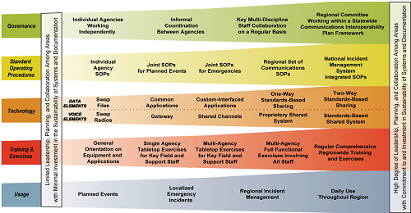
Vermont’s SCIP defines an implementation plan for enhancements in each of the Continuum areas and considers the statewide and local LMR networks, broadband use, broadband applications, PSAP and call centers, and alerts and warnings.
The SCIP also includes sustainability funding goals including the identification of other sources of funding. (Section 12.3 discusses several federal funding programs that can help attain these goals.)
The Cross Border/Interstate Interoperability Marker in the SCIP indicates that Vermont currently has little to no “established capabilities to enable emergency communications across all components of the ecosystem”. Vermont public safety can plan to establish SOPs and MOUs with agencies and continue to have training and exercises that include bordering states and/or Canada over the next decade. Of note, Canada is currently evaluating models for their public safety broadband network. The PSBN Innovation Alliance (PIA) is piloting one of those models, a system of system model, with sites activated in the Toronto area. Their model would interconnect existing carrier networks and support the expansion of existing carrier networks to facilitate the provision of broadband to unserved rural areas. If the PIA’s network expands eastward, interoperability with FirstNet or other U.S. carriers would be ideal.

Vermont Radio Technology Services
The Department of Public Safety’s Radio Technology Services supports the land mobile radio (LMR) and related backhaul systems used by the Vermont State Police, the Division of Emergency Management, and the Division of Fire Safety; telephone systems used by several DPS units; and the VCOMM network which uses shared frequencies enabling interoperability among state, county, and municipal agencies.
RTS is currently upgrading the DPS LMR network to APCO Project 25 (P25) which will facilitate interoperability—not only among state agencies but between state and local agencies. The first agency to migrate to P25 will be the State Police.
One of the goals presented in the SCIP is to “Establish P25 as the operational standard in Vermont and migrate users to the new standard”. This migration of State radio users to P25 moves Vermont state departments to the highest voice technology Standards-Based Shared System level on the Interoperability Continuum. RTS notes that agencies across the state (as in most states) different LMR technologies are in use – some are P25, some still using older technologies and would advocate for agencies to employ P25 over the next 10 years.
RTS continues to operate and maintain the microwave network which primarily provides backhaul for the LMR system but also provides a backup network for the DPS agencies’ telephone system – a resourceful shared use of infrastructure and systems. DPS reports this network is highly reliable and adequately supports the capacity needed for these purposes. However, some agencies are migrating to fiber network services through the Agency of Digital Services for telephone backup. While in theory fiber networks can provide an adequate level of reliability and availability, plus the capacity needed, the fiber networks used by the state are also operated by commercial providers and therefore subject to their standards of reliability (which may not be public safety grade/mission critical) and also travel through public network switching locations. Therefore, any consideration of “streamlining” communications should closely examine the areas of risk and likely differences in network resilience.
RTS administratively supports FirstNet within Vermont. This provides Vermont agencies with a state view of the progress of FirstNet, a clearinghouse for information, and some support. RTS should continue to be this conduit for FirstNet information throughout its evolution and migration from 4G LTE to 5G. RTS should stay also abreast of technical advances in radio networks for voice, data, public safety internet of things (PSIoT) applications, and location determination (including z-axis (height) data).

Vermont Enhanced 911 Board and Next Generation 911 (NG911)
The Enhanced 911 Board was established by the legislature in 1994 as the single governmental agency responsible for design, implementation, and oversight of the statewide 911 system. The Board consists of nine members, appointed by the Governor, representing state, local and county law enforcement, emergency medical services, fire service, municipalities and three members of the public.
A 10-member Board staff implements the policies and directives of the 911 Board and is responsible for the day-to-day oversight of the statewide 911 system.

Statewide 911 System Overview
Vermont’s statewide 911 system has effectively served Vermont since 1998. Since the first call was placed on November 17, 1998, the system has received and processed over four million 911 calls. Nearly 210,000 calls for service were answered in 2020. Wireless calls accounted for 71 percent of total call volume. In addition, 340 text-to-911 messages were received.
Over the past 23 years, the statewide 911 system has kept pace with advances in technology and Vermont has taken a leadership role in the implementation of Next Generation 911 (NG911) services as the standards and best practices for that technology have evolved. NG911 services utilize Internet-Protocol (IP) to provide a more robust and resilient system. With its faster IP infrastructure, NG911 supports the transmission of both voice and data. This allows Vermont to take advantage of its robust GIS data which is used for address validation before a 911 call is even placed, as well as for locating the caller at the time of a call and displaying the primary emergency responders for the caller’s location.
NG911 technology also allowed Vermont to become the first state in the country to provide statewide Text to 911 services in 2012. Text to 911 provides life-saving access to 911 when callers are unable to make a voice call – including the deaf/hard of hearing community, domestic violence victims, and others. As industry standards and best practices continue to develop, the state is positioned well to support additional benefits of NG911 technology such as the ability to receive photos and videos to assist first responders in their work.

System Status
The current fully-hosted NG911 system, implemented in October 2020, is provided by INdigital, an Indiana-based company that is a proven system provider focused solely on NG911 solutions, which operates in 34 states including statewide deployments in Indiana, Alabama, and New Hampshire.
Prior to implementation, the INdigital fully hosted system underwent an Independent Validation and Verification (IVV) process to assess system reliability and adherence to the technical requirements outlined in the contract. The results indicated the system was ready for deployment. Full results of the IVV are available upon request from the Board in a redacted copy of the IVV report.
Included in the INdigital contract are robust service level agreements (SLA) which align with industry best practice and will better serve Vermont than the SLAs in previous contracts. The partnership with INdigital will keep Vermont at the forefront of NG911 technology which is critical as NG911 deployments continue across the country. Additionally, the INdigital solution is expected to save the state just over $1 million in operating costs, as compared to the previous system provider, over the course of the five-year contract.
Vermont's NG911 maturity level is at the transitional state as defined by the FCC’s Task Force on Optimal Public Safety Answering Point Architecture (TFOPA) NG911 maturity model. As reflected in the National 911 Annual Report for 2019, Vermont has reached the jurisdictional end state for governance, GIS data, NG911 core services, security, and operations and is at the transitional state in the categories of routing and location, network, PSAP call handling, and optional interfaces. Moving to jurisdictional end state in the remaining categories is, in some respects, outside the direct control of the Enhanced 911 Board and is dependent upon originating service providers implementing certain functions such as Location Information Services (LIS) to proactively improve address validation and/or connecting to the NG911 system in a manner that allows for the delivery of location information with the incoming call. The Enhanced 911 Board intends to work with these originating service providers and others to encourage implementation of this functionality.
The national vision for NG911 implementation is the creation of a nationwide “system of systems”. Since the INdigital implementation, Vermont has been able to begin work in this area through the establishment of and interstate agreement with New Hampshire that allows for more efficient exchange of caller location information between the two states. Agreements of this sort with other neighboring states are possible, as is the possibility of improved disaster recovery planning options. Board staff will research the technical and operational implications of these types of agreements so that the 911 Board can fully consider these capabilities moving forward.
The 911 Board remains committed to providing a standards-based, resilient and reliable statewide 911 system and will continue to work with all stakeholders to ensure the best 911 service is provided to Vermonters.

Current PSAP (Public Safety Answering Point) Configuration
The 911 Board partners with five law enforcement agencies in Vermont for 911 call handling services. These five agencies operate a total of six PSAPs. Each PSAP is responsible for answering calls from a primary catchment area and is also responsible for handling overflow calls from all other PSAPs. The call handling services agreement, and associated reimbursement terms, are detailed in a formal Memorandum of Understanding with each agency.
The Vermont Department of Public Safety operates two PSAPs in Williston and Westminster. These PSAPs answered approximately 64 percent of the total 911 call volume in 2020 and, between the two facilities, house sixteen of the state’s 24 911 workstations. Four regional PSAPs are operated by the Hartford, Shelburne, and St Albans police departments and the Lamoille County Sheriff’s Department. These PSAPs answer about components 36 percent of total 911 call volume and each house two funded 911 workstations. In addition, two unfunded workstations are currently housed at two of the regional PSAPs.
The geographic diversity of multiple PSAPs operated by distinct agencies has served Vermont well. Not only does it lessen the impact of human or natural caused events that could significantly impair call-taking capability within the state, but it also aligns with the intent of the enabling legislation that the 911 system be a state and local partnership.
Technology allows 911 calls to be answered at any of the six PSAPs regardless of where the call originated and allows all call-takers access to the same technical resources and equipment. Because the Board has developed standards-based training requirements and call handling protocols, 911 callers receive the same level of service regardless of where their 911 call is answered.
Additional details about the current 911 system configuration are available in the recently updated report, “Redundancy and Resiliency in Vermont’s 911 System” – available upon request from the Enhanced 911 Board.

Priorities and Initiatives
With the approval of the 911 Board and in partnership with the system provider and other impacted stakeholders, the Board staff’s upcoming priorities and initiatives (that have not already been mentioned in this document) include:
- Implementation of Real-Time Text (RTT) functionality which will allow for more effective text communications and the ability for both voice and text communications at the same time.
- Advancing interoperability and information/data sharing with Vermont dispatch centers including existing CAD connection capabilities and identification of other potential mechanisms for improving communication.
- Implementation of the Board’s recently adopted “Rule Governing Outage Reporting Requirements for Originating Service Providers and Electric Power Companies” which is expected to provide information necessary to assess the impact of power outages on access to 911 in Vermont. The reporting requirements outlined in this rule for wireless and VoIP providers are much more granular than are required by the FCC and are more appropriate for the rural nature of Vermont. This rule mirrors the reporting thresholds implemented in California for wireless and VoIP carriers.
- Continued implementation of the Board’s Rule Governing 911 Requirements for Enterprise Communications Systems (ECS) which helps ensure direct access to 911 from multi-line telephone systems and requires improved dispatchable location information when 911 calls are placed from an ECS.
- Continued monitoring of wireless location accuracy to ensure carriers are adhering to current FCC location accuracy requirements.
- Continued sharing of our authoritative GIS date with constituents such as the Public Service Department, Department of Public Safety (supports CAD and mapping), Vermont Emergency Management (for reverse-911 capacity), Google and similar companies to provide updates that improve their data, National Address Database via the Federal Geographic Data Committee to help support national emergency response (FEMA and other response agencies). As noted earlier in this document, over four dozen entities in Vermont utilize the data collected and managed by the 911 Board including towns, regional planning commissions, and other public entities.
- Forest guide implementation; Vermont will monitor efforts at the national level to develop a national database that will allow a 911 call-taker to obtain accurate routing information for calls that must be sent to another jurisdiction.
- Engagement with stakeholders to discuss considerations and implications of receiving pictures and/or video through NG911 technology, including identification of benefits, costs, and other impacts.
- Continued work with constituents and partners to ensure adequate public and consumer education related to the way various telephone technologies interact with 911.

U.S. Department of Commerce FirstNet Initiative

Overview
The Middle Class Tax Relief and Job Creation Act of 2012 (“the Act”) created the First Responder Network Authority (FirstNet) to implement a nationwide, interoperable wireless broadband network for public safety users. It established FirstNet as an independent authority (with its own 15-member board of directors) within the U.S. Department of Commerce’s National Telecommunications and Information Administration (NTIA) and allocated over $7 billion for the network and other public safety needs. This funding was not expected to sustain the network beyond initial startup.
By law, FirstNet must oversee the planning, building, operation, and maintenance of the network—including its nationwide core and Radio Access Networks (RANs) in each state. The network itself offers mobile broadband communications and is meant to supplement, but not replace, mission-critical public safety voice radios. As the network matures, however, it may ultimately support mission-critical voice applications.
Figure : FirstNet by the Numbers
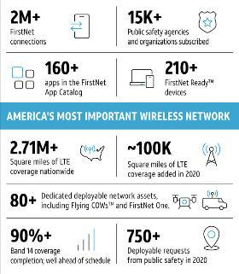
The Act requires that the network’s minimum technology standards be based on commercial Long-Term Evolution (LTE), a fourth generation (4G) wireless technology that bases its operating standards on the Internet Protocol (IP), hence offering higher capacity and transmission speeds than previous technology and enhancing communications for emergency response and recovery.
Through a competitive bidding process, the FirstNet Authority selected AT&T to deploy and maintain a nationwide public safety broadband network (NPSBN). AT&T is making its commercial spectrum plus 10 MHz of public-safety dedicated spectrum leased from the Federal government available to public safety plus priority (next in line) and preemption (kicks user off the line) features. AT&T has been upgrading and building new sites to add the public safety spectrum and features throughout the country. The snapsot of FirstNet deployment in Figure 2 shows the status per AT&T FirstNet as of February 2021.
AT&T also maintains a fleet of portable network assets for public safety agencies’ emergency response needs at no additional cost. These 80+ deployables come in various form factors (cellular sites on vehicles, drones), are in demand (AT&T received more than 750 requests in 2020) and are located strategically throughout the country facilitating more rapid deployment.
The contract with AT&T includes the migration to 5G as AT&T migrates its commercial network. Initial upgrades made last year to the FirstNet Core enable access to 5G services for FirstNet subscribers. According to the FirstNet Authority, “FirstNet subscribers will have access to AT&T’s 5G mmWave spectrum in parts of 38 cities and more than 20 venues across the country” in April 2021.

FirstNet Built by AT&T in Vermont
The project team interviewed AT&T representatives to understand the current status of the FirstNet network in Vermont. AT&T continues to build out the FirstNet network in Vermont, and thus their commercial network as well. They anticipate deploying 36 FirstNet sites in Vermont by the end of the first quarter of 2023. There were 19 FirstNet sites activated as of January 2021 and AT&T continues to deploy more, although access to viable tower site locations remains a challenge due to Vermont’s terrain. In addition, there is often a balance of interest for tower builds in communities between advocating for public safety broadband and enhanced commercial wireless service and the environmental and aesthetic issues surrounding a large vertical structure installation.
To help offset these challenges and extend their coverage and capacity in Vermont, AT&T has a roaming agreement with VTel Wireless who provide fixed wireless (LTE) network services in some rural areas of Vermont. This also eliminates the need for building additional sites in some areas since the network will use existing VTel infrastructure. Building a new structure entails acquisition of a Certificate of Public Good after acquiring “State and local permit, certificate, or approval that has been issued for the facility under a statute, ordinance, or bylaw pertaining to the environment or land use.” The Certificate of Public Good requires a 60-day public comment period which, in AT&T’s opinion, may be too long since they have not received a high volume of comments for new structure builds.
A fast backhaul network is very important to data-focused networks such as FirstNet. Fiber optic connections are ideal because of their capacity and ability to scale to higher speeds, but where fiber deployment is challenging or even impossible due to terrain, wireless microwave connections can be used. Satellite is rarely used for the fixed macro sites as it is quite expensive and comparably slow. AT&T notes that they are not having difficulty getting fiber backhaul to planned sites and the VTel roaming agreement enables AT&T to avoid having to build new sites in VTel’s service area.
According to AT&T, the timeline for 5G deployment in Vermont is largely unknown, although there are some deployments in New Hampshire and Massachusetts. Over the next 10 years, however, Vermont should see the migration of not only AT&T to 5G but also T-Mobile and Verizon.

Identified Broadband Gaps in Vermont: Overview of Service Based on State Broadband Mapping and Testing
The Department of Public Service maintains a rich set of data providing address-level broadband coverage in the state (Figure 3)—which is one the most comprehensive and detailed in the country. They also have valuable wireless coverage data based on drive tests on major state roads. These maps provide an excellent foundation for assessing and addressing the state’s broadband and mobile voice and data coverage challenges.
Figure 3: Unserved Premises in Vermont (Source: Department of Public Service)
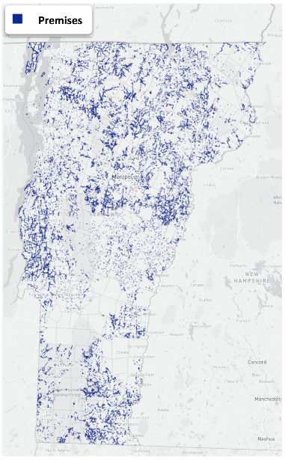
First, however, there are several important historical events in the evolution of broadband deployment and availability in Vermont worth noting for context in this plan and to understand the current broadband landscape.

History of Broadband in Vermont
Nationally, the telecommunications landscape in rural areas has been shaped by the trajectory of local exchange carriers (LEC), which have provided landline telephone service across the country since the breakup of the Bell Telephone Company. These same companies were often the first in an area to start providing internet service as well, originally via dial-up service and later with DSL. Today, these companies are also frequently replacing their old copper-based phone and internet systems with fiber due to its greater reliability, capacity, and ability to provide symmetrical speeds.
In Vermont today, there are a range of incumbent LECs (ILEC), the largest of which is Consolidated Communications, Inc (CCI). CCI provides the vast majority of LEC service in Vermont, and operates in an additional 21 states. CCI’s presence in Vermont started with their purchase of FairPoint communications in 2016.
FairPoint Communications had been the major player in the phone and internet space in most of Vermont since 2007, when FairPoint acquired a large portion of the LECs from Verizon in Vermont (as well as New Hampshire and Maine). FairPoint was ultimately a challenging ILEC for residents, plagued by service disruptions, poor customer service quality, a major workforce strike, and bankruptcy. The legacy of FairPoint Communications still concerns some Vermonters today.
Today, competitive ISPs also provide service to a significant number of Vermonters. Charter Spectrum and Comcast are the two primary cable companies, but in various parts of the state there are additional smaller cable companies like Duncan Cable and Stowe Cable and fiber providers like Mansfield Community Fiber, Burlington Telecom, and ECFiber.
Vermont has made supporting broadband deployment a priority of the state since the first broadband grants were made in 2003 and 2004 to help small wireless companies provide service to areas that only had dial-up service. Another important historical event in the state’s telecom trajectory was the receipt of significant federal Broadband Technology Opportunities Program (BTOP) and USDA funding by the Vermont Telephone Company (VTel). BTOP funding allowed VTel to build much needed transport fiber and middle mile in Vermont and New Hampshire. Middle mile and backhaul availability in the state today, including middle mile owned by VTel, CenturyLink, Firstlight, CCI, and VELCO, is widespread and well suited to future broadband expansion.
The USDA funding received by VTel in as part of the American Recovery and Reinvestment Act allowed VTel to build a fiber-to-the-premises network in their ILEC territory, which provides some of the fastest internet in the nation at up to 10 Gbps symmetrical to residents in Springfield and surrounding towns.
Another portion of the USDA funding was used to set up a fixed wireless network across the state. This network was intended to provide a significant number of premises with fixed wireless service. The network ultimately received a varied reaction from consumers; fixed wireless network service is impacted by trees and hills and performance can significantly vary from the speeds that can be achieved in perfect conditions.
The lasting repercussion of that fixed wireless deployment, however, has been that most of the state has not been eligible for other USDA broadband funding due to the agency’s protocol not to fund the same area twice for another 10 years. Below is a map provided by the USDA showing funded areas in Vermont currently ineligible for additional subsidy.
Figure 4: USDA Map of Funded Areas
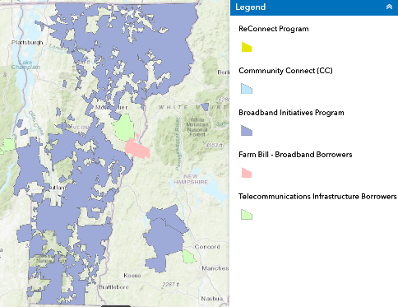

This history has contributed, in part, to the strategies the state is pursuing today. Communications Union Districts (CUDs) were established in 2014 to allow local areas to assume responsibility and control over the broadband solution in their areas; they have been empowered to work towards solutions in collaboration with ILECs and competitive ISPs that will meet the needs of residents for the long term. More details on CUDs are provided below.

Mobile Voice and Data
Vermont’s mobile broadband coverage is strongly influenced by the topography and geography of the state. Due to the hills, mountains, and trees, almost no town is completely covered by service, though very few towns are also wholly unserved.
Through the directive of 30 V.S.A. § 202c, the state seeks to “support the availability of modern mobile wireless telecommunications services along the State's travel corridors and in the State's communities.”
Indeed, the need for improved access to reliable mobile voice and data service was highlighted in our research: 9 out of 10 respondents from our residential survey considered cell covered as highly important, and eighty-four percent of respondents agreed or strongly agreed that expanding cell coverage in Vermont should be a priority for state government to address.
Eight in 10 respondents agreed or strongly agreed that cell coverage improvements should focus on residences or where people lived, while fewer (49 percent) agreed or strongly agreed that improvements should focus on roads and roadways. In addition, almost half of survey respondents stated that they wanted the state to pursue the most efficient approach to improving service regardless of deployment method; a smaller group indicated a strong preference for deployment that did not entail building new towers.
The need for improved mobile voice and data was clear from interviews conducted with agencies such as the Department of Agriculture and the Department of Transportation sharing that cell coverage remained a major barrier for those that their department supported.

Drive Test Coverage Data
The Public Service Department conducted a wireless drive test data of Vermont state roads in 2018, and select regions of the state have mobile voice coverage data collected by volunteers. Because the drive test only measured coverage on major roads, the information from those tests is more impressionistic than comprehensive; however, it provides useful insight and is a good complement to the radio frequency propagation analysis performed for this plan.
The following is a high-level map of drive-test data gathered on major roads in 2018, with additional data collected by volunteers in 2020. (An interactive map is maintained by the Department of Public Service.)
Figure 5: High-Level Drive Test Routes
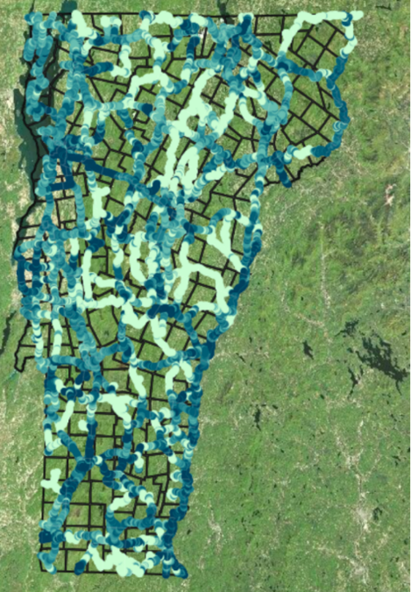

Radio Frequency Propagation Analysis
Locations of cell provider antenna sites in Vermont, obtained using Section 248a data, provided the basis for a radio frequency propagation model estimating the level of mobile service at Vermont homes and on roads. This dataset includes the type of tower, from latticed towers to monopoles or “stealth trees” to radios on siloes, steeples, or water towers, as well as the height and whether a telecommunications carrier is permitted to be on the structure, among other data.
Other data needed for the model was estimated based on mobile broadband provider industry standards and best practices for performing these analyses. For example, the predominant bands used by major carriers in the United States are 600 MHz, 700 MHz, 850 MHz, 1900 MHz, 2100 MHz, 2500 MHz, and mmWave bands. Out of all these bands, the lowest frequency band on which all the major carriers have capability to operate on is the 700 MHz band. Also, lowest frequency bands can propagate over much longer distances. Hence, the analysis assumed all the major carriers would be operating on 700 MHz band.
The following additional assumptions were used in assessing wireless coverage throughout the state:
- Only 248a towers with major carriers co-located used. The major carriers were T-Mobile, AT&T, Sprint, Verizon, and VTEL. Out of the 412 towers in the 248a dataset, 375 towers had major carriers co-located on them.
- For buildings, church, and silo we assumed antenna RAD centers as structure height. For all the other tower structures we assumed antenna RAD centers to be 90 percent of the structure height.
- Propagation maps were created for the 700 MHz band, and 10 MHz channel was available.
- Additional assume propagation characteristics include the following typical parameters:
- Transmitter power = 30 Watts
- Receiver Threshold = -91dBm
- Antenna gain = 13.6dBi
- Noise Figure = 4dB
- Signal to Interference Noise Ratio (SINR) = 6dB
- Body Loss = 3dB
- Fade Margin = 7dB
- Cable Loss = 3.5dB
- Adjacent/ Co-channel Interference = 10dB
- Building Loss (for indoor only) = 13dB
- Vehicle Loss (for outdoor only) = 5dB
Lastly, it should be noted that in some locations, mobile voice coverage in Vermont may be provided by a tower located in New Hampshire, New York, or Massachusetts; towers in other states were not used in this analysis.

Coverage of Vermont Premises
Using the propagation model and premises location from the Public Service Department, the data suggests that mobile voice and data coverage of homes and businesses in Vermont is illustrated by the following map, and comprises the indoor and outdoor coverage indicated in the table below. We estimate that a significant percentage of Vermonters, perhaps 40 percent, may have difficulty obtaining sufficient coverage and capacity at home, with even more only able to get reliable service outdoors.
Figure 6: Vermont Wireless Coverage Map
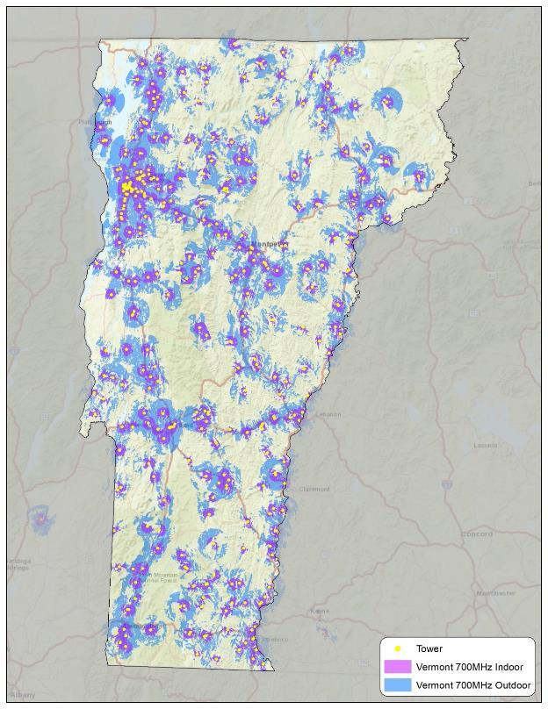
Table 1: Vermont Wireless Coverage – Estimated Addresses Served
Category | Number/  Percentage
Total number of PSD e911 addresses | 308,085
Addresses served indoors | 114,814
Addresses served outdoors | 184,072
Addresses served outdoors but not indoors | 69,258
Addresses not served either indoors or outdoors | 124,013
Percent of addresses covered indoor | 37%
Percent of addresses covered outdoor | 60%
Percent of addresses covered outdoor but not indoor | 23%
Percent of addresses with no coverage | 40%

Coverage Along Driving Corridors and Roads
To supplement the drive-test coverage data collected by the PSD, we performed an additional analysis of mobile voice and data coverage along Vermont roadways using the propagation analysis.
In order to perform this analysis, road centerline data was retrieved from the State of Vermont’s website. We then classified the road types to match the Vermont Agency of Transportation’s general road statistics. As this classification was not publicly available we received a lookup table from Vermont Center for Geographic Information via email as well as a general description on how the Agency of Transportation general road statistics were created. We then intersected the road polylines with our cell signal polygons generated from the RF propagation analysis, identifying areas that the analysis projected to be covered through both indoor and outdoor usage. These intersections allowed us to see what sections of roads, by type, fell within areas of mobile voice and data coverage.
The analysis reinforces the need for increased coverage along roads. Only slightly more than half (55 percent) of roads in Vermont, across all road types, currently have mobile voice and data coverage from according to our propagation analysis (again, this number does not include roads potentially covered by towers located across state lines). For full results by road type, please see the following table.
Table 2: Mobile Voice and Data Coverage Along Driving Corridors
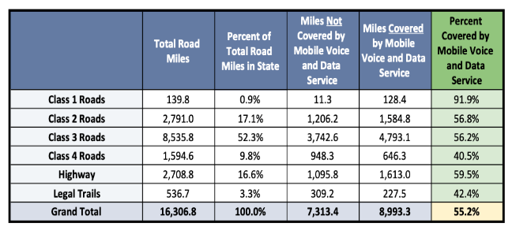

Wired Broadband Coverage
Vermonters have made it clear that they highly prioritize reliable, fast broadband. Availability of internet service was a key factor that Vermonters would consider when deciding where to move, and speed of connection was a primary consideration when choosing an internet provider.
Today, based on the state’s data, almost 70,000 premises, or about 20 percent of the total, do not currently receive at least 25 Mbps download and 3 Mbps upload speeds—the current definition of broadband by the FCC, and just shy of 17 percent of rural census blocks in Vermont have a choice between multiple providers who provide wired, 25/3 Mbps service. However, these numbers do not reflect recently announced investments in broadband expansion that are rapidly changing the broadband landscape.
This Plan’s analysis of the state of residential wired broadband and competition is as follows.

Scope of Unserved and Underserved Premises
Since the state’s broadband data were compiled in 2019, there have been expansions of service by providers (e.g., Consolidate Communications, ECFiber, Waitsfield and Champlain Valley Telecom, OTELCO, Mansfield Community Fiber, and others). The phone survey conducted during the preparation of Vermont’s Covid-19 Response Telecommunications Recovery Plan, which targeted premises considered to be unserved and underserved by the Public Service Department, found that 14 percent of those respondents (who were considered unserved or underserved) actually did have wired service capable of 25/3 Mbps, due in many cases to construction that happened after the data were collected.
The state also funded deployment to approximately 8,700 addresses via the Emergency Connectivity Initiative through a variety of technologies, roughly 2,000 of those addresses with fiber.
The FCC’s Rural Digital Opportunity Fund (RDOF) auction has granted funding to a variety of entities to serve approximately 19,000 premises in Vermont, 17,000 of which will be served by fiber, and 2,000 to be served by Starlink through a low-Earth orbit (LEO) satellite connection. Winning bidders have up to six years to complete construction to the unserved and underserved premises.
Consolidated Communications, in addition to winning a substantial portion of RDOF locations, has announced that a private equity investment is allowing them to build fiber to over 200,000 premises in areas that already have cable. Construction has already started in Brattleboro and Montpelier.
This report used various datasets from the PSD and the FCC and geospatial mapping tools to calculate the remaining sum of premises that are still lacking a clear path to 100/100 Mbps service. The assumptions used in this calculation are as follows:
- Premises currently unserved and underserved, but funded at the gigabit low-latency tier (which only fiber can provide) by RDOF, are considered served
- Premises currently unserved and underserved, but funded at the above baseline, low latency tier (in Vermont’s case, LEO satellite) by RDOF, remain unserved and underserved, because LEO satellites will never be able to provide symmetrical 100/100 Mbps service
- Premises served by cable currently are considered served; cable providers have upgrade paths to 100/100 service that do not necessarily involve new fiber construction
- Premises funded by the Connectivity Initiative with fiber are considered served
- Premises funded by the Connectivity Initiative with fixed-wireless solutions are considered unserved and underserved; for more information, see the discussion of the limitations fixed wireless in Section 5
Our analysis finds that approximately 54,000 premises do not currently have access to 25/3 Mbps service, and do not have a path to coverage. These premises are often on the outskirts of towns or in the most rural areas, and can be in non-contiguous areas. Serving these premises at the “last mile” presents a challenging business case; as such, they should be the priority locations for capital subsidy available for broadband expansion.

Communications Union District Coverage
In 2015, the Vermont Legislature authorized the formation of Communications Union Districts (CUD), enabling two or more towns to join together to provide communication infrastructure to residents. Much like a water and sewer or solid waste district, CUDs allow towns to aggregate demand for a service and find efficiency by sharing operation of the district.
CUDs are critical entities for closing the digital divide in Vermont. The state has promoted and supported CUDs as a mechanism for expanding broadband across the state in the most rural areas; the infrastructure the state has built around CUDs and the progress CUDs have made makes it clear that CUDs will continue to play an important role in the telecommunications landscape in the state.
East Central Vermont Telecommunications District (“ECFiber”) became Vermont’s first operational CUD in 2016 and has since served as a model for other regions across Vermont seeking to address the growing needs of unserved or underserved areas. In 2018, for instance, twelve municipalities in Central Vermont followed ECFiber’s lead to form CVFiber. By mid-2019, 27 towns in Vermont’s Northeast Kingdom region voted to form NEK Broadband, which now covers 48 cities and towns and serves as the state’s largest CUD.
A growing number of municipalities across the state have chosen to join or form a CUD in the last six years. In total, nine districts representing 186 of Vermont’s 246 towns and cities have formed, as identified in the following table and illustrated in the map below.
Table 3: Vermont CUD Membership (as of April 2021)
CUD | Town and City Membership
Maple Broadband | 20
CVFiber | 19
CVFiber/ECFiber | 1
Deerfield Valley CUD | 20
Deerfield Valley CUD/Southern Vermont CUD | 2
ECFiber | 30
Lamoille FiberNet CUD | 8
NEK Broadband | 48
Northwest CUD | 11
Otter Creek CUD | 15
Southern Vermont CUD | 12

Figure 7: Existing CUD Coverage (Source: Public Service Department)
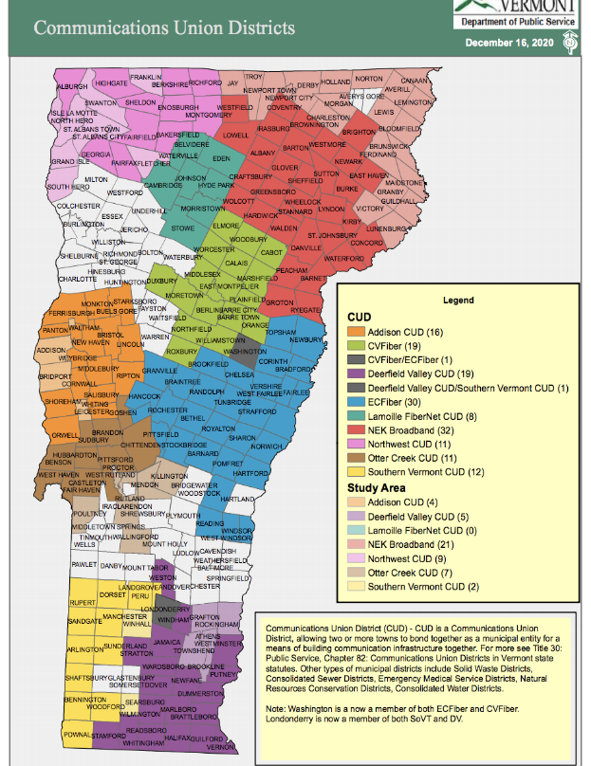
There are many reasons municipalities choose to form or join a CUD, but perhaps the most valuable benefit for rural communities is the ability to achieve efficiencies of scale by aggregated un and underserved premises across towns. Less dense and isolated towns may not individually provide the profitability needed for ISPs to expand or provide adequate service to their area, nor may they have the leverage to appropriately scale for efficient solutions on their own. By aggregating demand and sharing resources, CUDs allow towns to gain more negotiating power and increase their appeal to potential investors.
Some municipalities, including the majority of the Chittenden County area, and southern parts of the Windsor and Rutland areas, have yet to join a district. It is important to recognize that some towns may choose not to be part of a CUD if current broadband options provide adequate coverage for their residents. Indeed, Chittenden, Windsor, and Rutland counties have the lowest percentages of underserved (< 4/1 Mbps) buildings in the state and the highest percentages of buildings with internet speeds of 25/3 Mbps or greater, which may be a contributing factor to the delayed uptake of CUD membership in these areas. In contrast, areas with inadequate coverage have displayed a stronger response to CUD recruitment and formation.
It is expected that more towns will continue to join CUDs in the coming weeks and months, especially as state plans to support broadband expansion solidify, and as existing CUDs continue to do outreach to neighboring communities. In addition, it is expected that CUDs may explore merging with other districts to achieve greater scale. CUDs were originally formed loosely around Regional Planning Districts in the state, and though some will remain this size, some may merge or closely coordinate to share administrative burden, fixed costs, strategies, and gain greater scale.

Wired Broadband Competition in Vermont
Advocates and public officials in Vermont, as well as national data on broadband pricing, indicate that having a choice between multiple broadband providers can lower prices and benefit consumers. In rural areas, however, there are often not enough total potential customers to entice multiple ISPs to offer broadband service.
This report presents an original analysis that compares the amount of broadband competition in rural Vermont to states across the country. An analysis of census blocks in the FCC’s 477 data, filtering the dataset down to just rural census blocks, and comparing the number of census blocks with two ISPs or more vs those with one or none by state, finds that:
- The national average for number of rural census blocks with more than one fiber or cable provider is 16.8 percent, the median is 16.9 percent
- Vermont ranks very close to the average, with 16.7 percent of rural census blocks having a choice between two or more fiber or cable providers
- For context, the state with the most competition in rural areas is Rhode Island (76.7 percent of rural census blocks have multiple cable or fiber providers); however, this state is an outlier with very few census blocks designated as rural
- Massachusetts ranks 5th on the list, with 25 percent of rural census blocks having a choice; New Hampshire is 7th with 23 percent of rural census blocks having a choice
- The state with the least competition is Idaho; 3.38 percent of rural census blocks have a choice
All of the limitations of the FCC’s data apply to this analysis; namely, measurements at the census block are less precise than ideal, and the data is not current as of this report, and so recent construction is not reflected in this analysis. It is expected, however, that the recently announced plans by Consolidated Communications to build fiber to over 200,000 premises in areas with existing cable will greatly increase the amount of competition in Vermont. 200,000 premises presents a significant percentage of the overall number of premises in the state, and Vermont may well become one of the states with the most competition in rural areas after CCI completes their construction.

Price and Speed Comparisons With Other States
Internet speeds recorded by speed tests can provide context to the internet landscape of the state. The speed-test provider Ookla aggregates regional internet speed test data quarterly and publishes averages by state. As of Q1, 2021 New Jersey, Rhode Island, and New York had the fastest median download/upload speeds in the country: 138.69/35.70 Mbps, 134.19/33.71 Mbps, and 129.41/23.62 Mbps, respectively.
By comparison, Vermont’s median speeds were 73.08 Mbps download and 10.95 Mbps upload, placing Vermont 45th on the list and closely aligned with other rural states of similar demographics. However, this comparison should be considered with significant context; namely, that speeds vary based on many factors and do not simply reflect the availability of fast internet. For example, speed tests are impacted by the internet packages offered and purchased by consumers, in home equipment and distance from the access point, use of the test on a desktop, laptop, or phone, demographics (e.g., older people tend to not need or subscribe to as fast of internet), and the make-up of the local business sector. The rurality of the state will also have a big impact on speeds, as attenuation may occur to a greater degree when premises are more spread out.
Prices for service in Vermont range by provider, but do not seem to be significantly different than service costs in other New England states.
One difficulty in comparing service costs across states is that many major ISPs can and do change pricing, often by offering “teaser rates” that start at advertised low rates and gradually increase over time or after a certain length of service.
In addition, hidden fees change the price paid by consumers for internet. For example, Comcast had planned to implement data caps across the northeast during 2021, which could result in extra fees if customers exceed data limits in a month, however, they have delayed enforcement of data caps until an unspecified time in 2022.,
Lastly, it can be difficult to compare costs because the speeds those costs pay for can vary greatly. Some providers offer speeds “up to” a certain amount, though in practice, the actual speeds perceived by the customer could be very different than the maximum advertised speed. Comparing the cost of service rated “up to 200 Mbps” with service rated “up to 300 Mbps,” when there is no guarantee customers are getting advertised speeds, is a challenge.

Vermont Pricing
The table below summarizes the pricing, speed, and availability of services delivered by internet service providers in Vermont. Please note that all prices listed in this Plan were current as of the time of this writing and are subject to change at any time.
Table 4: Broadband Service Pricing in Vermont
Provider | Starting Price* | Download Speed Range | Technology
Xfinity | $39.99/mo. | Up to 300 Mbps | Cable
Spectrum | $49.99/mo. | Up to 200 Mbps | Cable
CenturyLink | $49.00/mo. | Up to 80 Mbps | DSL
Burlington Telecom | $55.00/mo. | Up to 150 Mbps | Fiber
Vermont Telephone Company | $34.95/mo. | Up to 1,000 Mbps | Fiber
Consolidated Communications | $62.00/mo. | Up to 100 Mbps | DSL, fiber
Viasat | $70.00/mo. | Up to 12 Mbps | Satellite
HughesNet | $99.99/mo. | Up to 25 Mbps | Satellite
*Pricing per month plus taxes for length of contract. Additional fees and terms may apply. Pricing varies by location and availability. All prices subject to change at any time. May or may not be available based on service address. Speeds may vary. As of 04/21/21. Source: https://www.allconnect.com/local/vt

Pricing in Neighboring States
The following tables include prices presented on the providers’ websites.
Table 5: Xfinity/Comcast Pricing in Neighboring States
Download Speed (Mbps) | VT | NH | ME | MA | CT | RI
25 | $49.95 | $49.95 | $49.95 | $49.95 | $49.95 | -
100 | $39.99 | $77.95 | $77.95 | $77.95 | $77.95 | -
200 | $54.99 | $39.99 | $39.99 | $39.99 | $39.99 | -
300 | $59.99 | $59.99 | $59.99 | $59.99 | $59.99 | -
600 | $69.99 | $69.99 | $69.99 | $69.99 | $69.99 | -
1000 | $79.99 | $79.99 | $79.99 | $79.99 | $79.99 | -
2000 | $299.95 | $299.95 | $299.95 | $299.95 | $299.95 | -

Table 6: Consolidated Communications Pricing in Neighboring States
Download Speed (Mbps) | VT | NH | ME | MA | CT | RI
10 | - | - | - | $27.00 | - | -
20 | $37.09 | - | $37.09 | - | - | -
25 | - | - | - | $43.95 | - | -
40 | $47.59 | - | $47.59 | - | - | -
50 | - | $49.89 | - | $46.95 | - | -
100 | - | $62.00 | - | - | - | -
1000 | - | $74.55 | - | - | - | -

National Pricing
The following tables include prices presented on the BroadbandNow website:
Table 7: Charter Spectrum Pricing (National)
Speed | Price/Month
100/10 | $49.99
400/20 | $69.99
940/35 | $109.99

Table 8: Viasat Pricing (National)
Speed | Data Cap in GB | Price/Month
12/3 | 12 | $50
12/3 | 25 | $75
12/3 | 50 | $100
25/3 | Unlimited | $150

Table 9: HughesNet Pricing (National)
Speed | Data Cap in GB | Price/Month
25/3 | 10 | $49.99
25/3 | 20 | $59.99
25/3 | 30 | $89.99
25/3 | 50 | $139.99

State-Level Pricing

Vermont
Table 10: VTel Pricing (Vermont)
Speed (Mbps) | Price/Month
1000 (Fiber Optic Internet) | $34.95
1000 (GigE Solo) | $69.95
1000 (GigE Gamer) | $79.95
10,000 | $399.95

Table 11: ECFiber Pricing (Vermont)
Download Speed (Mbps) | Price/Month
25 | $72.00
100 | $104.00
300 | $134.00
800 | $164.00

Table 12:Burlington Telecom Pricing (Vermont)
Download Speed (Mbps) | Price/Month
5 | $40.00
150 | $55.00
300 | $65.00
1000 | $70.00

Table 13: Waitsfield & Champlain Valley Telecom Pricing (Vermont)
Download Speed (Mbps) | Price/Month
10 | $46.95
25 | $53.95
50 | $63.95
100 | $76.95
500 | $91.95
1000 | $103.95

New Hampshire
Table 14:Granite State Communications Pricing (New Hampshire)
Download Speed (Mbps) | Price/Month
25 | $49.95
50 | $69.95
100 | $89.95

Table 15:Tamworth Wireless Cooperative Pricing (New Hampshire)
Download Speed (Mbps) | Price/Month
1 | $29.99
2 | $49.99
3 | $69.99
4 | $89.99

Maine
Table 16:Coastline Wireless Pricing (Maine)
Download Speed (Mbps) | Price/Month
20 | $39.99
40 | $54.99
60 | $69.99

Table 17:RedZone Pricing (Maine)
Download Speed (Mbps) | Price/Month
25 | $44.99

Massachusetts
Table 18: Starry Internet Pricing (Massachusetts)
Download Speed (Mbps) | Price/Month
100 | $30
200 | $50

Table 19: NetBlazr Pricing (Massachusetts)
Download Speed (Mbps) | Price/Month
200 | $39.95
1000 | $59.95

Table 20: Shrewsbury Electric and Cable Operations Pricing (Massachusetts)
Download Speed (Mbps) | Price/Month
100 | $54.95
200 | $69.95
300 | $99.95

Connecticut
Table 21: Thames Valley Communications Pricing (Connecticut)
Download Speed (Mbps) | Price/Month
6.6 | $29.99
110 | $39.99
330 | $59.99
1000 | $79.99

Survey of Other State Broadband Programs and Offices
The National Conference of State Legislatures performed a survey of state programs to address broadband gaps in June 2020. At that time, all 50 states had launched some program or initiate to address broadband gaps, ranging from temporary (and sometimes even unfunded) taskforces and commissions to fully fledged independent authorities and offices.
Almost certainly due to increases in resources to support broadband deployment, many states are now in the process of converting task-forces and commissions into more established frameworks, like state offices and authorities. A survey done by the project team found that most of these offices are or will be housed under Economic Development or Information Technology departments within state government, though this is not uniform across states. As part of the processes of expanding and establishing new frameworks, many states are also seeking to add staff capacity with broadband expertise.
Among Vermont’s New England peers, Maine and Massachusetts have the most robust broadband expansion programs. Maine’s program, the ConnectMaine Authority (ConnectME), was established in 2020 and has an annual operating budget of around $1.5 million, funded by a small surcharge (0.25 percent) on all communications, video, and internet service bills, as well as a surcharge ($0.10) on all landline numbers. In July 2020, Maine voters passed a broadband bond of $15 million, which ConnectME administers. ConnectME is also slated to oversee broadband investments of up to $129 million, funded by the American Rescue Plan Act.
The Massachusetts Broadband Institute (MBI) supported a 1200 mile, publicly owned middle mile network in 2014, which is operated by a private company. The network cost almost $90 million and was partly funded by federal BTOP grants. Since then, the MBI has provided over $30 million in grant funding to various broadband projects that are either hybrid fiber/coaxial cable, or fixed wireless.
It is hard to compare per capita spending on broadband state to state, considering the range of resources from different sources that have been used for different types of broadband infrastructure. Vermont’s allocation of 10.8M to the VEDA Broadband Expansion program via Act 79 in 2019 is slightly more per capita than Maine’s recent bond, but in the same order of magnitude. It is also more per capital than the $30 million in last-mile project funding Massachusetts has spent in the past few years; however, the varying time frames, projects, lending parameters, and processes do not make this a particularly useful comparison. Another complication in comparing per capita spending on broadband is the varied amount of federal funding for broadband awarded to each state. Vermont has been the recipient of substantial federal money, for example, the BTOP and USDA resources awarded to VTel, as well as CARES act resources that were directed to broadband.
Perhaps more important than how much money has been spent on a per capita basis is how the money has been spent. In that regard Vermont has been a regional and leader on the strategy and public policy behind broadband deployment.
Vermont’s Communication Union District model is being replicated across the country, including recently in New Hampshire and Maine., Many states, including Maine but also Tennessee, Georgia, and others, have undertaken or are currently pursuing efforts to improve upon the FCC’s 477 data for planning purposes, specifically about what areas are currently underserved. Vermont’s Public Service Department has been a nationwide leader on this front, having provided address-level broadband availability data for several years already.
In addition, Vermont’s emphasis on prioritizing 100/100 Mbps service will ensure that investments made now in broadband infrastructure will last for decades and not need to be duplicated in the future. Setting 100/100 Mbps as the goal is increasingly common amongst public advocates across the country, but Vermont is a leader in adopting it as the official state goal.
Crucially, Vermont’s emphasis on leveraging public entities in solving broadband challenges will ensure many of the goals set by advocates and public officials—like reaching the last mile and providing affordable service—can be realized. The involvement of local public entities in the broadband solution will also provide a foundation for addressing demand-side broadband challenges, like affordability and digital equity, for the life of the networks.
Lastly, Vermont’s approach to telecommunications policy on the local and statewide level is notably community-driven. The CUD mechanism is almost entirely guided by local decision-making and local control. Vermont is singular in the access and input it gives the public in statewide telecommunications planning between the public input sessions, comment solicitation, and draft review processes.

10-Year Technology and Usage Trends

Broadband Market and Technology Trends
Telecommunications systems, at their simplest, transmit packets of data from one location to another, around the world. Recent technological advancements have created faster and more reliable mechanisms to transmit packets of information; these new technologies are in the process of being deployed for commercial purposes and will impact telecommunication services and policy in the next 10 years. At the same time, all of our telecommunications systems are constrained by the properties of physics and so the highest-capacity and most reliable telecommunications technology today—technology that uses light traveling along a glass strand, or fiber optic cable—is not likely to be superseded in the future.

Fiber Broadband Deployment Trends
Fiber-optic based internet deployments are accelerating in urban and rural areas alike. The vast majority of subsidy in the FCC’s recent RDOF auction went to building fiber networks; a clear sign that if any amount of subsidy is available, building fiber networks is almost always the best long-term choice.
Part of the reason ISPs are electing to build fiber, other than the unmatched symmetrical speeds, is that fiber does not degrade as fast as other types of technology, like copper phone lines or coaxial cable. In fact, many cable providers and ILECs are slowly replacing copper infrastructure with fiber.
One related repercussion of the transition to fiber deployment is that technology used to require several connections to a premises is converging into being provided through a single fiber optic cable. Phone systems and cable TV are the notable examples—both are still predominantly provided over metallic cables, but can also be provided on a single strand of fiber where that technology is deployed.
This convergence can create challenges. For example, when phone service was transmitted over copper via electric pulses and thus did not also need power at the home, phone systems could work during a power outage at the home. Light waves transmitted over fiber optic cable cannot function without power at the home, so backup batteries much be provided at the home to keep phone systems working. See Section 6 for CUD network standards (i.e., best practices for resilient fiber networks).

Fiber Broadband Deployment Methods
In rural areas, the telecommunications systems are almost always Passive Optical Networks (PON) rather than Active Ethernet networks.
Gigabit PON (GPON) technology, or a PON network capable of reaching gigabit speeds, is a proven, cost-effective solution delivered by most fiber carriers today, especially in rural areas. The basic premise of all PON architecture is to share the optical feeder and port on the Optical Line Terminal (OLT) among as many subscriber terminals as possible (commonly 32 subscribers per OLT port). In common terms, GPON systems allow users to share the strands of fiber in the access network, rather than building out a dedicated strand all the way from the OLT to each premise, which is how they achieve cost savings. Because strands of fiber have so much capacity, many subscribers can share a fiber from the OLT to a splitter near the premises without performance issues or capacity issues. Typically, the maximum distance recommended between the OLT location (typically in a cabinet or hub) and the end user is about 12 miles, or 20 kilometers. As a result, GPON networks in Vermont usually have one hub per town in a central location, ideally with a backup generator.
The typical alternative to PON networks is called Active Ethernet. Active Ethernet architecture provides a dedicated strand from the network electronics to every customer premise, and as such requires more strands overall and a larger hub location or powered outdoor cabinets to house OLT equipment. Because each strand must be actively powered, the maximum distance from hub to end-user could be much further, up to 75 miles, and each user can have the full capacity of their dedicated strand. However, the cost of deploying an Active Ethernet network far exceeds the cost of deploying a PON network because, for example, the shared fiber strands in a GPON network enable the fiber operator to install lower fiber counts (at a lesser cost), and fewer ports are required on the OLT equipment. In addition, the passive nature of the network also eliminates the need for power at cabinets in the field. Overall PON architecture has advantages in lower capital expenditures and reduced energy consumption, less rack and hub space required, and more favorable resiliency metrics like longer mean-time-before-failure. Because the cost savings do not greatly affect network performance or capacity, new rural networks typically are PON.

Wireless Network Deployment Trends
Wireless network deployment in Vermont and across the country often takes many forms depending on the type of technology and frequency spectrum used. Deployments can be open access at the structure level, (e.g., a tower is used by multiple providers) or even at the radio level (a single antenna can be used by multiple providers). In addition, deployments can be at a variety of scales, from towers with high-capacity radios using frequencies that can send signals for 5 miles or more, to small-cell deployments that can reach a more localized area but do not require massive tower infrastructure.
Given the variety of deployment methods, networks need to be tailored to local contexts. Potential deployments in Vermont and around the country often are opposed by communities when new tower locations are proposed on prominent ridgelines, hills, or mountains. Communities generally are more supportive of placing new towers next to existing towers or more antennas on existing towers, because this minimizes the damage to natural habitats, or on hills or mountains with less local prominence or significance. The reality is that mobile voice and data deployments must be tailored to the local context; we expect the aesthetic concerns regarding new towers in Vermont communities to continue to be a factor in deployments moving forward.
Whatever the future wireless deployment mechanisms are in Vermont, wireless networks will be made much easier by widespread availability of fiber because the latter requires the former for backhaul. Solving the last mile residential broadband challenge will also make future wireless deployments of all varieties much easier.

Cable Industry Trends
Cable providers, like Comcast, Charter, Duncan Cable, Stowe Cable, and others, are major providers of broadband to homes and businesses in Vermont. Several trends in this industry are worth noting.
First, though cable systems are not considered to be able to provide symmetrical speeds, the speeds upon which data can be transmitted across coaxial cable are increasing. Cable technology is measured by the telecommunications standard known as Data Over Cable Service Interface Specification (DOCSIS), and the most up-to-date commercially deployed DOCSIS standard, DOCSIS 3.1, is capable in of providing multi-gigabit download speeds and a gigabit of upload capacity to an aggregate group of subscribers sharing a network node, in perfect conditions. (Actual speeds rarely if ever meet the speeds that are theoretical under laboratory conditions; actual speeds depend on constraints with customer devices and electronics, backhaul, oversubscription, attenuation, and other factors.)
Because of the speeds that DOCSIS 3.1 (and in the future DOCSIS 4.0, which is not yet commercial prevalent) offer, cable providers can and will continue to remain competitive as bandwidth demands increase, and upgrades to cable systems will meet the state’s 100/100 Mbps goal. Comcast, for example, has an “upgrade path” to incrementally increase the speeds of its network by primarily by upgrading the electronics on either end of the cable (without needing to replace the cable itself) as consumer demand increases.
Another trend apparent in the cable industry, predominantly with bigger providers, is to implement data caps for residential customers. Data caps set a limit to the total amount of data that can be accessed per month, and result in extra fees when customers exceed that limit. Data caps are not regarded by advocates as a pro-consumer policy.
Implementation of data caps is a national trend that has not affected Vermont cable subscribers yet, but may within the next few years. Comcast considered implementing data caps in 2021 but has announced they will not enforce those caps until 2022. Charter Spectrum, as a condition on their merger with Time Warner Cable, is not allowed to implement data caps until May 2023.

Emerging Technologies
Several new broadband technologies, namely 5G wireless and low-Earth orbit (LEO) satellites, have received a lot of attention nationally and in Vermont as providers, advocates, CUDs, and others consider how these technologies will affect the market and potentially be part of the solution to providing access to every Vermonter. It is important to understand the benefits of these technologies, along with their limitations, so as to understand where they have a role in the broadband landscape.

5G Wireless
5G is the fifth generation of mobile network technology. Like other wireless technologies, 5G uses electromagnetic radio waves to transmit data; but can transmit data at significantly higher speeds than advanced 4G LTE technology and other wireless predecessors. 5G uses a wider range of frequency bands, including millimeter waves for the very highest speeds, with a much higher frequency and wider channels than have been used before. Signals travel between devices over many paths, beam-forming technology dedicates capacity to individual devices, and radios are more sophisticated; together, these innovations allow the network to transmit more data at higher speeds. Industry advocates have shown that 5G wireless technology can deliver multi-Gbps peak data speeds at ultra-low latency in perfect settings, however, actual speeds experienced by wireless users are often only a small percentage of the peak data connection rate.
However, the many limitations to this technology mean the vast majority of Vermont 5G deployments will use the same low-band and mid-band frequencies as currently used in 4G deployments; as a result, the performance will be an incremental improvement to 4G—and 5G is not an economical or viable technology to close the broadband access gap, relative to a fiber solution. In addition, the highest frequency and highest speed millimeter-wave 5G signals that provide fiber-like speeds do not permeate common physical barriers like hills and trees very well, so outdoor deployments meant to serve all premises and indoor users in rural areas would not be an effective strategy.
More importantly, millimeter waves are strongest within 800 feet from 5G-enabled antennas. To reap the full benefits, all premises would need to be within 800 feet of an antenna, and the network would also need to have access to fiber backhaul. This would require a significant fiber network, and moreover, the number of radios needed to cover low-density rural areas would be cost-prohibitive. There is simply no business case for providers to deploy millimeter wave 5G radios in rural areas due to the low density of population. As cell carriers and major ISPs decide where to begin deploying 5G networks, they will likely focus on high-density cities first, and only bring the varieties of 5G that operate on low-band frequencies to rural areas. As a result, 5G deployments in rural areas will only provide an incremental improvement over 4G.

Low-Earth Orbit Satellite
LEO satellite internet is another emerging technology that has received significant attention in the past year. In particular, Elon Musk’s company SpaceX and their internet company Starlink is currently emerging from a Beta test of their service, which was available to a select number of Vermonters as well as people across the country.
LEO satellite companies aim to create a constellation of satellites to provide better internet coverage than traditional satellites. In particular, because these satellites are closer to earth, they provide connections with lower latency connections than traditional satellite internet.
Anecdotal user reports found in the press indicate that users without a better option were generally happy with the service during the beta test, however reliability issues, price, and the possibility of data caps on the service in the future caused some concerns.,
The reliability of the service is impacted by a few factors. First, trees and other obstacles have a material effect on the service and can block internet for a time until the satellite moves past the obstacle. Second, the receiver dishes will always have to skip from one satellite to the next as they pass over (the satellites are not geo-synchronous), potentially resulting in an interruption in service until the satellite constellation is complete. Third, and most importantly, it is yet to be seen how speed and reliability will be affected as more people join the network. Like any network and in particular wireless networks, the more users there are, the lower speeds can be, as there is a set amount of bandwidth available to be shared amongst users.
In general, LEO satellite service appears to be a good option for Vermont premises that currently only have access to DSL or traditional satellite. There are thousands of camps and off-grid premises in the state that could benefit from Starlink’s service for the long term, and some Vermonters are already enjoying improved service via Starlink.
That being said, Starlink’s service does not replace the need to build fiber to as many premises as possible. Starlink’s service may not scale as quickly as fiber as bandwidth needs increase in the next decade, and will not be able to provide symmetrical speeds. Importantly, the satellites will also need to be replaced every five years or so. If the service is not making sufficient profit in five years, 10 years, or further in the future, Space-X may not replace satellites or the service may shutter altogether. The state is right to promote fiber-to-the-premises connections, which will be fast, reliable, and meet the needs of Vermonters for decades.

Broadband Use Trends
According to FCC data, bandwidth needs and broadband usage across public and private spheres increased 38X from 2010 to 2020, and there is every indication our increased need for broadband capacity and speed will continue apace.
The Covid-19 pandemic fundamentally altered the way we live, and as we emerge from the pandemic, many of our newfound ways of using the internet to learn, work, and socialize will remain. From increased videoconferencing and video consumption at higher and higher resolutions to an ever expanding number of household items and machines and sensors connected to the internet, bandwidth needs will only continue to grow.
Based on interviews conducted during our previous analysis, internet service providers across the state reported recent increases in bandwidth usage, likely due to the pandemic, with a larger increase in upstream utilization. For example, Waitsfield and Champlain Valley Telecom reported a 30 percent increase in bandwidth usage; AT&T reported that core network traffic increased 22 percent and that video conferencing increased 400 percent. ISPs also reported changes in peak utilization times. Peak internet usage used to be around 8 p.m., but providers are finding now that peak usage occurs throughout the day as well as in the evening, as people continue to work and learn from home. While residents return to pre-pandemic routines, usage will see a decrease, but future forecasts show that overall, bandwidth need will continue to increase. A report states that data usage increases annually by 20 percent to-30 percent per person.

Remote Work
Many American workers worked from home at some point during the pandemic. A report by the Upwork Economist found that the remote work experience over the past year has contributed to a doubling of the expected growth rate of full-time remote work over the next five years from 30 percent to 65 percent.
For many employees, the flexibility to work remotely in part or in full will become a permanent part of their job. In one survey, 56 percent of hiring managers feel that the shift to remote work has gone better than expected, while only one in 10 feel it has gone worse than expected. In the same survey, 61 percent of hiring managers stated that they will include remote options in their work post pandemic.
Working remotely cannot be done without reliable, high speed internet, and remote work in particular relies on upload speeds as much as download speeds for sending files like PDFs, images, videos, and datasets to colleagues, as well as two-way videoconferencing.
Vermont began positioning itself as a remote work destination before the pandemic, offering $10,000 incentives for remote workers to relocate to the state. During the pandemic, due to low Covid-19 case numbers and an emerging brand as a remote work destination, many more people with an ability to work remotely moved to the state, in addition to the thousands of existing Vermont residents who transitioned to working remotely.
For those with good internet access, this transition to remote work was relatively easy, but for those without an existing connection, remote work was a challenge. The ability to work remotely is considered a perk by employees and now, a reality of life. Not having a fast broadband connection will only become more of a limiting factor to Vermont workers and the Vermont economy; it is clear that for Vermont workers to maximize their potential, broadband must be ubiquitous and fast.

Population Changes
Population growth in Vermont slowed in the past several years, with Census data showing incremental decreases prior to the pandemic. Now, however, the state has seen a surge in home purchases by people from outside Vermont as a result of the pandemic. Though the impact of these home sales on the state’s population change is not yet clear, the Agency of Commerce and Community Development cited research from the University of Vermont which anticipates that, of the new arrivals in Vermont (many of whom are currently working remotely), one-third will stay permanently (and will presumably continue to require broadband service), one-third will leave after the pandemic is over, and another third are undecided.
Currently, more than 80 percent of home sales in Vermont are going to out-of-state buyers. The repercussions of the current immigration trends and real estate market are numerous, but a common concern in surveys of Vermont residents and interviews with employers and advocates alike was that given how critical broadband is to remote work, new Vermonters will be clustering in areas with good broadband—and areas without good broadband will be left behind. Though it is not clear the extent to which this is happening now (the real estate market is strained all over), realtors report an intense concern over the broadband and mobile voice coverage amongst prospective buyers, and the underlying concern that gaps in broadband could create geographic inequalities is very valid.
In addition, there is growing concern that more in-migration prompted by climate change may happen in the next 30 years—well within the lifespan of the telecommunications infrastructure being planned and built today.
Taken together, it is clear the state must ensure the telecommunications systems being planned and built this decade are resilient, future proof, and have the capacity to scale should in-migration continue and bandwidth needs increase.

Education
As with many other aspects of life, our education system may be forever altered by the Covid-19 pandemic.
During our work on the Covid-19 Response Telecommunications Recovery Plan, we found that students without home broadband whether due to lack of access or affordability challenges accessed school assignments at friends’ houses, or at public Wi-Fi locations such as libraries or school parking lots. Clearly, school districts with better broadband infrastructure were able to better reach students.
In addition, the school districts that were not 1:1 with devices before the pandemic were able to use emergency resources to acquire devices so that students were able to better learn from home. Now, those devices will continue to be used for homework and in other out of school contexts, even if teaching is done in-person.
As a result, it is expected that districts may continue using a combination of in-person and “in the cloud” teaching, whether that be “flipping the classroom,” assigning homework where students must collaborate over Google Docs, or even teaching during snow days.
In addition to conducting more classes online, a growing number of schools are providing curriculum about digital skills that are necessary for many 21st century jobs, like coding and computer science. These courses can start at a young age and require a computer and internet connection to practice and learn.
For students that do not have access to reliable, fast internet at home, the education opportunity gap will continue to widen; it is critical that Vermont’s telecommunications policy and planning includes strategies to address both broadband access and affordability across the state.

Telehealth
In Vermont, telehealth usage skyrocketed at the height of the Covid-19 pandemic. While telehealth usage has leveled off to some extent, usage remains significantly higher than pre-pandemic numbers, and the populations increased exposure to telehealth will likely result in more long-term usage.
Due to the pandemic, more than 60 percent of healthcare providers now offer telehealth services, also stating that they plan to continue offering similar services in the future. The changes to reimbursement for telehealth services have helped increase adoption, with the U.S. Centers for Medicare & Medicaid Services (CMS) issuing waivers that allow a range of medical visits to be reimbursed by Medicare and the temporary allowance of audio-only telehealth appointments to be reimbursed by Medicaid at the state level. Continuation of telehealth reimbursements post-pandemic are still under consideration.
In particular chronic care management and mental health services have seen increased patient engagement and success. According to a OneCare Vermont survey, the top four telehealth services Vermont providers plan to continue post-pandemic are chronic management, mental health services, medication management, and non-urgent acute visits. ,,
According to UVM’s 2020 eHealth summary, telehealth saw a decrease in no show rates. No show rates from in person visits were consistently higher in comparison to telehealth video visits, the average no show rate being 3.3 percent lower with video visits (Figure 8).
Figure 8: In-Person vs. Video Visit No-Shows
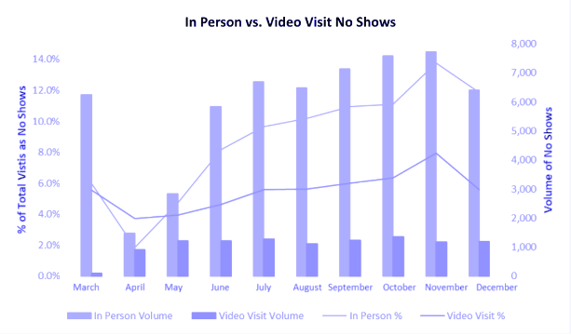
As the telehealth services continue to expand, areas with limited broadband are increasingly at a disadvantage. Video-based telehealth services work best with at least 25/3 Mbps speeds, and according to a OneCare Vermont survey, over 75 percent of providers reported insufficient broadband access as a barrier for patients to participate in telehealth services. Providers routinely experience appointments where they are required to switch to audio-only to complete providing care. Though audio-only appointments may make telehealth services available to more people, some providers believe that video-enabled telehealth appointments provide for better outcomes especially with certain specialties.
The benefits of telehealth are clear; telehealth offers access to care for residents that are limited by transportation, health needs, or even busy schedules. It also decreases no-shows, saving hospitals money, and decreases road miles that need to be driven to appointments. Telecommunications systems in Vermont are a critical foundation to improving health outcomes for Vermonters and the overall efficiency of our healthcare system.

Transportation
One of the most rapidly advancing sectors in the United States is the transportation sector, and as our transportation system gets smarter, more electrified, and more efficient, connectivity needs must increase as well.
Autonomous driving is, in part, already a reality, but as more vehicles have these capabilities and autonomous driving systems become more sophisticated, our transportation landscape could change significantly.
One forecast suggests that vehicles with some level of automation will increase to 40 percent to 60 percent of all vehicles on the road by 2050. A more assertive forecast suggests that 95 percent of passenger miles traveled will be in automated vehicles by 2030. These forecasts are further supported by the number of electric vehicles on the rise. Vermont had the highest number of public electric vehicle chargers per capita in November 2020 with 114 EV chargers per 100,000 people.
Advancements in transportation promise to reduce accidents, reduce the number of cars on the road, eliminate traffic jams, and provide greater safety to passengers and pedestrians alike. However, these systems will rely on low-latency internet connections to react, adapt, and communicate with vehicles and other inputs.
One estimate suggests that data traffic associated with mobility and transportation is expected to grow to 9.4 exabytes every month by 2030 as autonomous vehicles become more ubiquitous. This exponential growth will exert significant pressure on broadband systems unless sufficient capacity is built into our systems. In the next 10 years and beyond, Vermont will need ubiquitous wireless broadband access along roads to accommodate the great advances already underway in our transportation systems, along with the fiber to connect the networks.

Shift in Consumer Habits Driving Data Consumption
Consumer habits are driving an increased need for more data and more bandwidth and are expected to drive bandwidth needs substantially in the next decade.
The core reason is that more and more of our communication and entertainment systems are being delivered over a broadband connection. Just like email replaced physical letters, smartphones are replacing traditional landlines, and streaming services are replacing cable subscriptions.
Secondly, more and more electronic devices are internet enabled and therefore users of the overall bandwidth coming into the house. Phones and computers may be obvious to most, but increasingly printers, radios, televisions, refrigerators, car chargers, doorbells, and more are also connected.
Lastly, consumers are also gravitating towards entertainment and leisure activities that require more and more bandwidth. For example, high-definition movies or sports, interactive online videogames, and Zoom calls with family all require more bandwidth than watching lower-definition video (or DVDs), offline gaming, and audio-only calls.
Taken together, the collective bandwidth usage of our society is increasing by as much as 30 percent each year. Ensuring our telecommunications systems are built to last will mean designing them with the ever-increasing bandwidth demands of consumers in mind.

Incentive Regulation Plan for Consolidated Communications, Inc.
Vermont’s Incentive Regulation Plan (IRP) for Consolidated Communications, Inc., is set to be re-evaluated in the coming year by the Public Utility Commission PUC). IRPs regulate the phone service rates of large local exchange carriers (LEC) in Vermont and are meant to protect consumers who have no choice for phone service while also allowing LECs to remain competitive as more customers have greater choice in phone service providers and technologies (e.g., mobile cellular, VoIP). The IRP is not a mechanism for negotiating or regulating other aspects of telecommunication service beyond telephone rate regulation. By statute, IRPs expire—and so must be re-evaluated—after seven years.
Currently, the regulation of basic local exchange service (BLES) through the IRP provides consumers with a low-cost option that could otherwise be unavailable. Because many residential premises in Vermont have no choice in phone service due not being covered by either mobile voice service or a competitive ISP, it is crucial to continue to protect consumers’ access to an affordable phone connection in future years. As wireline broadband is deployed to more under- and unserved addresses, the Public Utility Commission may consider revisions to future IRPs that reflect progress made in providing customers with more choice. Such revisions could include ending rate regulation in areas with competitive choice from other wireline carriers.

Technology Assessment and Recommendation for Fiber for Unserved Areas
Fiber optics, cable, and fixed wireless are the dominant technologies for delivering broadband. Based on our evaluation, the state should focus its efforts on deploying fiber in unserved areas to most efficiently and effectively meet its goal of providing access to 100/100 Mbps service throughout Vermont. Locations with coaxial cable have an upgrade path to 100/100 Mbps speeds (potentially through the expansion of fiber and upgrade of electronics in the cable network). While fixed wireless has certain strengths, its inability to scale as quickly and its higher long-term costs make it unviable for closing the state’s broadband gaps over the long term.

Fiber Is the Most Capable, Scalable Broadband Technology
Broadband transmitted through fiber optic cable (often called fiber broadband) is the highest-speed and most scalable broadband technology available. Current off-the-shelf technologies enable fiber-to-the-premises (FTTP) networks to provide capacity in excess of 1 Gbps to each subscriber, with new electronics making it possible to go to 10 Gbps or beyond in the coming years. It is possible to reach faster and faster internet speeds by upgrading the electronics on the fiber strand without needing to replace the underlying fiber—fiber internet will be relevant for decades to come.
Fiber broadband also is more reliable than many other technologies—especially wireless broadband technologies, as fiber does not suffer from interference from other signals or line-of sight limitations.
Importantly, maintenance and repair costs of fiber optic cables are low—approximately 1 percent of construction costs annually. Equipment replacement occurs every seven years, but new equipment costs are only a small percentage of the capital cost of an FTTP network. Because of the low maintenance costs, the fact that the fiber itself does not degrade, and the fact that speeds are fast and able to be increased considerably as demand dictates, FTTP is the only internet infrastructure that is “future-proof.”
In addition, fiber broadband has been shown to have a significant positive effect on local economies. A Purdue study noted that every dollar invested in fiber networks by rural electric co-ops added $4 to the economy in return, and fiber broadband has also been shown to increase housing values by more than 3 percent.

Fiber-to-the-Premises in Currently Unserved Areas Will Make Mobile Deployment Easier
A significant additional benefit of an FTTP investment is that fiber will lower barriers to deploying mobile service. Fiber availability reduces the cost and time to market for wireless carriers to deploy antennas in unserved areas.

Overview of Mobile Carriers’ Need for Fiber
The wireless industry needs fiber to backhaul its antenna sites because 3GPP standards require capacity and reliability. If hundreds of users are to be connected from a site—and each user needs 10 Mbps to 50 Mbps of capacity—then even with oversubscription, the mobile carriers need at least 1 Gbps to the site.
Mobile wireless capacity is a particularly limiting factor in locations where residents are unserved or have only satellite or fixed wireless service; because those residents do not have more robust home broadband as a communications option, they need greater mobile bandwidth. Mobile capacity was also less of a concern when voice or text were the main mobile communications; with web access and streaming media now the norm on smartphones, downstream and upstream capacity is now essential.
Fiber is not the only way to achieve this capacity at wireless sites—but as described in Section 5, it is reliable and, importantly, also scalable. Once an antenna site is connected to fiber, backhaul capacity is no longer the limiting factor—and the tower owner can add sectors, upgrade technologies, or make space for more carriers.
In areas unserved by fiber, however, there is a chicken-and-egg element to deploying mobile service. Wireless providers typically work with a wireline provider such as CCI, Comcast, or Crown Castle at the time of installation of new antenna sites. According to AT&T, fiber providers have procedures under which they typically will not begin work until a new site is in place. This practice potentially greatly increases the amount of time needed to bring wireless service to an area, since the fiber extension (which may be many route miles in areas that are unserved or served only by DSL) can require months to construct.
In contrast, in an area where FTTP has been built using best practices such as spare fiber and scalable electronics, the fiber is already in proximity to a wireless site. This has advantages both in terms of time and cost, since even a complex drop installation can be done in days or weeks instead of months. From a cost perspective, too, this approach has significant benefits. A short drop installation may be thousands of dollars instead of tens or even hundreds of thousands of dollars—entirely changing the business case for adding a site and serving an area.
Also, fiber providers often will not want to build to an unserved area to connect a single location (e.g., a wireless site) unless there is an adequate business case for the fiber—such as potential demand for service to other businesses or institutions. in contrast, building an FTTP network reverses this equation, with the business case already created by the FTTP network and serving the unserved residents, and the wireless service simply adding to the revenue already in the model.

Overview of Fiber’s Benefit to Expansion of Cellular and Public Safety Service in Vermont
Residential broadband is only one aspect of the state’s critical telecommunications landscape. Mobile voice and data service coverage (colloquially known as cell service) is another important service with significant gaps in the state. Fortunately, improving other aspects of telecommunications will only get easier with the deployment of fiber.
Mobile voice coverage systems, including public safety communications systems, use radio transmitters to propagate wireless signals, and these radios have to be connected to the greater internet to provide service. This is known as connecting to backhaul, and to ensure mobile voice systems have as much capacity as they need, the ideal backhaul is a fiber connection. In this way, deploying more fiber throughout the state will make improving other communications systems easier.
There is a range of ways to improve mobile voice service, from placing high-powered radios on big towers on hills and ridges, to using small cells on utility poles to provide coverage to a half mile area. Either of these methods are benefitted by access to fiber backhaul.
For example, the following is a map of existing fiber plant in Vermont.
Figure 9: Fiber Infrastructure in Vermont
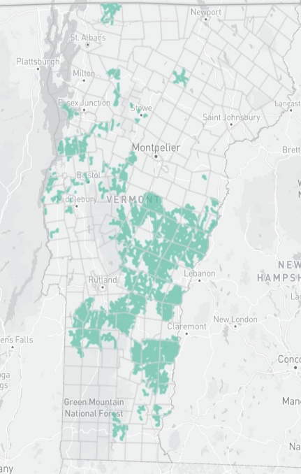

Many locations that already have fiber struggle with mobile voice coverage. By overlaying a propagation model performed for this report (see Section 3), it becomes apparent where a wireless antenna deployment would be made easier due to the presence of fiber.
In this map, for example, it is clear that many premises in Strafford and Tunbridge may have gaps in mobile broadband coverage.
Figure 10: Mobile Voice Service Gap in Orange County
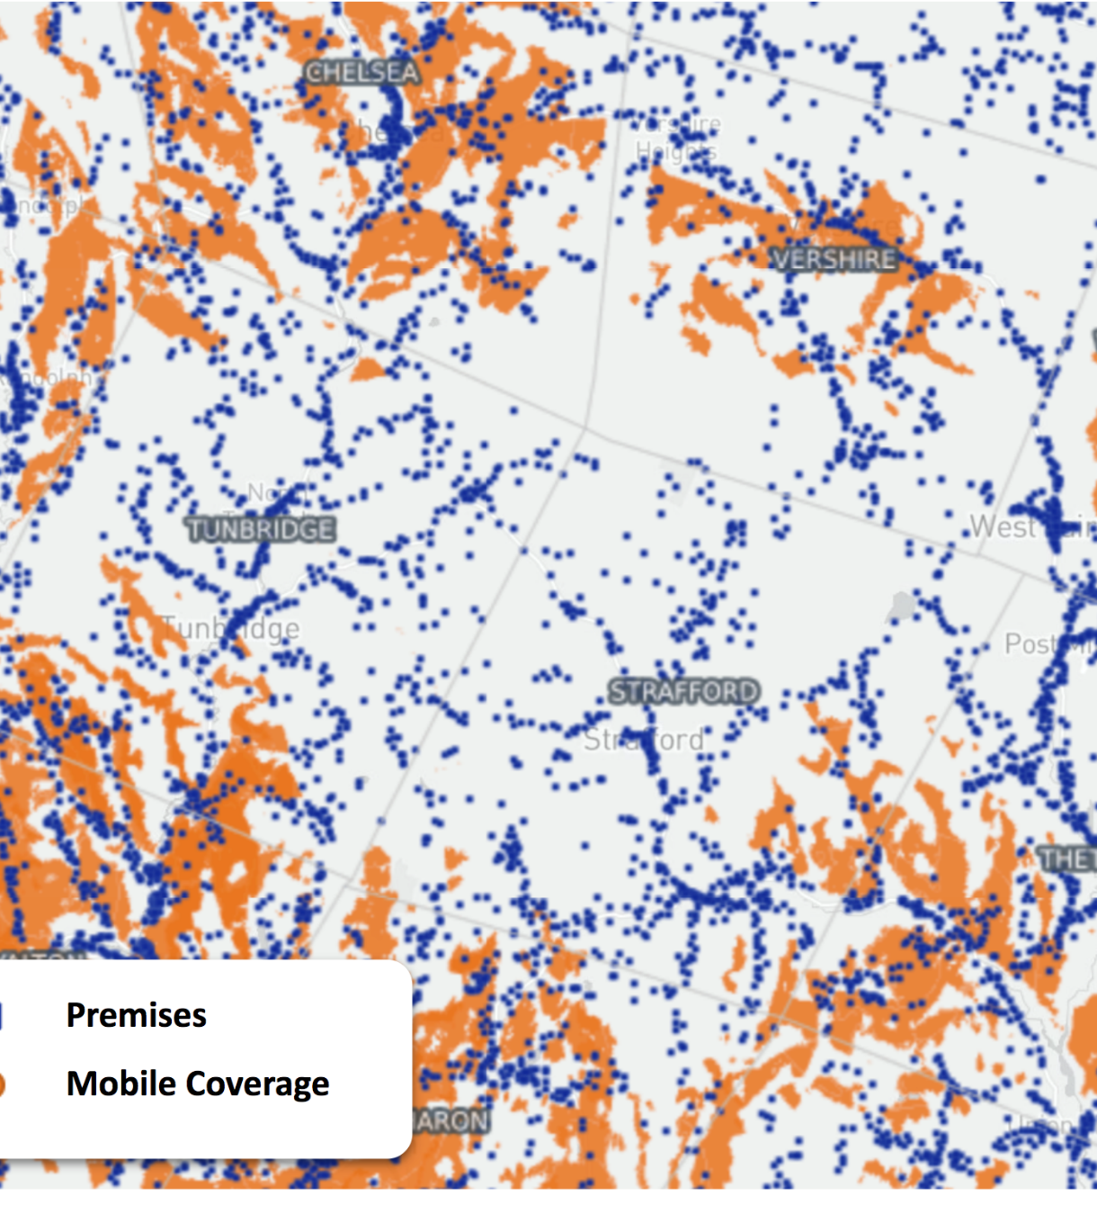
However, those premises are almost all within half a mile of a last-mile fiber network, as evidenced by the map below:
Figure 11: Fiber Penetration in Mobile Service Gap in Orange County
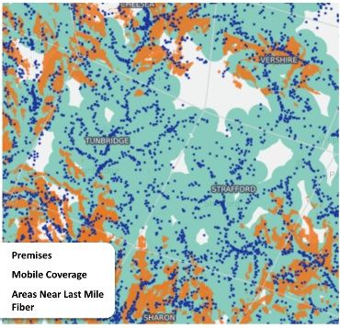
The presence of this fiber should make new mobile radio deployments easier; new fiber backhaul need not be brought to the ideal radio locations from far away because fiber already permeates the area.

Cable Broadband Is Upgradeable with Fiber and Electronics
Cable broadband is the dominant broadband technology in Vermont and in the U.S. with the capability of providing 25/3 Mbps service (i.e., the FCC’s definition of broadband) in almost all cases. However, because cable originated as a one-way television technology and evolved through a broadband environment where download speeds far exceeded upload speeds, the technology is capable of increasingly fast download speeds—up to 1 Gbps in some places—but generally is limited to 10 Mbps or less in the upstream direction. In other words, Comcast’s cable broadband network in its current form cannot achieve Vermont’s requirements (i.e., 100/100 Mbps).
The cable industry recognizes that the upstream limit is a significant impediment, particularly given the need for broadband service that can support interactive video, telemedicine, and remote learning and work; it also recognizes that achieving higher upstream capabilities will require investment in the infrastructure. But, while the cable industry as a whole is looking at a range of options to address the upstream issue, it has not yet embarked on any single course as its next step. The potential approaches range from a focus on upgrading network electronics to one that stays with the current technologies but expands fiber optics closer to users’ homes.

Cable System Upgrades Could Take Different Forms
In its 1Q21 earnings call, Comcast reported lab testing of more advanced electronics and that it intended to “increase upstream in a capital-efficient way”—an allusion to new DOCSIS 4.0 technology that adds many enhancements to the current DOCSIS 3.1 standards. Perhaps most notably, DOCSIS 4.0 adds the ability to operate in “full duplex,” in which the entire cable spectrum is available for both upstream and downstream operation. In tests, this has been shown to deliver multi-gigabit download speeds with 1 Gbps upload.
Upgrading to DOCSIS 4.0 will require enhancements in the outside cable plant, including replacement and upgrade of headend and hub equipment, and node and amplifier electronics, as well as expansion of fiber outside plant—and installation of new cable modems and set-top converters at users’ premises. And, since the technology is still in the lab, it will require an assessment of what cable plant design will be needed, and what elements of the current systems can be kept as-is.
Another approach (which does not rely as heavily on technologies still under development) would be to expand fiber optics deeper into the network. Doing so would reduce the number of subscribers sharing a network segment and make more of the limited upstream capacity available to a given subscriber. Cable operators in many communities are already doing this reactively as they find parts of their networks experiencing congestion.
As the fiber upgrade process continues, a cable system may gradually become a fully fiber-optic network. In portions of the system that have aerial plant (like most of Vermont), this generally requires lashing a fiber cable to the coaxial cable at relatively low cost per foot. In some parts of their systems, Comcast and other operators are able to offer fully symmetrical services (that is, upload speeds that match the download capability), as well as services higher than 1 Gbps; that can occur when the operator has built fiber to that home or business—and the operator typically then prices the service at level sufficient to recover the cost of the fiber build.
A third approach to upgrading a cable broadband system would be a combination of enhanced fiber and modifications of electronics. While keeping the current DOCSIS 3.1 headend and hub electronics and cable modems, the cable operator can modify the node and amplifier diplex filters to increase the upstream bandwidth. In this way, the cable operator is essentially widening the upstream bandwidth beyond its current home (in a small sliver below the former Channel 2) to a wider band.

Upgrading a Cable System Will Cost an Estimated $1,000 to $2,000 per Passing
As mentioned, the past approach of the cable operators has been to increase bandwidth incrementally and reactively based on local demand. The effort to upgrade a cable system to 100/100 Mbps or more would require one or more of the above technical approaches, which will cost on average $1,000 to $2,000 per passing, depending on a range of factors, including the density of the area (dictating how much fiber is needed per subscriber), the condition of the system, and whether the area is aerial or underground utilities.
The upgrade cost will go toward the following:
- Expansion of fiber through aerial overlash or underground construction
- Modification or replacement of nodes and amplifiers
- Sweeping and balancing of the upgraded cable plant
- Replacement of coaxial cables and other components that are not capable of carrying the enhanced capacity
- New headend and hub electronics
- New cable modems
Finally, it is worth noting that cable, like most utilities, is designed in a “branching tree” design (Figure 12). The last quarter-mile to the home can constitute 75 percent of the cable plant—meaning that even a relatively small push of fiber toward the home requires overlashing or building many miles of fiber.
Figure 12: Cable Broadband in a Branching Tree Design

Fixed Wireless Has Strengths in Some Use Cases—But Is Not a Viable Solution on Its Own for the State’s Broadband Gaps
Fixed wireless has many technical advantages and is effective as a broadband solution for a range of use cases. However, based on our analysis, fixed wireless technology is not a viable solution for the state’s unserved areas, for two primary reasons. First, fixed wireless cannot comprehensively address the state’s 100/100 plus scalability standard. Second, a fixed wireless solution will be more costly than fiber in the long run, despite having lower upfront capital costs.
In the sections below we outline fixed wireless’ advantages, followed by its limitations.

Fixed Wireless Has Advantages in Terms of Deployment Speed and Capital Cost
Broadband speeds in compliance with the FCC’s definition (i.e., 25 Mbps download, 3 Mbps upload) are more readily available from fixed wireless networks than in the past, owing to the recent introduction of the Citizens Broadband Radio Service (CBRS) spectrum into the market and new wireless technologies. While wireless ISPs (WISP) typically are not able to offer connection speeds on a market-wide basis comparable to cable or fiber networks built to each premises, a fixed wireless connection may be a desirable solution if cable or fiber is not cost-effective. This is especially true in low-density rural areas where there are few homes and businesses per mile, and therefore the cost of building wired networks is often high.

Relatively Fast Speed to Deploy
Fixed wireless has many advantages as a broadband technology, including a relatively fast speed to build if rooftops or other elevated sites are readily available. As opposed to an underground or aerial cable, wireless broadband is provided from access point antennas on towers or rooftops. The customer antenna may be on the home or business or on a mast on the customer premises (Figure 13).
Figure 13: Example Fixed Wireless Network with Antennas on a Monopole and Customer Premises
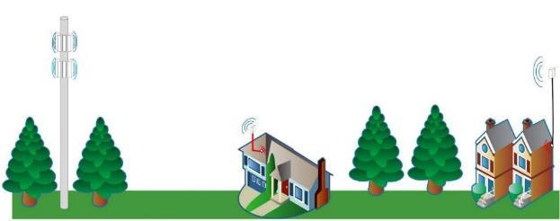

Lower Upfront Capital Costs per Premises
While fixed wireless service can be provided in some cases using customer-provisioned hotspot-type devices, in rural areas and many urban ones it is usually necessary to also install an antenna on the building or outside a window. Even in these use cases, we find that fixed wireless has a lower capital cost per premises than a fiber network. For example, we typically find capital costs for fixed wireless deployment to be $1,000 to $3,000 per installed customer in a rural environment, with an additional $500 or more on average for customer premises equipment and installation at the premises.

Increasing Performance Possible With New Spectrum and Technology Improvements
Fixed wireless networks can use various technologies and spectrum bands. The fixed wireless technologies we evaluated use the following spectrum:
TV White Space (TVWS) 500 MHz
Unlicensed 900 MHz, 2.4 GHz, 5 GHz
Educational Broadcast Service 2.5 GHz
Citizens Broadband Radio Service (CBRS) 3.5 GHz
Fixed wireless performance has increased in recent years due to the availability of new spectrum and technology improvements. In many use cases, fixed wireless can deliver tens of Mbps download per user with mid-band CBRS and unlicensed spectrum, and greater than 100 Mbps download in optimal line-of-sight conditions over a lightly loaded network.
New mmWave technology provides the potential for even higher speeds—hundreds of Mbps and even 1 Gbps over short distances with direct lines of sight. Trial implementations have attempted to deploy mmWave using a mesh architecture, though these are in flatter, less treed areas than many parts of Vermont.
Of the bands identified above, EBS, CBRS, and 5 GHz technology have channel widths capable of delivering 25 Mbps down and 3 Mbps up (i.e., the federal definition of broadband). For unlicensed spectrum, there exists the potential for other networks to be operating on the same, adjacent, or other interfering frequencies. Network planners need to take precautionary measures to mitigate different types of interference; such efforts include checking for a clean frequency in the area of interest and appropriate antenna and antenna pattern choice.
TVWS delivers service over unused television frequencies (known as white space). TVWS bands have much better non-line-of-sight transmission qualities than the other bands; however, due to its narrower bandwidth, TVWS is not capable of delivering 25 Mbps down except to small numbers of users, and therefore should only be considered in cases where other connectivity is not available or feasible. Also, TVWS equipment is far more expensive than other off-the-shelf wireless equipment. Finally, in areas near Montreal, Burlington, and Albany there are existing broadcast television channels, and the potential TVWS spectrum is significantly more limited than in more remote areas.
Most fixed wireless networking solutions require the antenna at the subscriber location to be in or near the line of sight of the base station antenna. This can be especially challenging in mountainous regions. It is also a problem in areas with dense vegetation or multiple tall buildings. Wireless internet service providers (WISP) often need to lease space at or near the tops of radio towers; even then, some customers may be unreachable without the use of additional repeaters. And because the signal is being sent through the air, climate conditions like snow, rain and fog can impact the quality of service.
In addition, there is a tradeoff in these bands between capacity and the ability to penetrate obstructions such as foliage and terrain. The higher frequencies have wider channels and therefore the capability to provide the highest capacity. However, the highest frequencies are those most easily blocked by obstructions. Wireless equipment vendors offer a variety of point-to-multipoint and point-to-point solutions. Point-to-multipoint networks may have limited network capacity, particularly upstream, making the service inadequate for applications that require high-bandwidth connections. A medium-sized business, then, would likely need a point-to-point solution with dedicated bandwidth, while small businesses and residences could be served by a less expensive point-to-multipoint solution.
The CBRS band is predicted to connect the most addresses—primarily due to its spectrum properties, and the fact that FCC licensing rules allow CBRS antennas to be mounted higher than TVWS antennas. It also has the greatest broadcast power of the three technologies and is available throughout Vermont.

Fixed Wireless Is Effective as a Broadband Solution for Limited Use Cases
Given the characteristics of fixed wireless technology, it generally is effective in use cases such as the following:
- The service area is extremely low density, and therefore the average cost per premises of the fiber is very high (perhaps significantly more than $10,000),
- The service needs to reach the full target population within a year, as opposed to over two or more years
- The network is only expected to operate for a few years, and therefore does not need to be replaced as it becomes technologically or physically obsolete
- The network will be deployed in a higher-density setting (urban, suburban), but one where there is only limited capital funding available (making fiber builds unaffordable), and only a limited percentage of individuals in the dense environment needs to be reached (for example, families of schoolchildren, or individuals who cannot afford wireline services—who collectively will not overload the network)

Fixed Wireless Is More Costly Than Fiber in the Long Run
A fixed wireless solution may have a lower initial capital cost and faster deployment time than a fiber solution, but fixed wireless typically has higher total cost of operations, even in rural settings. Outside of the use cases described above, fixed wireless is more expensive in the long run, as we describe below.

Fixed Wireless Cost Factors
The following factors will determine the costs associated with a fixed wireless network:
- Wireless equipment used: Different wireless equipment has different aggregate bandwidth capacity and use a range of different spectrum bands, each with its own unique transmission capabilities.
- Backhaul connection: Although the bottleneck tends to be in the last-mile connection, if a WISP cannot get an adequate connection back to the internet from its tower, equipment upgrades will not be able to increase available speeds beyond a certain point.
- Future capacity and lifespan of investment: Wireless equipment generally requires replacement every five to 10 years, both because exposure to the elements causes deterioration, and because the technology continues to advance at a rapid pace, making decade-old equipment mostly obsolete. The cost of deploying a wireless network is generally much lower than deploying a wireline network, but the wireless network will require more regular investment.
- Availability of unobstructed line of sight: Most wireless networking equipment require a clear, or nearly clear, line of sight between antennas for optimum performance. WISPs often lease space near the tops of radio towers, to cover the maximum number of premises with each base station.

Sample Cost Comparison (Fixed Wireless vs. Fiber)
As an example, we consider the real-world costs for a rural county with 4,190 passings and a density of 19 passings per mile. In that county, a comparison of candidate fixed wireless and fiber deployments found that fiber had lower long-term costs.
In the sample cost comparison, fiber construction and electronics cost an estimated $16,000 per passing. Ongoing costs of fiber maintenance and electronics were estimated at $150 per passing per year, with a two-year construction period and an eight-year replacement cycle for the electronics. The fiber would connect all 4,190 passings.
In contrast to the fiber model, the fixed wireless model for the county would reach only 3,215 passings (due to lack of line of sight to about one-fourth of the passings). Using a mixture of CBRS, unlicensed, and TVWS technologies, the fixed wireless deployment would have an estimated capital cost of $6,100 per passing for core and base station equipment, installation, and user electronics.
Operational costs for the fixed wireless network include tower leases, maintenance, and regular replacement of the electronics—and add a significant $2,400 per year per premises for the fixed wireless network.
Leasing antenna space on a tower costs approximately $60,000 per year at typical market prices. This is a critical consideration because, for a typical site that serves 60 passings (potential customers), the cost for tower leases alone exceeds $1,000 per year per passing.
Upgrading a wireless network requires replacement of the radios at the antenna site and at the user premises. Electronics may need to be replaced at five- to 10-year intervals due both to technological obsolescence and wear and tear—and unlike a fiber network, the electronics comprise almost all of the capital cost of the network, thus significantly increasing the ongoing cost.
As the chart below illustrates, because of the fixed wireless network’s higher ongoing operating costs, the total cost of the wireless solution exceeded the cost of the fiber network after the first five years (Figure 14).
Figure 14: Representative Comparison of Costs for Fiber and Fixed Wireless Solutions
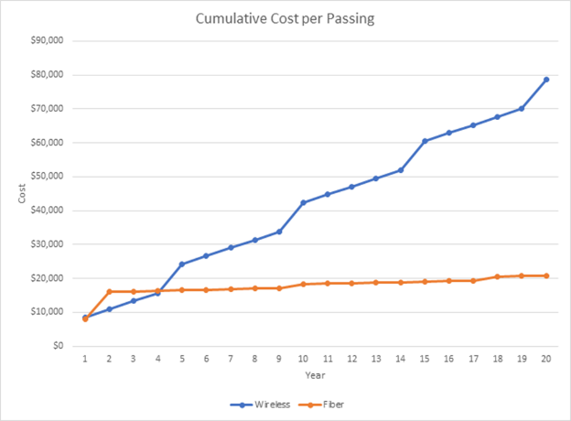

Fixed Wireless Cannot Comprehensively Address the 100/100 Plus Scalability Standard
Stated simply, fixed wireless technology cannot comprehensively address the standard of 100/100 Mbps and continue scaling to higher speeds.
Fixed wireless technology provides an aggregate capacity between 100 and 250 Mbps. Using unlicensed and CBRS spectrum and innovations like higher-order multiple input, multiple output (MIMO) antennas and spatial multiplexing, these capacities could increase to as much as 750 Mbps. That means download speeds in the tens or even low hundreds of Mbps may be possible for a limited number of users over a fixed wireless network.
However, it is important to note that this is the aggregate capacity out of a single antenna or antenna array; in a point-to-multipoint architecture, this capacity will be shared among all users connected to a single base station. And given the limitations of available spectrum, a wireless solution is not as scalable as a wireline solution; the spectrum available for fixed wireless broadband provides much lower bandwidth than what is available in an FTTP network. Adding base stations to provide greater capacity to more users (e.g., building new towers or adding antennas to existing towers) dramatically increases the cost of a fixed wireless network—making that approach much less feasible.
Cost aside, and focusing solely on technical capabilities, fixed wireless networks are also hampered by terrain, trees, and population density. Vermont’s unserved areas typically are less dense and more rugged, wooded, and isolated—and therefore different from a typical fixed wireless use case with a town center or hilltop site covering hundreds of premises in relatively close proximity. The longer the distance from a base station antenna to users’ homes, the more difficult it becomes to serve those homes with fixed wireless technology. (As an example, CBRS technology in most situations cannot consistently deliver more than 25 Mbps downlink capacity further than 6 miles away, or if there are more than 600 users.)
Except for point-to-point networks such as the microwave links used by public safety networks (which have two perfectly known antenna endpoints on towers, and optimized links over licensed spectrum), it is difficult to impossible to guarantee performance over a fixed wireless network. A fixed wireless network’s real-world performance usually will not be accurately known until an installer arrives at the premises to be served.

Infrastructure Design and Costs for Unserved Areas
This section describes the design and cost estimates for deployment of a statewide fiber-to-the-premises (FTTP) network to connect all unserved businesses and residents. The FTTP infrastructure will be able to serve as the cornerstone network in its service area, providing residential, business, and institutional services and, likely, also significant amounts of wireless backhaul or even connectivity to the hub sites operated by satellite providers.
In this role residents will need to rely on the CUDs’ fiber networks to reach 911, both in the current voice and text form and for future video and advanced applications. Especially in areas where wireless signals are weak or nonexistent, residents will rely mostly or entirely on the fiber network to call for help.
Telcordia recommendations call for 99.9 percent availability of telephone lines, and this level of predicted and actual availability should be the absolute minimum for any broadband infrastructure in the state. It is possible with sound design and operational practices to improve on this number, potentially to bring availability closer to 99.99 percent.
As described below, to achieve this level of reliability, the CUDs’ network standards should include requirements that reflect best practices for fiber routing and resiliency; hub facilities, switching, and routing; and interconnection with 911 systems and the internet backbone. For example, having redundancy in field equipment as specified below is a solution to the sort of problem that, on traditional phone networks, was known as remote host isolation. These best practices include:
- Redundancy of fiber routes from the headend and hub facility to the internet backbone. If these routes are operated by other service providers, then there also need to be demonstrated service level agreements (SLA) and repair and maintenance plans that guarantee continued connectivity through multiple data centers and points of presence (such as, both to Boston and New York).
- Appropriate resilience in headend/central office and hub facility
  - Sized for CUD network equipment, colocation by ISPs and potential wireless or other providers and room for growth
  - Physically robust structure, such as a precast building using steel reinforced concrete
  - Two or more separate cable entry points for fiber
  - Appropriate mounting of cables in cable ladders, under floors and/or above ceiling
  - Redundant (1+1) HVAC sized for initial equipment and expansion, fed from separate circuit breakers
  - Electrical service for initial equipment and expansion, 120/240V service and surge protection
  - Generator sized for initial equipment and expansion
  - Security and fire protection systems including alarms and inert gas fire suppression systems
- Sufficient backup power
  - Generator and fuel and battery providing backup power of up to three days at all central office or hub buildings.
  - Fixed or deployable generators and batteries to provide three or more days of backup power to active field electronics in cabinets.
  - Backup power of up to three days for all switches and components handling interconnection to the public network (also for separate ISP infrastructure handling this role, if open access)
  - Backup power at the premises for broadband and VoIP phone service in accordance with state and federal regulations, including the option for customers to purchase more backup battery capacity should they want to exceed minimum requirements
- Redundancy in backbone electronics to provide 99.999 percent availability for the electronic network, including staff and spares to ensure continued operation.
- Regular third-party cybersecurity and configuration audit of network operators and ISPs, including verification of 9-1-1 operation and compliance with resilience best practices.
The sections below describe the design and cost estimates for deployment of a statewide fiber-to-the-premises (FTTP) network to connect all unserved businesses and residents.

FTTP Service Area Definition
FTTP deployment costs are determined for addresses identified by the State as unserved – a total of 54,406 addresses for which there is no 25 Mbps downstream / 3 Mbps upstream (“25/3”) service available, not including locations awarded by RDOF at the gigabit, low-latency tier. Addresses served by fixed wireless that were funded by the Connectivity Initiative are included in this analysis.
The total list of target unserved addresses was divided by CUD to create service areas corresponding to each CUD (Figure 15, below), with a candidate hub location selected to function as an aggregation point to house distribution network electronics located within a served area. While the specific hub location is not significant to the cost estimate, a viable candidate was chosen for each CUD that is central to the target address in each CUD to allow a detailed design to be created for purposes of cost estimation. Moreover, each candidate hub location sits on property owned by the State or other governmental entities, such as fire stations.
For this analysis, all towns across the state that have unserved premises but were not yet in a CUD were assigned to a CUD based on geographic proximity. Towns without any unserved premises (e.g., Springfield) were not included in a CUD. It was also assumed for this analysis that a new CUD was formed in the Chittenden County region. The resulting address list is illustrated in Figure 16, below.
The ultimate CUD configuration will be different than the arrangement pictured. This arrangement should not be taken as a recommendation for how towns should sort into CUDs; it was created for the sake of performing the cost analysis based on current CUD membership and possible future CUD growth.

Figure 15: CUD Service Area Boundaries
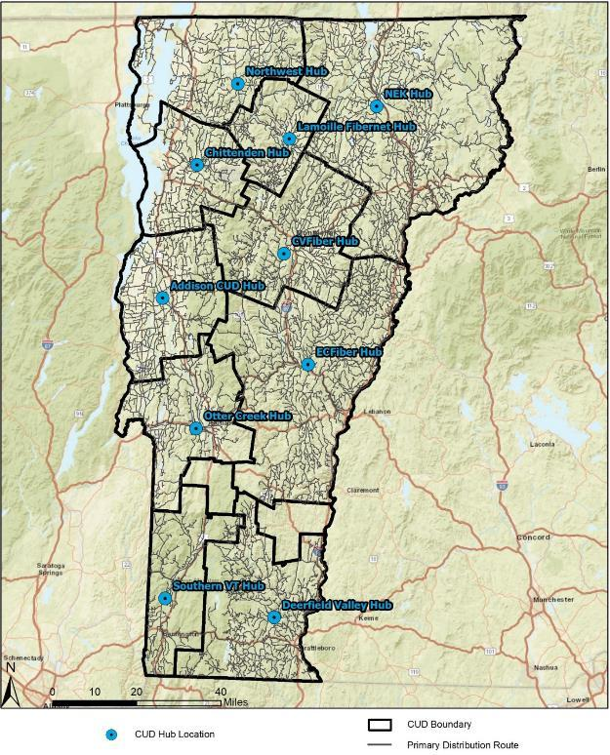

Figure 16: Target Unserved Addresses for FTTP Deployment
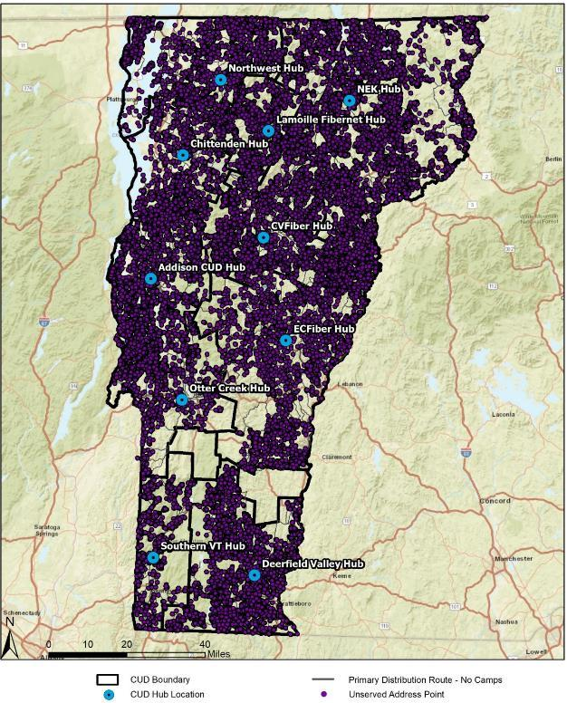

A significant challenge presented by a design targeting only unserved addresses in a rural environment is that the address points are located in numerous noncontiguous pockets or in areas on the perimeter of towns or other served areas. As a result, any representative model must take into account the need to build cable plant through served areas in order to connect unserved area. Our model does not include addresses in served areas, but includes many miles of cable in served areas in order to create a workable design.
Within an ESRI ArcGIS framework, addresses were set to “snap” to roads, identifying the roads where cable plant was needed in order to serve the addresses. The ESRI Network Analyst tool was used to create a cable topology to connect the addresses to aggregation points (fiber tap locations and fiber cable splice points), and to connect the aggregation points to the hub locations where the network distribution containing electronics would reside. The design model anticipates placement of a small communications It is assumed that connectivity to each hub can be achieved by a potential operator without new cable construction.
The approach provides the street mileage and number of unserved passings for each CUD area (Table 22).
Table 22: Miles of Cable Plant and Addresses Passed
CUD | Miles of Cable Plant | Unserved Addresses Passed
Addison | 923.91 | 6,126
Chittenden | 650.28 | 2,083
CV Fiber | 1,294.23 | 6,879
Deerfield Valley | 1,232.24 | 6,455
EC Fiber | 1,881.67 | 5,746
Lamoille Fibernet | 528.97 | 3,933
NEK | 2,422.72 | 11,455
Northwest | 966.36 | 7,229
Otter Creek | 687.43 | 2,746
Sothern Vermont | 471.43 | 1,754
Totals | 11,059.24 | 54,406

The resulting cable plant architecture is shown at a high level in Figure 17.
Figure 17: High-Level FTTP Cable Plant Routes
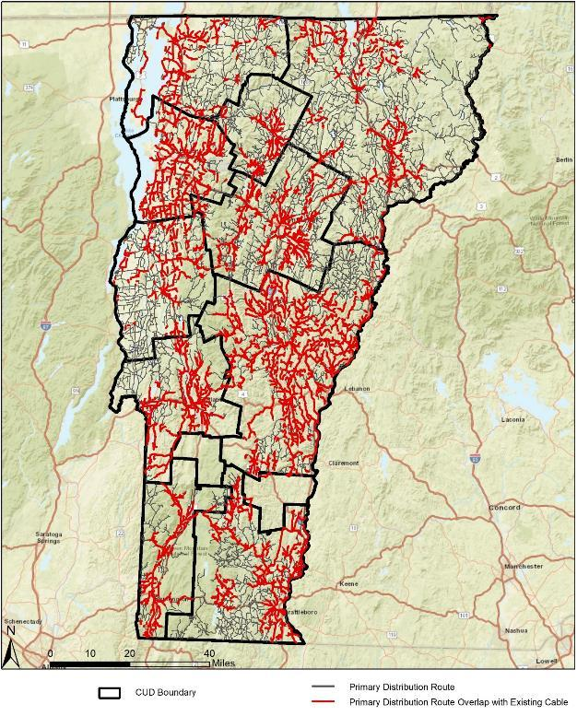

We note that these totals include 9,126 addresses identified in the State’s database as “camps,” which range from unimproved properties without power, to larger buildings off the electrical grid powered by solar energy, that are improved buildings. We created a design that excluded the camps, which reduced the needed cable plant mileage by 795 miles, or seven percent of the total.

Design Objectives and Key Attributes
CTC developed a conceptual, high-level FTTP outside plant network design and cost model that is aligned with best practices in the industry; reflects the State’s goals for capacity, resilience, and scalability; and is able to support a variety of electronic architecture options. The design assumes a combination of aerial and underground construction based on the placement of the existing utilities.
The recommended architecture is a hierarchical data network that provides critical scalability and flexibility, both in terms of initial network deployment and its ability to accommodate the increased demands of future applications and technologies. The characteristics of this hierarchical FTTP data network are:
- Capacity – ability to provide efficient transport for subscriber data, even at peak levels
- Availability – high levels of redundancy, reliability, and resiliency; ability to quickly detect faults and re-route traffic
- Failsafe operation – physical path diversity in the network backbone to minimize operational impact resulting from fiber or equipment failure
- Efficiency – no traffic bottlenecks; efficient use of resources
- Scalability – ability to grow in terms of physical service area and increased data capacity, and to integrate newer technologies without new construction
- Manageability – simplified provisioning and management of subscribers and services
- Flexibility – ability to provide different levels and classes of service to different customer environments; can support an open access network or a single-provider network; can provide separation between service providers on the physical layer (separate fibers) or logical layer (separate Virtual Local Area Network (VLAN) or Virtual Private Network (VPN) providing networks within the network)
- Security – controlled physical access to all equipment and facilities, plus network access control to devices
This architecture offers scalability to meet long-term needs. It is consistent with best practices for either a standard or an open-access network model to provide customers with the option of multiple network service providers. This design would support the current industry standard Gigabit Passive Optical Network (GPON) technology, as well as emerging 10 Gbps XGS-PON and NG-PON2 standards. It could also provide the option of direct Active Ethernet (AE) services on a limited basis, such as for business customers, using spare fiber capacity built into the designs.
Specifically, the physical fiber design uses a distributed tap architecture, suitable for a low-density deployment in which service drops to the network tend to be separated by considerable distance. The relatively low density of the target deployment, having less than five homes per mile, suggests a slightly different design approach is needed than for higher density areas in which commercial FTTP is most prevalent.
In a higher density area, having perhaps 50 or more homes per mile, service drops can be cost-effectively run from a fiber access point serving upwards of 12 passings. Overlap of fiber drop paths and other layers of the network hierarchy are limited by the close proximity of these access points Rural deployments of this type are characterized by large distances between passings, adding significant cost to overlay these layers of fiber using more traditional “distributed split”, “centralized split”, or “home-run” architectures. Instead, a distributed tap architecture allows access points (fiber “taps”) to be placed at varying distances within the network, each serving only one or two homes in many cases. A single fiber strand can be used to serve up to 32 homes along a given leg of the network, avoiding the cost of long segments of overlapping network layers and the corresponding duplication of fiber strands without an effective increase in capacity.
Scalability to meet future needs is built into the network by limiting the number of passings served by a given leg of distributed taps, each supported with a single fiber strand, and by incorporating spare fibers into the distribution plant to allow these legs to be split into two or more with minor resplicing of fiber strands.
Figure 19, below, shows a logical representation of the FTTP network architecture we recommend based on the conceptual outside plant design. The drawing illustrates the primary functional components in the FTTP network, their relative position to one another, and the flexibility of the architecture to support multiple subscriber models and classes of service.
The design assumes placement of manufacturer-terminated fiber tap enclosures within the public right-of-way or easements, providing watertight fiber connectors for customer service drop cables, and eliminating the need for service installers to perform splices in the field. This is an industry-standard approach to reducing both customer activation times and the potential for damage to distribution cables and splices. The model also assumes that the entity constructing the network obtains easements or access rights to private roads.
The network design and cost estimates assume the network will:
- Use existing publicly-owned land to locate a central office or headend facility; the cost estimate includes the facility costs with adequate environmental and backup power generators to fulfill the resilience requirements in this report
- Obtain easements or access rights to private roads where public right-of-way does not exist.
The FTTP network design was defined based on the following criteria:
- Fiber will be installed in the communications space of the electrical utility poles where poles are present, and in newly constructed conduit in other areas, or with new utility poles, depending on what is most cost-effective. Based on communications with pole owners in the unserved areas and with CUDs who have constructed networks in similar areas, we assume aerial plant comprises 90 to 95 percent of the plant and create two separate models—one with 90 percent aerial and one with 95 percent aerial
- We assume construction costs averaging approximately $30,000 per mile in unserved areas, which includes approximately $5,100 per mile for make ready, also based on communications with pole owners and CUDs
  - Utility pole make-ready costs of approximately $10,400 are estimated for routes passing through served areas
  - Make-ready credits available through the Vermont Electric Coop and Green Mountain Power tariff riders were not included in this calculation; this program could reduce make-ready costs by as much as $15M overall
- Fiber will vary between 12- and 288-count based on the need in the area
- Underground fiber will be installed in the public right-of-way or in an easement on the side of the road
- The network will target up to 32 passings per secondary distribution aggregation point (distributed tap leg)
- Hub shelters will support network electronics with backup power generation, redundant cooling systems, robust physical security, and inert gas fire suppression systems
- If possible, the distribution plant network routes will avoid crossing major roadways and railways

FTTP Network Deployment Costs
The estimated cost to construct the outside plant portion of the proposed FTTP network is approximately $392 million, or $7,200 per passing. As discussed above, the base model assumes approximately 95-percent aerial fiber construction, based on the construction of existing utilities in the area. From our discussions with pole owners and other CUDs who have performed similar construction in the State, our base model determines an average fiber construction cost of approximately $30,000 per mile for FTTP infrastructure.
This estimate includes the following cost components:
- Project Management – encompasses overall project and contract management, including oversight of the construction and engineering contractor(s), equipment suppliers, and right-of-way agreements.
- Engineering and as-Builts – includes system level architecture planning, preliminary designs and field walk-outs to determine candidate fiber routing; development of detailed engineering prints and preparation of permit applications; and post-construction “as-built” revisions to engineering design materials.
- Conduit and vault infrastructure – consists of all labor and materials related to underground communications conduit construction, including conduit placement, vault/handhole installation, and surface restoration; includes all work area protection and traffic control measures inherent to all roadway construction activities.
- Aerial infrastructure – consists of all labor and materials related to aerial strand installation; includes tree trimming and all work area protection and traffic control measures inherent to all roadway construction activities.
- Utility pole make-ready – consists of relocations of existing utility pole attachments to provide clearance for a new attachment, utility pole replacements, and other remediation work required for compliance with code and the utility pole owner standards.
- Fiber optic cables and components – consists of the material and labor costs specific to the installation of fiber optic cables, taps, splice enclosures, and other related components, irrespective of the cable pathway (underground conduit or aerial placement).
- Fiber splicing, testing, and documentation – includes all labor related to fiber splicing of outdoor fiber optic cables.
- Hub facilities and systems – consists of the material and labor costs of placing hub shelters and enclosures; related hub systems (backup power generation, cooling systems, etc.); and terminating backbone fiber cables within the hubs.
- Distribution network electronics – includes all distribution-layer network electronics necessary to activate connections between the hubs and the subscribers, as described in Section 6.3.4.
- Service drops – consists of all costs related to outdoor fiber service drop installation, including outside plant construction on private property to an indoor or outdoor fiber termination point, typically a Network Interface Device (NID) attached to an exterior wall of the structure.
- Customer premises equipment – consists of all costs related to the installation and provisioning of the CPE, including testing and limited indoor cabling.
Table 23 provides a breakdown of the estimated FTTP implementation costs. (Note that the costs have been rounded.)
Table 23: FTTP Implementation Cost Estimates
Fixed Costs
Project management | $1,850,000
Engineering and as-builts | $58,600,000
Conduit and vault infrastructure | $54,300,000
Materials | $11,050,000
Labor | $43,250,000
Aerial infrastructure | $122,200,000
Materials | $31,900,000
Labor | $90,300,000
Utility pole make-ready | $73,850,000
Fiber optic cables and components | $74,050,000
Materials | $67,550,000
Labor | $6,500,000
Fiber splicing, testing, and documentation | $4,400,000
Hub facilities and systems | $2,500,000
Outside Plant Subtotal | $391,750,000
Take-Rate-Dependent Costs (50% take-rate)
Distribution network electronics | $4,050,000
Subscriber drop costs | $38,100,000
Customer premises equipment | $12,800,000
Total Implementation Costs | $446,700,000

Figure 18 illustrates the total implementation costs at take-rates up to 100-percent.
Figure 18: Estimated Network Implementation Costs at Varying Take-Rates

Deployment Scenarios
The actual cost to construct FTTP to every unserved premises in the state could differ from the estimate due to changes in the assumptions underlying the model. For example, if make-ready and pole replacement costs are too high, the network would have to be constructed underground—which could significantly increase the cost of construction. Further and more extensive analysis would be required to develop a more accurate cost estimate.
While anomalies and unique challenges will arise regardless of the design or construction methodology, the relatively large scale of this project is likely to provide ample opportunity for variations in construction difficulty to yield relatively predictable results on average.
We assume any underground construction will be done using an industry-standard approach for this type of environment, which consists primarily of saw-cutting a trench in the ground, or horizontal, directional drilling. The design model assumes a one to two 2-inch, flexible, High-Density Polyethylene (HDPE) conduit over underground primary distribution paths (hub to distribution splice points) and a single 2-inch conduit over secondary distribution path (splices to tap locations) to provide for initial needs with spare capacity for growth.
The amount of underground construction may vary from our data depending on the condition and availability of utility poles, particularly in unserved and less thoroughly documented areas of the service areas. To provide and estimated upper end cost, we estimate costs for a scenario in which 10-percent of the routes are constructed underground (90-percent aerial). Moreover, total serviceable passings in unserved areas may vary with the need to include those address points designated as camp sites in the State’s database. We examine fixed implementation costs, excluding take-rate dependent costs (distribution electronics, service drops, and CPE) as a range reflecting these variations in underground route prevalence and total passings, as shown in Table 24.
Table 24: FTTP Implementation Costs for Alternative Scenarios
Attribute | Implementation Cost Scenarios
 | Base Scenario –  95% aerial, camps included | Alternate A –  90% aerial, camps included | Alternate B –  95% aerial, camps excluded | Alternate C –  90% aerial, camps excluded
Total fixed implementation costs | $392 million | $439 million | $362 million | $406 million
Utility pole make-ready | $74 million | $70 million | $69 million | $65 million
Total route miles | 11,097 | 11,117 | 10,291 | 10,317
Cost per mile (OSP only) | $29,600 | $33,800 | $29,400 | $33,900
Total Passings | 54,406 | 54,406 | 45,282 | 45,282
Cost per passing (OSP only) | $6,040 | $6,900 | $6,690 | $7,670
Cost per passing (total) | $7,200 | $8,060 | $7,990 | $8,970
Total costs (50% take-rate) | $447 million | $494 million | $407 million | $452 million

Central Network Electronics Costs
Incremental network electronics equipment to serve the unserved area will cost an estimated $15.0 million, or $350 per passing, also assuming on an assumed take-rate of 50 percent. (These costs will increase or decrease depending on take-rate, and the costs may be phased in as subscribers are added to the network.) The network electronics consist of the distribution electronics to connect subscribers to the FTTP network, not including the electronics at the customer premises. The core electronics forming the provider backbone are less dependent on take-rate, but which will vary depending on the provider architecture. Table 25, below, lists the estimated costs for each segment.
Table 25: Estimated Central Network Electronics Costs (50% Take-Rate)
Network Segment | Subtotal | Subscribers (50% Take-Rate) | Cost per Subscriber
Core Electronics | $10.9 million | 54,406 | $200
Distribution Electronics | $4.1 million | 27,203 | $150
Central Network Electronics Total | $15.0 million | 27,203 | $350

Electronics are subject to a seven- to 10-year replacement cycle, as compared to the 20- to 30-year fiber optic cable plant.

Core Electronics
The core electronics manage the routing of the network traffic and provide connection to the backhaul link to the internet, or other ISPs in an open access model. The core electronics consist of high performance routers, which handle all the routing on both the FTTP network and to the internet. The core routers have modular chassis to provide high availability in terms of redundant components and the ability to “hot swap” line cards and modular in the event of an outage. Modular routers also provide the ability to expand the routers as demand for additional bandwidth increases.
The cost estimate design envisions running networking protocols, such as hot standby routing protocol (HSRP), to ensure redundancy in the event of a router failure. Additional connections can be added as network bandwidth on the network increases. The core sites would also tie to the distribution electronics using 10 Gbps links. The links to the distribution electronics can also be increased with additional 10 Gbps and 40 Gbps line cards and optics as demand grows on the network. The core networks will also have 10 Gbps to ISPs that connect the FTTP network to the internet.
The cost of the incremental core routing equipment is approximately $10.9 million. These costs will vary depending on the provider’s existing infrastructure, but are estimated to be in the ballpark of about $200 per subscriber. In addition, the network requires operational service systems (OSS), such as provisioning platforms, fault and performance management systems, remote access, and other operational support systems for FTTP operations. For a network of this scale, an OSS system costs approximately $100,000 to acquire and configure.

Distribution Electronics
The distribution network electronics at the hubs connect the subscribers to the FTTP network by connecting the backbone to the fiber that goes to each premises. These electronics are commonly referred to as optical line terminals (OLT). We also recommend deploying modular access network electronics for reliability and the ability to add line cards as more subscribers join in the service area. Modularity also helps reduce initial capital costs while the network is under construction or during the roll out of the network.
The cost of the distribution network electronics for the network is estimated at approximately $4.1 million at a take-rate of 50 percent.

Customer Premises Equipment and Service Drop Installation (Per Subscriber Costs)
Customer premises equipment is the subscriber’s interface to the FTTP network and for GPON networks is referred to an optical node terminal (ONT). For this cost estimate, we selected CPE that both terminates the fiber from the FTTP network and provides only Ethernet data services at the premises (however, there are a wide variety of additional customer premises equipment offering other data, voice, and video services). The customer premises equipment can also be provisioned with wireless capabilities to connect devices within the customer’s premises. Using the assumed take-rate of 50 percent, we estimated the cost for subscriber customer premises equipment will be approximately $12.8 million.
Each activated subscriber would also require a fiber drop cable installation and customer premises electronics, which would cost on average $1,870 per subscriber, or $50.1 million total—again, assuming a 50-percent take-rate.
The drop installation cost is the biggest variable in the total cost of adding a subscriber. A short aerial drop can cost as little as $250 to install, whereas a long underground drop installation can cost upward of $5,000. We estimate an average of approximately $1,400 per drop installation.
The other per-subscriber expenses include the labor to install and configure the electronics, and the incidental materials needed to perform the installation. The numbers provided in Table 26, below, are averages and will vary depending on the type of premises and the internal wiring available at each premises.
Table 26: Per Subscriber Cost Estimates
Construction and Electronics Required to Activate a Subscriber | Estimated Average Cost
Service Drop Cable Construction and Materials | $1,400
Subscriber Electronics (ONT) and Installation | $470
Total | $1,870

Figure 19: High-Level FTTP Architecture

Operating Costs
Some of the ongoing costs of operating an FTTP network include fiber maintenance, fiber locating, pole attachment fees, equipment maintenance, and equipment replacement. These estimates include costs directly related to the maintenance and operations of the physical and network electronics layers of the network but does not include costs associated with higher layer services and other fixed administrative expenses.
Regular fiber maintenance includes any repairs, adds, moves, and changes required of the network. For example, if a roadway is widened a pole line may be moved or undergrounded, requiring the network owner to relocate this fiber. We estimate that 1 percent of the total capital costs is required annually for fiber maintenance, or $3.3 million.
In the few underground utility areas, fiber locating includes the marking of underground utilities as part of the state’s DigSafe process. Each underground utility is responsible for locating and marking their utilities in the right-of-way. We estimate the cost at $1,800 per mile of underground construction annually for utility locates, or $1.1 million annually for the estimated 591 miles of underground plant.
For every pole that the fiber network attaches to, the network owner must pay the pole owner an attachment fee for using the pole. Pole attachment fees go toward the maintenance of the utility pole line. We estimate a pole attachment fee of approximately $4.7 million annually for approximately10,500 miles of aerial plant based on a $10 per pole cost as an approximate average of a range of rates. Pole attachment fees are estimated and would be negotiated with the pole owners as part of the pole attachment process (We adopted a $10 per pole cost as an approximate average of a range of rates.)
Equipment maintenance consists of hardware maintenance contracts required to receive technical support, replacement of failed equipment, and ongoing software/firmware updates. We estimate total annual maintenance costs of $2.1 million for core and distribution electronics.
In addition to equipment maintenance, equipment replacement is necessary on a periodic basis as product lines and technologies reach obsolescence. There are many approaches to handling equipment replacement, but one best practice is the network owner establishing an equipment replacement fund where it allocates yearly a portion of the necessary funds to replace the network electronics. We recommend planning on replacing the network electronics every 10 years, requiring the network owner to allocate approximately $1.5 million annually.
Table 27 summarizes the FTTP technical operating costs.
Table 27:Annual Fiber-to-the-Premises Technical Operating Costs
Description | Annual Cost
Fiber Maintenance | $3.3 million
Fiber Locating | $1.1 million
Pole Attachment Fees | $4.7 million
Equipment Maintenance Fees | $2.1 million
Equipment Replacement Fund | $1.5 million
Total | $12.7 million

Possible Structures for State Broadband Funding Program to Address Unserved Areas
The state of Vermont has an unprecedented opportunity to build resilient, long-term broadband infrastructure using federal stimulus money from the American Rescue Plan Act (ARPA).
With this opportunity comes the significant challenge of determining how to use those resources most effectively. Stakeholders across the state have been debating structures and strategies for using this funding at the same time as this plan has been in development and legislators and other stakeholders may decide the structure before this plan is finalized.
The recommendations below are based on best practices nationally, experience with public and private broadband efforts, and knowledge of the Vermont context.

Context for the Recommendations
This Plan’s recommendations were developed in context of how Vermont has endeavored to close the broadband gap in recent years, and how this plan must supplement and accelerate existing plans.
For the past year, Communications Union Districts (CUD) have been developing feasibility studies and business plans, funded by the state’s Broadband Innovation Grant program, to understand if and how it was possible to build broadband infrastructure in their communities that met the states 100/100 Mbps goals.
However, Vermont is in a wholly new situation now than it was a year ago. In late 2020, the FCC awarded $32.5 million in their Rural Digital Opportunity Fund (RDOF) auction to ISPs in Vermont to serve non-contiguous rural census blocks, in some cases with LEO satellite service but in most cases with FTTP infrastructure. These companies have up to six years to fully meet their obligations.
Across the state, these RDOF awards changed the business cases and planning work of CUDs, who needed to pivot to incorporate the plans of the winning bidders into the CUDs’ own projections. In many cases, the FCC’s awards, which are not ensuring that the last mile is built in Vermont, made the work of the CUDs harder in their attempts to guarantee service to every home.
In addition, the largest ILEC in the state announced that they were using private equity investment funds to build fiber to more than 200,000 premises in the state that already had access to cable. Providing Vermont residents choice and increased competition is undoubtedly a good thing; but once again it required CUDs reconsider their planning and trajectory mid-stream.
On top of the FCC RDOF awards, billions of dollars in new stimulus funding have been allocated to broadband expansion, which represent both an opportunity and a challenge. It is an opportunity because the state has money to actually address its broadband challenges for the long term. However, the vast amount of money allocated to broadband has caused a spike in demand for labor and materials that is unpredictable and challenging, especially for networks without a scale that would be enticing to vendors that have a choice of projects. These resources added to an already disrupted market as Covid-19 caused factory closures and other issues in the supply chain. Right now, there is a nine- to 12-month waiting period on orders of new fiber.
The reality is that CUD plans have had to be continuously adapted and reassessed based on changes to the broadband landscape due to the FCC’s RDOF auction, the pandemic, great fluctuations in construction and materials costs, penetration rates, and ongoing announcements of new construction in targeted areas across the state. New private investment in and construction of fiber in Vermont is, in part, a testament to the legitimacy of the CUDs, which have spurred private entities to invest. This is good for Vermonters; more fiber broadband that gets the state closer to its goal of 100/100 Mbps is clearly welcome. That said, new investments in infrastructure continue to complicate the CUDs’ planning process by requiring them to adapt and pivot their plans.
After a year of planning in a dynamic, ever-changing environment, CUDs are aware of the challenges they still face, and the fact that CUDs still have a long way to go and a lot of work ahead of them, especially for their mostly all-volunteer boards. CUDs are continuing to be careful in the planning, ensuring that any funds they have available to them will be used effectively and responsibly. Some newer CUDs have delayed finalizing their Broadband Innovation Grant business plans so as not to depart that program in a dynamic environment in which business plans need to continuously be updated.
This plan’s recommended framework for disbursement of broadband subsidy recognizes that CUDs, being municipal entities that are mid-stream in their planning work, are the best vehicle for bringing broadband to the last mile, where private entities have seldom or never been willing to build. Without a profit motive, and with access to tax-exempt revenue bonds, CUDs will be integral to making stimulus money stretch as far as it can. That being said, CUDs still need considerable pre-development and pre-construction support to be as effective as they can be in delivering service to unserved and underserved premises.
It should also be noted that CUDs are in different positions and different phases in their planning processes. Some of the new CUDs (i.e., beside ECFiber) started their planning processes earlier, and have built up considerable expertise and momentum; others are newer to the work. This report’s recommended framework for broadband funding is meant to accommodate all CUDs, wherever they are in their planning process, however, the authority ultimately in charge of overseeing the program should build discretion into the process, or mechanisms that account for the varying stages of the CUDs to ensure that the authority is not holding back or delaying CUDs that are farther advanced in the process, nor letting CUDs that are just starting out fall behind.
Though some stakeholders have considered a hybrid framework that allows both CUDs and private ISPs or ILECs to compete over funding the same areas of the state. That framework presents challenges in that applications for funding from both public and private entities will be very difficult to compare, and moreover, will position CUDs and private companies against each other in a way that precludes constructive partnership conversations and the prospect of working together to reach a solution. Incentivizing CUDs and private companies to work together by encouraging public ownership of assets and private operation will result in bringing together the values expressed by public advocates and the state, like the need to reach the last mile, and the valuable experience and expertise of private network operators. Together, this framework will result in a win-win for public entities, private businesses, and the end consumer.
The recommended program is designed to continue to champion local decision-making, local control over solutions, and long-term consumer agency, while also creating accountability structures that are necessary for administering significant amounts of federal resources responsibly. The recommendations are not meant to add bureaucracy to the process or remove decision-making from CUD hands; instead, the recommended process is designed to ensure that all CUDs have the structure and support they need to meet the high thresholds of quality and responsibility asked of them as they develop broadband solutions that will ultimately require hundreds of millions of dollars of capital investment.

Distribution According to Governor Scott’s Recommendation via H.360 Legislation
The recommendation is to use Governor Scott’s allocations for construction and pre-construction resources and the framework presented in H.360, with some important modifications to ensure the resources are used effectively and long-term goals are met.
Resources should be allocated to CUDs as a right of first refusal where CUDs exist; ILECs and private companies are encouraged to partner with CUDs to provide service and leverage the funds. CUDs should receive the resources with conditions and a comprehensive funding application and oversight process should be used to ensure accountability (a proposed process is described below).
Funding for construction and pre-construction should be proportional to the unserved and underserved premises in member towns, meaning premises not currently served by wired service that can achieve 25/3 Mbps, and not already funded at the gigabit low-latency tier via the RDOF auction. Premises funded under the Connectivity Initiative for fixed wireless service should be considered unserved; this equipment will be reaching the end of its lifespan as fiber is deploying in the next few years and as a long-term solution, fixed wireless will not meet the 100/100 Mbps minimum and cannot be upgraded to do so.
Because of the increased administrative burden and decreased leverage that would result from individual towns remaining independent of existing CUDs, towns should continue to be encouraged to join CUDs if at all possible. However, where a CUD does not exist, the state authority in charge of this program may assume control of that town’s funding and direct procurement on that town’s behalf, likely from the following options:
- Grouping some or all towns into a new district and running a procurement process on their behalf
- Providing subsidy to a neighboring CUD to extend their plans into the un-districted town
- Working with existing ILEC or CLEC entities to do line extensions to reach unserved premises or upgrade existing infrastructure

Suggested Grant Program Refinements
The following conditions, processes, and parameters should be placed on the broadband funding so that solutions remain locally driven, standards, oversight, support, and expertise are provided by the state, and the long term consumer interest is protected.

Obligation to Cover All Unserved and Underserved Addresses
Receipt of ARPA funding should obligate CUDs to provide service to all on-grid underserved and unserved addresses in their member towns. This would mean that if ARPA funding were not sufficient to build to every unserved and underserved premises, CUDs would need to commit to using follow-on funding, likely in the form of municipal revenue bonds or resources from a future federal infrastructure bill, to do so.
Of the premises that the PSD indicates do not have 25/3 Mbps service, 16.8 percent are considered “camps.” Of these camps, a material portion may not be connected to the electrical grid. CUDs will determine which are on-grid during their pole data collection and network design.
Serving premises that are not on the electrical grid with wired broadband could cost hundreds of thousands of dollars per location, by either burying conduit for miles up a dirt road, or installing poles where there were none before (which homeowners often dislike since it requires clearing trees along the right-of-way). In the vast majority of cases, off-grid camps are seasonal and not residences where the owners want internet.
In addition, this requirement is not meant to preclude a CUD from having policies about “long drops,” or installations where the premises is a significant distance away from the right-of-way. Standard installations can cost $1,400 per customer for premises near to the road; if a premises has utility poles along a mile long driveway, this installation could increase to $40,000 for that single customer. It is standard practice for ISPs to request special installation fees for premises farther than, for example, 400 feet off the right-of-way.
Lastly, a requirement to serve all unserved and underserved premises should have a deadline attached to be useful. We believe this timeline should be decided at the discretion of the governing authority based on market conditions at the time of the program launch. It may be the case that material production delays are reduced later this year; alternately, if a federal infrastructure bill passes with significant additional funding for broadband, labor and materials may become even harder to obtain.

Refinement of H.360 §8086 Funding Priorities
Section §8086 of H.360 dictates broadband funding priorities; we recommend these be refined and separated into requirements, which must be met to receive ARPA funding, and priorities, which are encouraged but not required.
Providing 100/100 Mbps service and targeting unserved and underserved premises as directly as possible should be considered a requirement, not a priority. (Note, this does not preclude CUDs from eventually building to all premises; it simply asks that CUDs prioritize unserved and underserved premises with this funding.)
In addition, meeting best practices for technical standards to ensure long-term, resilient broadband for decades to come, should also be a requirement. See Section 6.1.1, CUD Network Standards, for more information.
Other items in this section may be kept as priorities, not requirements, with the understanding that not all networks will be able to meet all priorities due to their financial, geographic, and legal constraints.
For example, because of the increased costs open access networks may require and barriers for likely partners, those arrangements may not be feasible for all networks, and indeed may counteract the goal of providing coverage to the last mile.
Net neutrality can serve as a priority for CUDs if they so choose. However, some potential partners for CUDs may be precluded by participation by corporate policies that don’t allow for net neutrality. Local control and community decision making suggest that CUDs should have the option to develop plans and partnerships with or without net neutrality, with the choice to weigh that policy among others in determining a path forward.
In summary, the recommendation is for the following requirements and priorities:
- Requirements:
  - Provide service to unserved and underserved locations within the Communications Union District
  - Support broadband service that is capable of speeds of at least 100 Mbps symmetrical
  - Meet best practices for technical standards to ensure broadband infrastructure is resilient and secure
  - Build networks capable of supporting future public good services, like mobile wireless expansion and public safety use cases
- Priorities:
  - Provide consumers with services that adhere to pro-consumer values like net-neutrality, transparent pricing, no data caps, and data privacy
  - Utilize public-private-partnerships to ensure service quality is high
  - Provide consumers with affordable service options and support low-income or disadvantaged communities
  - Leverage lease payments on owned assets into a long-term funding source for digital skills, digital equity, and digital inclusion efforts
Finally, networks should be built with enough extra capacity to accommodate growth and multiple use cases (e.g. public safety or mobile wireless expansion), but the challenging economics of rural broadband suggest that open-access, which can add uncertainty to a business structure, should not be required. Rather, CUDs should have the opportunity to explore such arrangements as is locally desired and appropriate, such that they can weigh the benefits and complications of open access in addressing the trade-offs between benefit and risk.

Recommendation for a Phased Application Process
The state should establish guardrails and check-points around the use of ARPA funding for broadband, for several key reasons.
First, since passage of the American Rescue Plan Act (ARPA), counties and municipalities across the country have been inundated with inquiries from untested companies promising to serve those towns with broadband using ARPA funds. The scruples of some of these companies are clearly suspect based on the promises they are making to unaware local leaders, and the speed with which they claim to be able to work. Vermont is not immune to companies attempting to score a quick profit off of a community desperate for broadband.
Second, even credible, well run private companies that would and will make good partners to CUDs may try to take advantage of CUDs during the negotiation process, essentially by negotiating from a position of power and expertise with an entity that is still growing in sophistication. State guardrails and checks throughout the planning process are important junctures for additional reviews of CUD plans, and can in fact be part of a process that empowers CUDs to negotiate on a more even playing field with their private partners.
Though some CUDs have existing expertise around, for example partnership negotiations or fiber network operations, good public policy dictates that the state provide systems that will work for CUDs of all maturity. Though the authority of the broadband funding program should provide discretion or create mechanisms so that more advanced CUDs are not being held back unnecessarily, CUDs should be required to pass key thresholds to obtain funding that ensure funding is being used responsibly and that CUDs are following a process that empowers them to plan with confidence and negotiate from a position of knowledge and strength.

Phase 1: High-Level Planning
This phase is meant to allow CUDs to make improvements to their Broadband Innovation Grant business plans that reflect the extreme changes in the broadband landscape over the last year, and to begin to form high-level partnerships with potential providers.
We recommend that CUDs still in planning stages be awarded at least $50,000 from the Governor’s pre-construction allocation to update existing business plans and execute high level partnership negotiation. This should be sufficient to allow the CUD to use their recalibrated business models to build a high level partnership framework with a private ISP.
This may involve publishing an RFI to understand the potential partners available, and then may require some negotiation with potential partners to refine a framework for a partnership.
The output of this phase should be that the CUD presents two items to the state: an updated business plan, and a Letter of Intent (LOI) with a private entity detailing a high level partnership framework.
The business plan should present 10-year pro-forma projections, a financially prudent path to meeting the state grant obligations above, and credible estimates for the cost to customers. In addition, if ARPA funding is projected to be insufficient to reach all unserved and underserved premises, the CUD should demonstrate a plan to secure follow-on funding to meet that need. Potential follow on sources of debt CUDs may pursue, like subordinate debt or municipal revenue bonds, will be significantly de-risked by the ARPA funds provided by the state.
The LOI should document the roles the CUD and the private partner will take on, the partnership structure and/or lease payment structure that will be pursued (see Section 9 for possibilities), and the values that the private entity is open to complying with (e.g., no data caps, net neutrality).
We do not believe at this time the CUD and private entities need to present a robust legal document, as those documents can require hundreds of thousands of dollars of legal fees to finalize. The LOI should be detailed enough to demonstrate that both partners are committed to working together in good faith to negotiate a partnership.
If these two elements are adequate, we recommend that the state award the CUD $750,000 of additional pre-construction dollars to facilitate the negotiation of robust legal agreements, and complete other planning needs.

Phase 2: Detailed Planning
This phase is meant to allow CUDs to fully execute partnership agreements and contracts, update pro-formas and business plans if needed, and create high-level network designs demonstrating how they will target unserved and underserved premises.
Note: the recommendation that CUDs be provided $750,000 during this phase does not constitute the sum total they will need for pre-construction work. It is the amount we feel will be sufficient for every CUD to negotiate a complicated contract with a partner, create a high level design demonstrating the CUDs’ initial build paths, execute on complex financial planning, and fund administrative costs required to transition to the construction phase.
Each CUD may need $250,000 to cover expert legal support and financial advisory through the process of partnership negotiation. In addition, a high level design may cost in the range of $225/mile, which could amount to over $300,000 for the largest CUDs. In addition to that expense, financial advisory services, grant-writing or fundraising services, accounting, and project management services may be needed.
To advance from Phase 2 and secure additional pre-development funding, and construction grants, we recommend that CUDs present the following to the state:
- Signed partnership agreement with private operator
- High level network design demonstrating prioritization of unserved locations
- Pro-forma projections incorporating final contract terms and structure
Upon successful completion of Phase 2, we recommend CUDs become eligible to apply for additional pre-development funding, to perform a detailed design, execute a pole survey if needed, submit pole applications, and begin make-ready work.
After Phase 2, CUD awards are recommended to be the full amount eligible to the CUD, not a set amount by year, allowing recipients to build as much in early years as possible and secure follow-on funding (e.g., municipal revenue bonds) as soon as possible.

Alternate Strategy: Aggregated Procurement Option
This plan is being developed at the same time as the legislature is working to design a funding program, and at a time when the rules for use of stimulus funds are being written by US Treasury officials. Given that context, this plan presents an alternate strategy by which the state could administer broadband infrastructure grants that can serve as a backup in the event that major changes necessitate a new plan. This strategy offers different advantages and disadvantages that could result in meeting the state’s 100/100 Mbps goals.
An aggregated procurement strategy would mean that the state initiates a procurement process for part or all of the functions needed by the CUDs, including potentially finding a private operator partner. The aggregation leverages the scale of all the CUDs and the state’s expertise in procurements and vendor oversight. Though this would remove some planning responsibilities from the CUDs, this could also be an efficient process from a time, resources, and expertise point of view, and in an environment where vendors and materials are highly sought after, larger contracts could interest additional bidders.
When New Zealand ran a country-wide procurement process to build a fiber network, it divided the country into regions that overlapped with electric utility regions. Though the utilities had largely not participated in residential internet before, they became an immediately credible entity to bid on serving their territories with internet. Intense competition, therefore, was set up between public electric utilities and investor-owned incumbents. In some instances, electric utilities won the bid, and in others, the investor-owned incumbent won, but had to make major concessions in the process, resulting in better service for constituents.
A similar process could be enacted in Vermont. Regions aligning with entities would ensure strong competition drove down state costs and increased concessions from private companies. The state would be in a better position to negotiate for lower construction costs and features like data privacy, net neutrality, and low-income subsidy tiers in a way that CUDs on their own may not have the leverage to do. In this way, the state could efficiently and effectively achieve many of the CUDs’ stated goals on their behalf.
A variation on this aggregated procurement option would be one in which the CUDs could “opt out” of the state procurement by proving they have a credible and actionable plan of their own. Having opted out, CUDs would then be responsible for serving their member towns and following the service requirements and obligations set by the state.
In this scenario, the state would set a date by which CUDs needed to present their individual plan to the state and indicate their desire to opt-out. Though this option would allow CUDs to maintain autonomy if they wanted, others that would prefer the state to handle the immense amount of work needed to plan a new network could bow out of the process and devote their energy to other activities like digital equity, inclusion, and skills development.

Recommended Resources and Support for State Program to Address Unserved Areas
For the state to effectively meet its goals of providing 100/100 Mbps service everywhere in Vermont, substantial resources must be applied to the planning and execution.
All new CUDs have accessed Broadband Innovation Grants, which are supporting feasibility studies to understand the viable paths a CUD may take, and business plans to guide the CUDs’ implementation. The Vermont Community Foundation and other entities have also supplied resources to support CUD planning efforts that fall outside of the Broadband Innovation Grant scope.
Though the resources that have been allocated thus far are substantial and have been put to good use, based on what the project team has seen across the country, the typical amount of start-up support required to plan and execute new fiber networks of the size and complexity that CUDs are undertaking is likely significantly more.

Expected CUD Expenses
The Governor’s proposed allocation for pre-construction support should be sufficient for CUDs’ pre-construction needs; that said, we believe it prudent to outline the likely expenses CUDs may have in more detail so that CUDs and the authority governing them understand the likely pre-construction resource needs.
Legal support for partnership negotiation – In many cases, CUDs may be negotiating complex partnerships with private entities that have deep pockets and sophisticated legal resources at their disposal. CUDs should expect to devote significant time to the negotiation process, which can take months, and significant resources for the assistance of legal counsel during negotiations. Legal fees during complex public-private partnership negotiations can cost $250,000 or more.
Financial advisory services – Even if the current construction labor and materials market was not volatile and unpredictable, CUDs must retain professional assistance during partnership formation to ensure that their long term financial needs will be met. Further, these financial advisors can help the CUD plan follow-on funding, if needed, to ensure every on-grid unserved and underserved premises gets served. CUDs should not be in a position where an unforeseen change in costs results in being unable to meet debt service obligations, and good financial advisors may require $100,000 or more.
Vendor procurement – Vendors will need to be procured for the CUD throughout the process. Though not as challenging as negotiating a public private partnership, RFPs should be reviewed by experts to ensure they solicit accurate and quality responses, and vendor contracts should be reviewed by lawyers. CUDs may need to spend $50,000 for support during vendor procurement.
High-level design – The best way to validate the cost and materials estimates, and to prove the CUD has a plan to reach all unserved and underserved premises, is to create a high-level network design. This design does not need the accuracy and detail of a design suitable for construction and can even be based on road centerlines rather than utility poles; however, it should include route miles, strand counts, splitters, cabinets, central offices, fiber access points, and MSTs. This work can cost $200 to $250 per mile.
Pole data collection – Data about most utility poles in the state has been published and is available through the Vermont Geodata portal. This includes lat/long, pole height, attachments, and more. However, the CUD will still need to send people into the field to perform pole data collection. Considering the wealth of data available, CUDs may not need to hire people to collect detailed data from the beginning; for example, they may be able to use the pole data to submit pole applications, and then during the ride-out, collect any additional information needed. Regardless, CUDs should follow standards set by the Vermont CUD Association (VCUDA) to ensure uniform data collection.
In cases where CUD is partnering with an ILEC that already has sufficient data about their poles, this step may not be needed. If data collection is required, it may cost 20-25 dollars per pole, or $600-800/mile.
Pole applications – Often, the same entity that collects pole data can also help with pole applications. Fees in Vermont are a tariff rate of $10/pole/year.
Detailed network design – Every CUD will need a detailed network design and bill of materials before construction can begin. A quality, thorough design is critical to ensuring that construction happens smoothly, and if possible, it can be beneficial to use the same vendor for design and construction to increase continuity between these two steps. A detailed network design may cost $700-1000/mile. Note: if the same vendor is used to create the detailed design as creates the high level design, efficiencies may be secured.
Make ready – Make ready, or the process by which poles are prepared to have another attachment, will be a major cost center for CUDs before construction. During this process, older and weaker poles will need to be replaced, and in areas with existing attachers in the telecommunications space, other wires may be moved to create space.
Green Mountain Power and the Vermont Electric Coop have both offered tariff riders to offset make ready costs, specifically a $2,000 discount off of make ready costs for every unserved premises served. Even with this credit, CUDs can expect to pay potentially up to $2,000 per mile in areas without competitors (unserved areas) and $10,000 or more per mile in areas with existing cable or fiber providers.

Structure of State Support for CUDs
The project team wants to acknowledge the challenge of providing oversight to a public broadband entity while simultaneously regulating private operators.
Legislators and other public officials have proposed a variety of major changes to the way that CUD support and oversight be administered to address this, namely, restarting the Vermont Telecommunications Authority, starting a Community Broadband Authority, or placing CUD jurisdiction within the Agency of Commerce and Community Development. Another proposal is to house CUD oversight in an independent body within the Public Service Department, like the Clean Energy Development Fund.
The project team would like to document the challenges that must be met should a new authority be established to oversee CUD work.
One challenge is that the establishment of a new authority will take months, especially if a board must be formed first before a director is hired. Executive level searches take months, and if the authority’s work is essentially on hold during this start-up window, CUDs may not have the full support they require.
Second, the new authority may not have access to the full extent of the institutional knowledge held by the Department of Public Service on broadband issues and CUD planning. Though some staff with great expertise will transfer, losses of collective knowledge may be inevitable as a new team is formed.
Third, the new authority may have to establish new relationships with institutional players and assets critical to the process, like private operators, CUD leadership, consultants, and legal counsel in the state (both public and private).
Lastly, if the new authority has a sunset window, as has been proposed, it may be even more challenging to find qualified staff, especially at a time when telecommunications experts are in significant demand around the country.
The authors of this report urge the state to allocate sufficient resources to the entity overseeing CUDs in line with what is typical for this work across the country. Planning telecommunications in Vermont costs just as much as anywhere else, and even though volunteers have been mobilized around the state to serve on CUD boards, significant expertise and financial support is critical to ensuring long term success. Mistakes made, delays, or inefficiencies introduced during the pre-construction process will have a ripple effect through the life of the network, and the state will do a disservice to their own efforts and to constituents by not providing CUDs the support they need.

Framework of Business Models and Negotiation Opportunities for CUDs
Vermont’s Communications Union Districts have a range of options for business models to provide service, however, some models are better suited to the Vermont context than others. This plan does not prescribe models CUDs should use; rather, it presents a range of options—and outlines in more detail the potential models that likely will be most common.
Note that these examples are for illustrative purposes only. As discussed further in Section 9.3, partnership negotiation is a long and complex process. CUDs will require strategic input and review along the way from telecom consulting experts, financiers, and lawyers versed in contracts and telecommunications.

Potential Business Models
CUD business models will vary greatly depending on a range of factors, including but not limited to:
- The roles the CUD is comfortable taking versus the roles it prefers to contract
- The sources of financing available or expected to be included in the capital stack
- The customer base and likely final size of the CUD’s market
- The services the CUD wants to offer in addition to data (e.g., phone service, television)
- The CUD territory’s geographic proximity to existing potential operators
- The ILEC(s) and electric provider(s) in the CUD’s territory
Each CUD may have a different business model, and it is beyond the scope of this plan to exhaustively document the permutations available to the CUDs. However, this plan outlines some of the most common models that would apply to the Vermont CUD context, and major decision points for the CUDs to consider that will affect their business models and ongoing operations.
It should also be stated that there is no credible scenario in which CUDs perform every aspect of network construction and operation themselves; even a nominally publicly operated network will use contract labor for pieces.
Given the experience, expertise, and assets of the CUDs, this plan assumes all CUDs will contract for the pre-construction (pole surveys, design) and construction (pole applications, make-ready, and stringing fiber) of networks. With the exception, perhaps, of pole data collection, the complexity of construction and pre-construction work is immense, and CUDs put their progress at extreme risk by attempting to execute the work themselves.
Because every CUD will leverage private vendors for some aspect of the build, it could be said that any model the CUD develops is a public-private partnership. This is not entirely a matter of semantics; CUDs and private companies alike are encouraged to closely consider the meaning of a “partnership.” A true partnership is one in which both partners share decision-making, share risk, and share the potential upside. If the risk in a public-private transaction or relationship is solely held by the public entity, it is not a true or equal partnership.
That is not to say that CUDs may not want to pursue engagements with private entities that are simply transactional, fee-for-service arrangements. On the contrary, there are very good reasons to do so. What follows are the most likely models CUDs may consider.

Public Operation With In-House Staff
One scenario is that the CUDs operate the network themselves. At a high level, this would entail starting a new operator under the direct guidance of the CUD board by employing staff, purchasing equipment and office space, setting up in-house systems for network operations, and supplementing CUD-owned and controlled resources with contractors as necessary.
This scenario does not mean that current volunteer CUD representatives and leadership would be converted to paid employees and charged with running the networks. The first thing the CUD would need to do is hire qualified and experienced leadership, who would then build out a team. Many responsibilities below the leadership level, from customer service to installations and maintenance, could be contracted for to some extent on a fee-for-service or retainer basis. However, there are financial implications and customer experience tradeoffs to contracting for various network operations and the leadership and CUD would need to make a determination which roles made sense to hire for and which to contract for.
The potential upside to this option—as with any fully public service—is that the network would not have any profit motive, and could therefore in theory provide as inexpensive service to customers as possible. The extent of savings of this option to the end customer, however, is unknown and may not even amount to anything due to the lack of scale a new, small network operator would have. Private operators with existing customer bases would be able to spread their fixed costs, including equipment, assets, leadership salaries, and more, across more customers, which may negate any potential savings the CUD could see with fully public operation.
This option also places the risk of failure of execution on the CUD itself, which would in turn increase the risk of failure in the eyes of potential financiers. Financiers—like bond underwriters and banks—generally prefer to know that a trusted and experienced operator is in control of the network.
In discussions with CUDs to date, a publicly operated network has not been seriously considered, and in general, this is likely not to be the most expedient route for CUDs to take. This reports presents it here primarily for informational purposes and to put into context the benefits of using a private partner for network operations.

Vendor-Based, Fee-for-Service Network Operations
Instead of bringing on staff to operate a network or engaging in a true “partnership,” a CUD could still rely on vendors to do all of the day-to-day work. This would entail contracting out essentially all network operations on a fee-for-service basis in a framework where the private entity doing the work would provide little to no investment and have little to no risk.
The potential upside to this option is similar to the last—which is that the network would not have any profit motive, and could as a result provide as inexpensive a service to customers as possible, minus the fees needed to be paid to the private operator to fulfill network operations needs. Again, if the CUD were to contract to vendors on a fee-for-service basis, they should have total control over the network pricing and policies. In addition, this is one of the more likely scenarios that CUDs may pursue, because this arrangement:
- Reduces the risk of failure by using an established, trusted entity for all work
- Will likely be deemed less risky by investors and financiers
- May better comply with the IRS rules for accessing tax-exempt financing, like municipal revenue bonds
One word of caution is that just because CUDs are entering a fee-for-service vendor relationship does not mean the private operator should not be consulted in the planning of the network, the construction, the modeling of the finances, and more. A fee-for-service operator can be a critical thought partner in designing the network to the right standards (the partner will want to operate a network similar to one they are used to already), vetting the CUD assumptions and models, and ensuring the network construction and launch are successful.

Public-Private Partnership
CUDs may also form a partnership with a private entity to perform network operations on their behalf and share the risk of the effort. In this case, the private partner should ideally contribute capital to the construction and assume some risk by agreeing to cover some debt service shortfalls. In doing so, they also earn the right to share in the upside if the network performs better than expected.

Variation A: Partnership With an Incumbent Local Exchange Carrier
Incumbent Local Exchange Carriers (ILEC) are private phone companies that at one point received government subsidy to provide phone service to every premises in a region. Across the country, ILECs typically provide a DSL connection to every house in their footprint, though in some cases are deploying fiber to denser areas to provide faster internet, reduce their ongoing maintenance costs (their traditional copper infrastructure degrades much faster than fiber optic cables), and diversify their customer base as traditional landlines are disconnected.
CUDs should consider partnerships with the ILEC in their territory because these partnerships may allow CUD resources to extend the furthest. Because ILECs in Vermont already own space on the utility poles, they can often bypass make-ready work and pole applications by overlashing the fiber to their existing copper plant, thereby saving thousands of dollars per mile during construction. In Vermont, this may save $5,000 to $6,000 per mile in unserved areas, though if the partnership extended into areas with more pole attachments and therefore greater make-ready costs, this partnership could save CUDs $10,000 to $15,000 per mile in those areas.
Another point of potential savings by partnering with an ILEC is that they will have immense additional assets, from equipment to personnel, already in the CUD territory that can be easily leveraged. This would reduce the operating costs associated with running the network (essentially it would allow the ILEC to spread existing fixed costs over more customers), potentially resulting in cheaper end prices to subscribers.
However, there are an important drawbacks to consider with this model. By overlashing to copper on the ILEC’s owned space on the poles, CUDs would have a harder time disentangling themselves from the partnership in the event of default or at the end of a contract term. This challenge could be mitigated with strong and clear contract language detailing the CUD’s rights of use in the event of default or non-renewal, but it presents an additional layer of complexity to a potential dissolution of the partnership.
In a variation on this model, a CUD could also partner with another incumbent, such as the local cable company. A cable broadband provider would bring to the table many of the same advantages as an ILEC, though the cable company would not be able to overlash in rural areas, as these companies tend not to have existing plant or services outside population centers.

Variation B: Partnership With a Competitive ISP
CUDs may also partner with (or contract with on a fee-for-service basis) a competitive ISP to provide service to customers. A partnership of this nature also has a few trade-offs.
In this scenario, the CUD would need to pay make-ready costs and pole data collection because neither the CUD nor the partner would have this already. In Vermont, Green Mountain Power and the Vermont Electric Coop have created a tariff rider program to offset the make-ready costs required to reach underserved premises; that said, it is unlikely that these tariff riders would be able to offset make-ready costs completely in underserved areas, and they would not apply to any future overbuilding CUDs may pursue.
Though the dissolution of a public-private partnership with any CUD is challenging, it may be the case that it may be easier for the CUD to transfer operations to a new competitive ISP in the event of a non-renewal of contract with the previous partner.
Lastly, depending on where the competitive ISP is based, it may not have as many existing assets (equipment, personnel, office space, central offices) in the region. Starting or growing a presence in a new area would increase their costs, which may in turn require increasing costs to the end user.

Private Network Extended with Public Support
In some instances, it may not make sense for the CUD to own broadband infrastructure. For example, the CUD may not want the ongoing responsibility of asset ownership, or they may be in an area with almost complete coverage already (e.g., in many Chittenden County towns). In these instances, the CUD may be able to enact a deal with a local ISP to subsidize the extension of their network to reach un and underserved premises. This could be in small, discrete areas (e.g., line extensions), or a deal could be reached over a larger area that essentially matched enough CUD funds with private investment to make building to all unserved and underserved areas worthwhile.
Obviously, if the CUD alone paid for infrastructure, the CUD should own the infrastructure; if it were to contribute a smaller percentage to a larger capital project, the CUD may not need, want, or be able to take an ownership stake in the assets.
The goal of this type of arrangement would be for the CUD to pass through some funding in a way that obligates the private operator to, at a minimum, cover all on-grid premises. Ideally the CUD can exact more concessions as well, based on the CUD priorities (e.g., low-income service subsidies or values like transparent pricing or unlimited data).
The benefit to this arrangement is that, in some instances, it is much cheaper to pay a little bit for an existing provider to extend their network than to build and start a new network to serve disparate premises. In addition, for CUDs who do not seek long-term involvement in the provision of broadband service, this method would relieve them of ownership of assets and therefore long-term responsibilities.
However, if receipt of state funding obligates CUD to cover all on-grid premises, and the CUD does not have sufficient subsidy to cover all premises in their region this may not be a viable route because the CUD would not own the infrastructure, and therefore not have a long-term revenue generating asset.

Open Access
An open access model is structured to create the potential for competition over the network—and open access can be required as part of any of the models described above. The challenge with open access is that it complicates the economics of network ownership through the very competition that it is intended to create – by reducing the likely revenues for any given provider and thus potentially reducing interest in the opportunity. For CUDs that value open access, this model can and should be considered, with full analysis of the financial and partnership implications.
There are two primary technical approaches to open access that CUDs may wish to consider. First, in a dark fiber infrastructure approach, the CUD would focus its efforts on building out the fiber and leasing strands of fiber to one or more lessees. Second, in an alternative model, open access would be provided over lit communications circuits rather than physical assets.

Lease Agreement Structures
There are a variety of methods by which a CUD may lease fiber they own to a private operator or enact a fee-for-service arrangement.
For partnerships in which the private entity is also contributing capital or assuming risk, lease arrangements that allow for some upside in exchange for that risk may be most viable to all parties. In the case of a simple fee-for-service vendor relationship, a preferable arrangement would provide predictable fees to the ISP for their services and allow the CUD to insulate against risk.
CUDs that use debt financing to reach unserved premises will need lease arrangements that cover their debt service to the greatest degree possible. Determining whether that is possible, and to what extent and with what kinds of assurances, will be the key point of negotiation for many CUDs.
Lease structures that prioritize predictability and stability to the CUD, and may provide significant upside to the private operator if the CUD is not involved in setting customer prices, include the following:
- ISP receives all customer revenue and leases fiber from the CUD at a set per mile per month basis
  - This model provides predictable revenue for the CUD, but no possibility of upside if the network generates more revenue than expected
- ISP receives customer revenue and pays the CUD a fixed amount based on CUD’s debt service
  - This scenario would allow the CUD to know with certainty how much it could cover of its debt service. The rate would likely be variable and subject to regular reviews, with pre-agreed-upon mechanisms for changing the rate as debt changes
Lease structures that may provide more upside to the CUD include the following:
- CUD receives all customer revenue and pays ISP a fixed fee for services based on a predictable metric
  - Commonly, fee could be per customer per month served, with additional fees for installations, network maintenance, and other services performed
Lease structures that may provide more balance and shared upside include the following:
- CUD or ISP receives customer revenue and pays the other a percentage
- ISP receives revenue and pays CUD per customer, or per customer and per passing, each month
  - By charging a larger fee per customer and smaller per passing, both entities are incentivized to convert passings to customers and thereby both will share in the upside
These are highly generalized, simplified explanations of what will ultimately be complicated contractual arrangements. Agreements will need robust review by legal counsel and potential underwriters to manage risk and ensure that the project is financeable.

Addressing Demand-Side Broadband Issues
Though much of the attention of this report and recent legislative activity in Vermont has been devoted to supply-side broadband challenges, i.e., increasing the presence of broadband infrastructure, demand-side issues are an equal component of ensuring broadband access and equity across the state. Closing the gap in access across the state must be accompanied by addressing issues like affordability, digital skill building, and digital equity for the state to maximize their investment in expanding broadband access.
Digital equity, digital skill building, and affordability are all a result of the historical challenges of our state and country around poverty, lack of racial equity, lack of education equity, housing discrimination, and more. Addressing those challenges at a systemic level is not the goal of this report; however, increasing access to broadband and to the internet via digital skill building programs, subsidies for low-income Vermonters, and digital equity should be a concern of all stakeholders involved in telecommunications in the state.
Many CUDs are already planning and discussing how they will incorporate affordability programs into their network plans. Unless the FCC’s Emergency Broadband Benefit Program subsidy of $50 per month for those who qualify for Lifeline is made permanent, it is recommended that CUDs continue to work together to devise a privately operated system for all of Vermont. This will remove the need to fund subsidies through state government, thereby removing arguments about how to raise subsidy funds. Equal Access Broadband, a nonprofit, has begun planning and designing a system that could be used by all CUDs.
As was discussed in the state’s Covid-19 Response Telecommunications Recovery Plan, Comcast, Charter, and other providers currently offer low-cost service to eligible Vermonters, and these programs are likely to continue to be available. Between the CUD efforts and those of existing providers, there is a path towards having every low-income Vermonter have access to a provider with a subsidized program.
Digital skill building refers to the technical ability of people to use and access internet functions successfully. As was discussed in the state’s Covid-19 Response Telecommunications Recovery Plan, the pandemic exposed great digital skill building gaps in our society as teachers, doctors, town officials, religious leaders, and others spent significant time on virtual events troubleshooting technical barriers being experienced by the general population.
Successful digital skill building programs are provided on a local basis, usually in person, between trusted community members. Libraries are a great resource for digital skill building programming—and CUDs as well can play a huge role as CUD members and volunteers can do outreach and training in the communities they know best. There are many options for curriculum that can be found online for educators and volunteers, with some notable ones including the National Digital Inclusion Alliance and Digital Learn.
The “Broadband Corps” idea presented in the state’s Covid-19 Response Telecommunications Recovery Plan provides another option to promote digital skill building at scale in Vermont. Though this was proposed in the context of the pandemic, the idea could be revisited in conjunction with new infrastructure builds as a way to employ Vermonters to support CUDs, train their neighbors in technology usage, update the state’s data for mobile broadband coverage, and ensure Vermonters can take full advantage of increased connectivity.
Lastly, digital equity (and digital inclusion) looks at ways that historically marginalized groups have less access to broadband and the benefits of the internet than groups that are not historically marginalized. There is a significant gap in home ownership between white Vermonters and black, Indigenous, and people of color (BIPOC) Vermonters, with 72 percent of white Vermonters owning a home compared to 48 percent of BIPOC Vermonters. This translates to digital inclusion issues because non-home owners tend to move more frequently, may need to pay installation fees for broadband, and need to go through the hoops of installation more frequently—like changing the address and payment information, and sometimes having to negotiate with the landlord to make changes to the house (e.g., drilling through a wall to feed a cable or fiber line).
Language barriers also present a challenge to digital inclusion, especially for new Vermonters and ESL learners. Certain cities and towns like Burlington, Winooski, and Brattleboro have large populations of non-English speakers; however, non-English speakers live all across the state. With Governor Scott’s stated intention to welcome more refugees and desire to be as welcoming as possible comes a responsibility to make sure that online services are being provided in multiple languages, or that interpreters are available to help people navigate the digital world.
Another clear shortcoming in digital inclusion is with incarcerated Vermonters. Often, incarcerated individuals have limited access to technology and receive little to no digital skill building training. Especially in instances of lengthy sentences, many formerly incarcerated people leave with no understanding of how to use technology that has advanced immensely during their time of incarceration. This leads to significant challenges with basic online functions like registering for classes, gaining new skills, searching for jobs, and corresponding via email.
In addition, the prices incarcerated Vermonters are charged to make phone calls are much greater than prices charged for non-incarcerated Vermonters. Incarcerated Vermonters pay almost 7 cents per minute for long distance, and 4 cents for local calls. Incarcerated Vermonters have no choice of phone service; the state should ensure that the prices charged incarcerated residents are in line with the actual cost of providing phone service and not overly inflated.
Especially if significant grant money is available to public entities like CUDs to build broadband networks, this funding can be parlayed into an ongoing revenue source to support affordability, digital skill building, and digital equity programs. Though the grant money should be used for building infrastructure, public ownership of that infrastructure will result in an ongoing revenue stream that can be used to fund these programs. CUDs should ensure that their lease agreements with private operators are sufficient to cover the amount of subsidy the CUDs plan to provide as well as support the additional digital skill building and equity programs that make sense for each community.

Recommendations to Improve and Expand Mobile Service
Cellular voice and data service expansion has been varied across the state in recent years. AT&T’s ongoing FirstNet deployments have increased coverage in a few towns, as well as new roaming agreements between major carriers and VTel. However, other expansion plans and programs have not been successful. For example, proposed tower construction in several towns has been protested by constituents of those towns, and in some cases blocked entirely, suggesting that deployments were not planned with adequate input from local municipalities. In addition, neutral-host, small-cell deployment by CoverageCo in 2016 and 2017 ultimately was not profitable and so dissolved.
As the state considers future deployment methods and conversation continues about neutral-host and small-cell deployments, it is worth noting and learning from the reasons why the CoverageCo deployment did not succeed:
- The first radios deployed were along driving corridors, and usage was 5x less than anticipated due to Vermonters talking less while driving than the national average, and soon after, the legislature enacted a moratorium on talking on the phone while driving.
- Many initial radios were deployed using DSL as backhaul, which proved to be unreliable and insufficient, leading to poor customer experiences.
- The refusal of one of the major carriers in the state to allow its subscribers to roam on the network led to decreased usage.
The problems listed above resulted in the majority of deployments losing money every month; clearly, an unsustainable operation.
The company pivoted their deployment strategy to focus on locations with cable or fiber backhaul, and in locations where the radios could serve residential clusters. This strategy relied on field organizing to find households, businesses, churches, and other entities willing to place a receiver on their structures; however, many were happy to do so to bring service to their neighborhood. Highly reliable and functional sites were put up, for example, at Coburn’s General Store in Strafford, Kedron Valley Inn in South Woodstock, and on the steeple of the Hartland Unitarian Universalist Church. These sites became profitable — however, CoverageCo was not able to pivot fast enough to install enough profitable sites to overcome the number of sites losing money month to month. This suggests that should an attempt be made to use neutral-host small cells again, the focus should be on residential neighborhoods with fiber backhaul.
The overall challenge in Vermont is that, as evidenced by the above examples, not every technology or deployment method is right for every town. As such, the state needs a deployment strategy that accounts for great differences in local preference and viability.

Request for Proposal Strategy
The governor has suggested using $25 million in American Rescue Plan Act of 2021 (ARPA) funds to improve mobile voice and data coverage. As the state considers how to improve and expand mobile service for Vermonters, we recommend the following Request for Proposal strategy. A version of these recommendations was also shared with Governor Scott’s administration upon its request for input on how $25 million of Vermont’s ARPA allocation could be used to improve cell service over the next two years.
This plan recommends a Request for Proposals strategy that does not dictate one particular technology and deployment mechanism, but measures impact and makes awards based on demonstrated impact and viability, and alignment with state goals. This will allow the state to consider a range of options and weigh their cost, benefits, and achievability.
As part of an RFP process, the state should include the requirements that proposals and plans must satisfy. For example:
- Plans should target areas currently unserved by any carrier
- Plans shall not involve state ownership or ongoing upkeep of any infrastructure
- Plans must be achievable within two years, taking into account permitting processes and backhaul connections
The state may also indicate that proposals will be given extra points for certain outcomes, e.g.:
- Points will be awarded for total road miles and premises served that were previously unserved
- Points will be awarded for inclusion of multiple mobile network operators
  - Note, proposals must contain LOIs documenting the agreed-upon participation of carriers
- Points will be awarded for plans that are demonstrably resilient, including features such as backup power and diverse backhaul
- Points will be awarded for the amount of private capital committed to the work
Lastly, proposals should demonstrate that the viability of the project has been thoroughly vetted from a technological point of view and a community perspective. This could mean, for example, that the company must supply propagation maps with all assumptions listed and able to be vetted for accuracy, as well as letters from relevant select boards stating their belief that proposed tower locations would be satisfactory to constituents.
This RFP process will also arm the state with data on what is achievable under different models, which will be key to ongoing policy development and decision making. For example, if a neutral-host proposal states an ability to serve X amount of unserved road miles, but a non-neutral host model can reach 2X, the department will be able to do more informed planning for future cell coverage expansion efforts.

Update Mobile Voice and Data Service Maps
Key to ensuring that a $25 million cell service subsidy process—or a similar process for other amounts—meets the needs of Vermonters is having updated maps. The current data along major roadways are largely from 2017, though some crowd-sourced volunteer data was collected last year. Between 2017 and now, new FirstNet towers have been erected, and roaming agreements have been established between providers like AT&T and VTel. The state may undertake a data collection exercise by providing cell service measurement devices to state employees who travel the roads (like State Police, road crews, or otherwise), with the goal of updating state data and adding smaller roads to the database.
Though the propagation maps created for this report also help in identifying major gaps, the analysis was performed with a range of assumptions due to incomplete or proprietary data. The most accurate data on cellular voice and data coverage can best be obtained by field measurements, like drive tests.

Possibility of Collaboration with Green Mountain Power
In interviews, Green Mountain Power officials expressed an interest in being involved in expanding mobile voice and data service in the state. This collaboration could make mobile broadband deployments more efficient and should be explored as part of any mobile voice and data deployment programs initiated by the state. Specifically, there may be an opportunity to leverage existing utility poles, connections to the power grid, and even backhaul owned by GMP or others on the pole to deploy cellular radios. GMP stated that a particular point of focus could be designated “resiliency zones” in Vermont where the utility is already planning on making grid upgrades, including upgrades to the telecommunications aspects of power delivery.

Recommendation to Support Public Safety Communications
Over the next 10 years, public safety will most likely see a proliferation of public safety broadband applications. Having an application strategy based on the Vermont’s emergency communications goals and initiatives will be key to selecting useful and reliable applications for different use cases. Using the same application among various agencies (such as with push-to-talk applications) will solve interoperability issues before they begin. In the sections below, we recommend considerations for public safety / emergency communications.

Applications

Push-to-Talk and Other Public Safety Applications
Push-to-talk applications and their ability to interoperate among wireless carrier networks and between LTE and LMR networks are at the forefront of public safety discussions. Some PTT applications, mission critical push to talk (MCPTT), are based on the 3GPP communications standards and others are over the top (OTT) applications. There is a risk that public safety agencies will select PTT products that are not interoperable and thus will not allow for seamless communications on scene. In addition, carriers may not allow PTT products to be interconnected even if they are compatible. As the implementation of the standards and the (primarily political) situation between carriers and their interoperability evolves, the hope is that agencies will have a PTT solution that works regardless of network. In the meantime, Vermont public safety agencies, both state and local, should select a compatible PTT solution.
Other public safety broadband applications include tools that support situational awareness, video surveillance, forensic intelligence, mapping, dispatch solutions, device security, building layouts, messaging, user priority elevation, and more. Both AT&T and Verizon have an “app store” for public safety users. FirstNet has a certification and verification assessment for applications listed in their catalog.

Other Public Safety Broadband Networks
Each of the major carriers (AT&T, T-Mobile, and Verizon) currently has its own public safety offerings with associated coverage, feature sets, and pricing available in Vermont. Although the FirstNet network has the greatest visibility, Vermont should continue to monitor the other carriers’ progress and enable public safety agencies to choose which network fits their needs.

Leveraging 5G in Public Safety
Vermont emergency communications would benefit from maintaining relationships with not only AT&T’s FirstNet representatives, but each of the wireless carriers to understand their roadmaps for 5G and integrate that into planning efforts. In addition, CISA, SAFECOM, NCSWIC, and NPSTC continuously monitor and research 5G in public safety.
5G will tremendously enhance the data capabilities of public safety networks including Internet of Things (IoT) applications such as environmental monitoring devices located throughout an area, drones deployed on-scene, vehicle-to-vehicle communications, and numerous smart city applications. The promised speeds of 5G allows for this information to be used for situational awareness during an incident as well as day-to-day use cases like traffic stops. Currently and in the near future wireless carriers will have hybrid networks migrating toward predominantly 5G networks in 10 to 15 years.
At the federal level, CISA’s Next Generation Network Priority Services (NGN-PS) is an acquisition program that will enable users to have priority voice, data, and video communications as the communications networks evolve. Much of their technical and operational research focus is on the use of 5G in many use cases. In addition, the National Public Safety Telecommunications Council has committees and working groups focused on public safety IoT, spectrum, and interoperability that are constantly touching on the impact and implications of 5G on public safety networks and applications.

Spectrum
With wireless communications technologies enabling faster speeds, public safety and non-public safety entities alike are protective of their current holdings and hungry for more. Public safety should continue to protect their spectrum allocations as the public safety 4.9 GHz spectrum is currently at risk and other bands may be at risk in the future. On the brighter side, public safety can consider

Current Public Safety Spectrum
As in any wireless communications market, spectrum plays a major part in public safety communications. Spectrum distribution by the FCC continues to provide both opportunities and challenges for public safety. Table 28 lists spectrum allocated to public safety as of May 2021. With the exception of the 700 MHz broadband, the 4.9 GHz, and the 5.9 GHz bands, public safety spectrum is primarily used for land mobile radio communications. The 700 MHz broadband is the Band 14 spectrum leased by the FirstNet Authority to AT&T. 4.9 GHz and 5.9 GHz are used for other public safety connectivity such as a wireless LAN for incident scene management, mesh networks, wi-fi hotspots, video security, and permanent fixed point-to-point/multipoint links for services or backhaul. Non-traditional public safety entities, such as utilities and commercial entities, and the Federal Government may enter into sharing arrangements with eligible traditional public safety entities to use the 4.9 GHz band in support of their missions regarding homeland security and protection of life and property.
Recently, the FCC has requested input on a change to the 4.9 GHz spectrum which would permit states to lease some or all of its spectrum to third parties. Some of the public safety community opposes this change including NPSTC which says “that the band needs to be preserved for public safety use”. If this change does indeed occur, the Vermont representative must ensure that public safety of Vermonters is considered first for the use of this spectrum.
Table 28: Public Safety Spectrum
Frequency Range | Common Name | Bandwidth Available for Public Safety
25-50 MHz | (VHF Low Band) | 6.3 MHz
150-174 MHz | (VHF High Band) | 3.6 MHz [non-contiguous]
220-222 MHz | (220 MHz band) | 0.1 MHz
450-470 MHz | (UHF Band) | 3.7 MHz [non-contiguous]
758-769/788-799 MHz | (700 Broadband) | 22 MHz (11 MHz x 11 MHz) [contiguous]
768-775/798-805 | (700 Narrowband)^{[1]} | 14 MHz (7 MHz x 7 MHz) [contiguous]
806-809/851-854 MHz | (NPSPAC Band) | 6 MHz (3 MHz x 3 MHz) [contiguous]
809-815/854-860 MHz | (800 MHz Band) | 3.5 MHz (1.75 MHz x 1.75 MHz) [non-contiguous]
4940-4990 MHz | (4.9 GHz Band) | 50 MHz [contiguous]
5850-5925 MHz band | (5.9 GHz Band) | 75 MHz [contiguous]
 | [1] This includes 2 MHz of guard band.

Additional Future Spectrum Possibilities
Vermont public safety can also consider the use of unlicensed or leased spectrum that is not traditionally public safety, for non-mission critical uses, including private LTE networks. Utilities, school districts, and other public and private entities are building private LTE networks for applications such as monitoring electric distribution lines in the field for breakage and providing student connectivity for at-home distance learning.
The FCC recently modified its rules on two blocks of spectrum—2.5 GHz Educational Broadband Service (EBS) and Citizens Broadband Radio Service (CBRS).
Unallocated EBS spectrum is scheduled to be available in many parts of the country through a planned 2021 auction and, more immediately, to those who apply to the FCC for Special Temporary Authority during the COVID epidemic.
The CBRS general authorized access (GAA) spectrum can be obtained via registration with a dynamic spectrum assignment system. There is also CBRS licensed spectrum recently auctioned as priority access spectrum with DISH, Windstream, cable operators and some smaller providers having obtained CBRS priority access licenses (PAL) in Vermont.
Other unlicensed spectrum is obtainable—the 900 MHz, 2.4 GHz, and 5 GHz bands are classified as unlicensed spectrum—but only the 5 GHz band has channel widths capable of delivering broadband speeds to a reasonable number of simultaneous users on a broadband network.

Funding Opportunities
There are ongoing and new funding opportunities for the state’s emergency communications agencies and departments to consider. The primary funding sources are the FEMA HSGP and the Emergency Management Performance Grants. These are discussed briefly below.
The best source of information regarding available federal funding assistance for public safety communications is found in the “List of Federal Financial Assistance Programs Funding Emergency Communications” developed by SAFECOM. SAFECOM has also published a comprehensive Guidance on Emergency Communications Grants which we encourage the state to review in detail and incorporate into their emergency communications funding strategy. CARES Act and ARP Act funding has increased the available funding of the established programs so there are more opportunities in the near-term for receiving these grants and loans.
In addition, the State should consider other grant and loan federal opportunities that are focused on broadband such as the USDA’s ReConnect and the NTIA’s new Broadband Infrastructure programs. Including public safety connectivity of patrol stations, fire houses, PSAPs, radio towers, internet of things devices, and other potential end point boosts an application’s chance of success. Public safety agencies, at the state and local level, should work closely with other departments to look for opportunities for a joint application that will help provide funding for public safety connectivity. Federal programs from the USDA, USDOT, NTIA, and the FCC can all be considered. These agencies have received additional appropriations for their legacy and some new programs that focus on expanding broadband primarily to unserved locations throughout the country. Grant funds and loans are available for broadband infrastructure and other technical services. Vermont emergency communications departments should continually monitor these agencies and the latest version of the SAFECOM funding materials.
Public safety in Vermont can also benefit from Department of Public Service broadband grants and should seek opportunities to partner with applicants to provide new or upgraded connectivity; for example, VTel was awarded close to $2 million to upgrade their equipment which in turn benefits FirstNet system users when they roam onto VTel’s network.

FEMA Funding Programs
The Federal Emergency Management Agency (FEMA) Homeland Security Grant Program (HSGP) supports three interconnected grants that are intended to enhance national preparedness capabilities: The State Homeland Security Program (SHSP), the Urban Areas Security Initiative (UASI), and Operation Stonegarden (OPSG). Of these, the SHSP and UASI hold the greatest promise for funding connectivity initiatives. SHSP in particular presents the most opportunity for rural connectivity projects. The estimated total funding has been increased for the HSGP to $1.12 billion for fiscal year 2021. The state may want to consider these grant opportunities to support the SCIP goals of continuing the deployment and use of P25, interoperability among state and local agencies, interoperability with federal border agencies and Canada, and developing a TICP and FOG.
SHSP and UASI are intended to support the implementation of State Homeland Security Strategies to address the identified planning, organization, equipment, training, and exercise needs at the state and local levels to prevent, protect against, respond to, and recover from acts of terrorism and other catastrophic events. States must spend at least 25 percent of SHSP funds toward law-enforcement, terrorism-prevention-oriented planning, organization, training, exercise, and equipment. Broadband deployment could satisfy these requirements. The period of performance is three years.
OPSG supports enhanced cooperation and coordination among Customs and Border Protection (CBP), United States Border Patrol (USBP), and federal, state, local, Tribal, and territorial (SLTT) law enforcement agencies to improve overall border security. SLTT law enforcement agencies use their inherent law enforcement authorities to support the border security mission and do not receive any additional authority as a result of participation in OPSG. Being a border state, Vermont border counties (as well as counties contiguous to the border counties and the counties contiguous to those – essentially the 10 northernmost Vermont counties) are eligible to participate in this program. A proposed project must clearly address two national priorities—enhancing information sharing and cooperation among federal agencies, including DHS, and addressing emergent threats.
For all HSGPs, grantees are expected to consider national areas for improvement (identified in the 2019 National Preparedness Report), which include improving cybersecurity and recovery-focused core capabilities, integrating individuals with access and functional needs, enhancing the resilience of infrastructure systems, and maturing the role of public-private partnerships. Broadband deployment is consistent with several of those priorities. Projects must align with the Statewide Communications Interoperability Plan (SCIP) and the National Preparedness Report. Proposed projects would also benefit from being aligned with the National Emergency Communications Plan.
The State Administrative Agency (SAA) is the only entity eligible to submit HSGP applications to FEMA, including those applications submitted on behalf of UASI and OPSG applicants. All 56 states and territories and the District of Columbia are eligible to apply for SHSP funds.
Emergency Management Performance Grants (EMPG) focus on all-hazards emergency preparedness. EMPGs are given to intra- and inter-state emergency management systems that encourage partnerships across all levels of government and with non-governmental organizations. Grants are given “for the purpose of providing a system of emergency preparedness for the protection of life and property in the United States from all hazards and to vest responsibility for emergency preparedness jointly in the federal government and the states and their political subdivisions.” The fiscal year 2021 appropriation is $355 million.
A single state application is accepted from the State Administrative Agency (SAA) or the State’s Emergency Management Agency (EMA) on behalf of state, local, or Tribal emergency management agencies. States and territories receive base amounts of the total available funding and remaining funds are distributed based on population. There is a 50 percent state cost match requirement.

NG911 Funding
An immediate priority for the 911 Board is the identification of a reliable and sustainable funding mechanism for the statewide 911 program. The 911 program is supported by the Vermont Universal Service Fund (VUSF) which is currently experiencing significant revenue shortfalls which impacted the 911 program in fiscal year 2021 and are expected to impact FY22 as well. While solutions to the immediate problem are currently being finalized at the legislature, the Board looks forward to working with the both the legislature and the administration to identify and implement a long-term solution that will ensure a dedicated, reliable, and sustainable revenue source moving forward.
The 911 Board may get some relief from the federal government if the latest infrastructure bill that would provide $15 billion in federal funds to pay for 911 centers nationwide to be upgraded to NG911 passes. While all public-safety organizations support the notion of NG911 funding, there are some disagreements within the community about some language in the legislation. If the infrastructure bill does not pass, there is consensus that public safety will continue to find an avenue for this legislation.

Continuous Emergency Access Regulations
The Continuous Emergency Access (CEA) rule in Vermont dictates that LECs provide a continuous phone connection capable of calling 911, even if the customer has discontinued their phone subscription. The rule was first instituted to ensure dormitories had access to 911 service even if students did not order phone service or were in transition between houses. The rule was last updated in 2002.
The primary challenge with CEA today is for VoIP phone providers. Unlike landlines, which simply require a phone jack and a phone, VoIP systems also require installation of a router and access to power. Because of this, compliance with CEA rules can be more expensive and challenging for these providers.
As ISPs and ILECs deploy fiber broadband and offer VoIP products, and as mobile voice coverage increases, regulators should revisit this rule to determine the impact of evolving technologies on residents’ ability to access 911 services and other public safety communications.

Recommendation to Support PEG
Vermont has more than two dozen Access Management Organizations (AMO) providing public, educational, and governmental television (PEG TV) services. These AMOs serve as platforms across the state for local news, coverage of local government, educational content, art and music content, school functions, local sports, and community-generated content. PEG’s locally tailored coverage and operations are of great import to the state. Within a national and regional media landscape that continually shifts away from local coverage and outlets, PEG stands as a bastion of localism.
Recently, PEG’s community functions and importance have been reinforced by the Covid-19 pandemic. As documented in the “Covid-19 Response Telecommunications Recovery Plan” released by the Vermont Department of Public Service in December 2020, during the pandemic, PEG stations have been tasked with providing crucial communications resources for Vermonters. This has included:
- Ongoing emergency management updates, including access to government press conferences, related to the Covid-19 pandemic.
- Production and technical support to stream and archive public meetings and events. This involves working with community members and institutions to facilitate best use of virtual meeting tools.
- Delivery of education programs for students and adults, including live-streamed distance learning opportunities, graduations and school ceremonies, and school sports coverage.
- Election coverage, including candidate forums, information on absentee ballot casting, and town meeting feeds.
- Production of community-meeting events and open forums, including anti-racism demonstrations, theater performances, and local fundraising events.
Over the course of the pandemic PEG viewership has been steady or increasing. In many cases, the Vermont community’s engagement with PEG resources has increased significantly, with stations reporting spikes in Facebook views, YouTube views, and Google website traffic. For example, GNAT saw a 71.6 percent year-over-year increase in Facebook video views from the July-to-September period in 2019 to the July-to-September period in 2020. BCTV saw a 197 percent increase in YouTube subscribers added from January to March 2020 compared to the same period in 2019; and CAT-TV saw a 75 percent increase in quarterly web traffic from April to June 2020 compared to April to June 2019. All the data collected and stakeholders interviewed, both for the “Covid-19 Response Telecommunications Recovery Plan” and this plan, underscored the importance of PEG in generating meaningful and valuable local content.
Despite the importance of PEG services and increasing community engagement with them, PEG stations have seen a five-year downward trend in revenues. This is in part due to decreases in cable franchise fees and declining cable subscribership, which peaked in 2017. They also face greater pressure on their existing technical capacities, as the growth in demand for coverage of an increasingly wide array of events is stretching staff thin. Stations report spending increased time on digital management and training of local community members on digital technology, and have had to adapt to health protocols in the actual filming and production of events during the pandemic. Additionally, pressure concerning funding is particularly acute for some stations as there is a wide range of operating budgets for individual PEG stations.
Given its vital importance yet uncertain future regarding funding source, it is clear the state must consider all options to make support for AMOs stable, predictable, and ideally more uniform across stations.
PEG funding concerns are covered extensively in the Agency of Commerce and Community Development’s report, “Analysis of the Financial Viability for Public, Educational and Government Access Television in Vermont,” prepared by Berkshire Telecommunications Consulting in February 2021.
The Berkshire report puts forward five policy options through which the state could provide financial support for PEG. As described in the report, those options are:
- A gross revenue tax on cable revenues for PEG capital costs.
- A streaming video charge.
- Modifying the Vermont Universal Service fund by raising the rate.
- A charge on each attachment to a utility pole.
- A multipart option that includes a pole attachment charge plus modifications to the Vermont Universal Service Fund, changes to the method of funding PEG capital costs, and repeal of the Telephone Personal Property Tax.
The Berkshire report acknowledges and this report affirms that the proposed funding sources do carry some legal risk for the state, especially if the state were to be an early mover in adopting a novel form of revenue generation for PEG.
The pole attachment tax proposed in the Berkshire report provide an interesting carrier-neutral revenue stream that acknowledges the need to be technology-neutral as the convergence of telecommunications technology continues. However, outside of any legal risk that strategy may carry, it also may counteract the state’s efforts to support deployment of telecommunications. An additional $10 per pole per year fee, for example, could ultimately cost CUDs and their customers $250,000 to $500,000 per year.
The proposed tax on streaming services provides a mechanism to augment the traditional source of revenue (cable subscriptions) with a source that has been replacing cable in viewership. A dedicated tax on streaming services has been proposed elsewhere in the US, and if that proves to be viable in other states, Vermont may consider adoption as well.
Ultimately, adopting a new tax in any of the methods proposed by the Berkshire report entails a complicated tax and legal analysis. Though it is beyond the scope of this report to provide a full legal analysis of that report’s findings, it should be reiterated that any option will carry litigation risk and a robust risk assessment would be required if the state were to pursue a path as an early mover on new taxation mechanisms.
Lastly, another option not discussed at length in the Berkshire report is simply funding AMOs from the general fund. Though there can be political challenges to this and finding a dedicated revenue stream reduces the need to allocate money yearly in seeming competition with many other worthy causes.

Legal Analysis
This section comprises a legal analysis of four topics related to the Plan:
  - Open access
  - Net neutrality
  - Extending electric easements to telecommunications
  - Carrier of last resort (COLR) / eligible telecommunications carrier (ETC)
This analysis was prepared by attorneys Jim Baller and Casey Lide (Keller & Heckman LLP) and Andrew Montroll (Montroll, Backus & Oettinger, P.C.).

Open Access

Overview
In the communications field, the term “open access” can have many meanings, but it most often refers to a business model under which a wireline network is built and operated for the benefit of multiple service providers, which can each access the network on a non-discriminatory basis and provide competitive services. , The term “neutral host” is most often used to describe a wireless network that an entity builds and operates to provide non-discriminatory access and support to wireless service providers. The operator of the physical network is itself not necessarily (although could be) a service provider.
Open access and neutral host models will not always be feasible. But proponents believe that they can simultaneously provide multiple benefits to multiple stakeholders. This may include accelerating buildouts and decreasing time to market for service providers: spurring and supporting robust competition among service providers, thereby enhancing consumer choice; increasing facility-owner revenues while decreasing service-provider costs; increasing the efficiency of maintenance; making it easier for facility owners to obtain financing, by reducing their dependence on the success of a small number of service providers; and decreasing the number and intensity of disputes with neighbors by minimizing duplication of support structures. In the case of public networks in particular, open access networks may be able to serve well in circumstances where exclusive arrangements between a government-owned network and a private service provider may not be legally permissible or advisable.
As the State considers its longer-term broadband options, it is likely to find that there are several potentially viable public, private, or mixed models for broadband development and that the feasibility of any particular model will depend on the circumstances involved. Given the sheer number of possibilities, we cannot here anticipate and analyze all of the potential legal issues that might be involved. We will therefore concentrate on the key legal issues that the State may need to address in deciding whether to support open access and neutral host models.
The State can support open access and neutral hosting in several ways: (1) it can try to use its regulatory powers to compel networks to open up; (2) it can seek to provide open access network or neutral hosting itself, using the fiber and other assets that it owns or controls; (3) it can make the fibers and other assets the State owns or controls available to other entities that agree to provide open access or neutral hosting; (4) it can offer grants, loans, or other subsidies to public or private entities that agree to provide open access or neutral hosting; or (5) it can combine elements of these options. We now turn to the legal issues that these approaches may implicate.
For convenience, in the remainder of this discussion we refer to open access and neutral host networks collectively as “open access” networks.

Federal Law
Federal statutes and regulations do not directly address open access networks as they are described above, but various aspects of federal law may come into play as Vermont, or a unit of local government, considers supporting such networks.
First, the Fifth Amendment of the U.S. Constitution prohibits the federal government from taking a person’s property without just compensation, and the Fourteenth Amendment prohibits state governments from doing so. For example, in Gulf Power v. Federal Communications Commission, 187 F.3d 1324 (11th Cir.1999), the Eleventh Circuit held the FCC’s regulations authorizing cable companies to make attachments to privately-owned utility poles were lawful because they also provided for just compensation. Similarly, in Loretto v. Teleprompter Manhattan CATV Corp., 458 U.S. 419 (1982), the Supreme Court applied the same rationale in upholding a New York statute that required landlords to permit cable companies to install facilities on their property without paying more than the amount determined by a state commission to be reasonable. To be sure, the law in this area is complicated and highly nuanced, but the underlying principle appears to be well established – i.e., a regulation that provides for open access must also provide for just compensation to the owner of the property thus opened. Moreover, even if the state does provide for just compensation, its methodology for determining just compensation may well face protracted legal challenges.
Second, while the State of Vermont may have authority to compel open access to existing networks, provided that it provides for suitable compensation, adversely affected parties would undoubtedly argue that federal law explicitly or implicitly preempts the State from doing so. We are not aware of any case that has addressed this precise issue, and it is uncertain how any future case would turn out. One thing is certain, however: such a State requirement would be vigorously challenged, and it might take many years for the courts to reach a final decision.
Third, even if the State believes that it has ample authority to require open access, it should carefully consider the pros and cons of doing so. If the State’s main goal is to spur deployment of new broadband networks, requiring owners of existing networks to open them up may not achieve that goal and, indeed, may discourage investment in future networks. This is a complicated matter that requires careful study.
In this regard, the FCC’s experience with unbundled network elements (UNEs) may be instructive. In the Telecommunications Act of 1996, Congress found that the telecommunications industry was highly concentrated and anticompetitive. Congress sought to remedy this situation by, among other things, requiring incumbent local exchange carriers (ILECs) to provide competitors unbundled access to portions of their ILEC networks at wholesale rates. In 2003, the FCC exempted network elements supporting Fiber-to-the-Home from its UNE rules, finding this necessary to remove disincentives to the deployment of advanced telecommunications facilities in the mass market. For the same reason, the FCC soon afterward also exempted network elements supporting Fiber-to-the Curb deployments. Over time, as “intermodal competition” has increased, the FCC has essentially dismantled the UNE process altogether – at least in urban areas.
To be sure, one can question whether the FCC made the right decisions for the right reasons in addressing UNEs, and some of the FCC’s conclusions may not necessarily apply to Vermont today. But the extensive factual and policy questions that the FCC asked are well worth studying.
Further complicating matters is the fact that the FCC’s authority with respect to broadband Internet access service – which is fundamental to the open access approach – has waxed and waned over the past ten years. As discussed above, the current FCC maintains that Internet access service is an “information service” over which the FCC does not exert regulatory jurisdiction. That could well change when under the Biden Administration or as a result of Congressional action.
In short, reliance upon governmental fiat to bring open access networks into existence carries with it a substantial risk of protracted litigation based on federal law (and possibly state law, as described below), with the outcome uncertain at best.
But while an open access mandate by the State may be problematic, the State could conceivably take steps to encourage open access networks by other, less coercive means. For example, the State may be able to provide open access to some of the fiber optic cables and related assets that it owns or controls in various locations across Vermont. Or it may be able to make such assets available to entities that will, in turn, make them available to third parties on an open access basis. The State could also explore whether it makes sense as a policy matter to tie State broadband grants or financing to the open access model – i.e., in exchange for State funding, providers would agree to operate on an open-access basis.
While federal law may have little to say about how the State uses fiber and other assets that it has funded exclusively itself, the State must be attentive to conditions that apply to assets that it has acquired in whole or in part with federal funds. For example, subject to the conditions and procedures set forth in 23 C.F.R. § 710.403, a state can give other entities access to currently unused assets that the state acquired for transportation purposes in whole or in part with funds from the Federal Highway Administration (FHWA). The state must ordinarily charge fair market value for such access, and it must use the proceeds for transportation purposes. These requirements do not apply, however, if the state can demonstrate to the FHWA’s satisfaction that “an exception is in the overall public interest based on social, environmental, or economic benefits, or is for a nonproprietary governmental use.”
In short, before making the fiber and other assets that it owns or controls available to other parties, the State of Vermont must ensure that doing so is consistent with federal law or other terms and conditions that apply to them.

Vermont Law
Vermont has a “takings clause” similar to the one in the U.S. Constitution. That is, Chapter I, Article 2, of the Vermont Constitution prohibits the government from condemning private property without adequate compensation. As a result, the arguments under federal law both for and against mandated open access discussed above could also be made under Vermont law. In short, Vermont can arguably require open access, as long as it provides for suitable compensation, but whether it should do so is a question requiring careful study.
Opponents of an open access mandate may also argue that the State lacks authority to regulate Internet access networks, and thus has no authority to impose an open access requirement. Here as well there are arguments and passionately-held views on both sides of the issue. So, an effort by the State to mandate open access could well result in years of time-consuming, burdensome, and costly litigation.
Rather than rely upon its regulatory authority, the State may be able to use fiber optic cable networks that it owns or controls in various locations across Vermont to advance open access. Doing so through non-regulatory means can be of great assistance as the State seeks to make broadband Internet services available to every resident in Vermont. While a government entity cannot take control or ownership of privately-owned fiber optic cable, or individual strands within a company’s fiber optic cable, without providing for fair compensation in exchange, the State nonetheless has a variety of opportunities to control fiber optic networks in Vermont.
For one thing, the State itself has deployed networks of its own fiber optic cables for its own purposes and has the right to construct further State-owned networks. To the extent that these State-owned fiber networks have excess capacity, the State can make them available to broadband providers.
The State also leases or licenses fiber optic strands in cables that have been deployed by third parties, which again it can make available for use by other broadband providers.
The State has potential opportunities to acquire further rights to fiber optic cables in Vermont. In addition to simply paying for such rights, the State can exchange rights to use State owned/controlled fiber for the right to use third-party fiber. Likewise, when the State provides grants or financing to construct fiber optic cables, it can seek to reserve for itself the right to use some of the fiber strands in such network.
Finally, as noted above, the Vermont Constitution contains certain eminent domain rights. To that end, Vermont, like most other states, permits the use of eminent domain on behalf of a telecommunications utility (and other public utilities) to obtain access to necessary rights-of-way. Entities that have received a CPG from the PUC, and that demonstrate the necessity of the condemnation, may exert a right of eminent domain as to the property of another private entity. The valuation of eminent domain by public utilities is established by the PUC.
Eminent domain, however, may be of limited use. While state law may permit the use of eminent domain on behalf of a telecommunications utility, we are unaware of any instance in which a government entity has condemned private telecommunications facilities for the purpose of putting such facilities to its own use, or for government-directed economic development initiatives. Indeed, Vermont law specifically prohibits a “governmental or private entity” from taking private property through the use of eminent domain “if the taking is primarily for purposes of economic development.”

Net Neutrality

Overview
At the most general level, the term “network neutrality” refers to a principle under which a broadband Internet access service does not degrade or favor its customers’ ability to access and use particular online services. According to network neutrality advocate Mozilla, “net neutrality prevents ISPs from leveraging their market power to slow, block, or prioritize content – ensuring that users can freely access ideas and services without unnecessary roadblocks. Without these rules in place, ISPs can make it more difficult for new ideas or applications to succeed, potentially stifling innovation across the internet.”
Over the past decade or so, the network neutrality concept has become a regulatory and political flashpoint, waxing and waning with the various political changes in Washington D.C. Over the years, network neutrality has driven a larger debate about the role of federal and state regulators with respect to advanced communications services. Unfortunately for Vermont policymakers who may wish to enshrine network neutrality in some form, the issue remains unresolved and unpredictable, and promises to remain so for the foreseeable future.

An Abbreviated History of Network Neutrality
The term “network neutrality” was first coined by Columbia University law professor Tim Wu in a 2003 paper. In 2005, the Bush-era FCC issued a policy statement – not a rule – that ISPs should not block legal content or prevent customers from accessing their chosen Internet connections, using applications and services of their choice.
Relying upon its 2005 Policy Statement, the FCC in 2008 ordered Comcast to stop interfering with customer connections using the peer-to-peer file sharing service BitTorrent. Comcast sued the FCC and won, with the D.C. Circuit Court of Appeals holding that the FCC had overstepped its bounds and did not possess authority to enforce the Policy Statement.
In 2010, the Obama-era FCC first attempted to enshrine net neutrality principles as a legally enforceable Order, rather than a mere Policy Statement. The FCC was sued again, this time by Verizon, and in 2014 the D.C. Circuit ruled in Verizon Communications Inc. v. FCC that the FCC’s net neutrality rules were in the nature of common carriage regulation. Therefore, the court reasoned, the FCC did not have authority to impose net neutrality rules on Internet service because it was not classified as a common carrier “telecommunications service” under Title II of the Communications Act.
The Open Internet Order. In March 2015, the Democratic-controlled FCC under Chairman Tom Wheeler did just that, asserting regulatory jurisdiction over “broadband Internet access service” (“BIAS”) by reclassifying it a “telecommunications service” subject to Title II. Alongside that determination, the Open Internet Order imposed a set of network neutrality rules on BIAS – while foregoing regulation of BIAS for most other purposes.
The Restoring Internet Freedom Order. Following the 2016 general election, the FCC came under Republican control, led by Chairman Ajit Pai. In January 2018, the Pai FCC released its Restoring Internet Freedom Order, which reversed the Open Internet Order and re-reclassified BIAS from a Title II common carrier “telecommunications service” to an unregulated Title I “information service.” The Restoring Internet Freedom Order held that BIAS is an “information service” not subject to FCC Title II jurisdiction, and therefore the FCC was without authority to promulgate or enforce most network neutrality rules.
In adopting the Restoring Internet Freedom Order, the FCC stated that it intended to free ISPs from unnecessary regulatory burdens and to allow them to pursue additional revenue streams. The FCC also found that existing legal and regulatory regimes, primarily under the administration of the Federal Trade Commission (FTC), would be sufficient to govern any ISP behavior that impeded on the openness of the Internet.
The Restoring Internet Freedom Order also purported to block states and local governments from enacting legislation addressing network neutrality.
Mozilla v. FCC. In a case known as Mozilla v. FCC, twenty-two states (including Vermont) and several Internet companies mounted a legal challenge to the Restoring Internet Freedom Order’s rollback of the prior Open Internet Order. In October 2019, the Court of Appeals for the D.C. Circuit ruled in favor of the FCC, relying on the Supreme Court decision in National Cable & Telecommunications Ass’n v. Brand X Internet Services to hold that the FCC acted within its authority to classify Internet services – yet again – as an unregulated “information service.”
While the Mozilla decision ruled that the FCC had sufficient authority to reclassify BIAS for purposes of federal regulation, the D.C. Circuit ruled against the FCC on the issue of whether the FCC could block state and local net neutrality regulation. As we discuss in greater detail below, this aspect of the Mozilla holding has become crucially important, as states have become emboldened to implement net neutrality legislation on their own, and the focus of net neutrality legal battles has shifted to state net neutrality laws (particularly in California)
2021. Following the 2020 election, the Biden FCC is under significant pressure to take action with respect to network neutrality. Presumably, this would require a return to the Wheeler-era re-classification of broadband Internet access service as a Title II “telecommunications service.” Thus far, however, the FCC has not undertaken any concrete action in that direction, nor has Acting Chairwoman Jessica Rosenworcel announced any plans to reinstate federal net neutrality rules. No action is likely on the issue until President Biden successfully appoints a fifth FCC Commissioner, which could take months, at least.
Nor has the issue been a significant priority in Congress. The 50-50 split in the Senate, the Biden Administration’s focus on infrastructure (including broadband infrastructure) and other significant spending programs, and the pending California litigation all suggest that Congress is unlikely to enact meaningful net neutrality regulation before the 2022 midterm elections.
In the meantime, net neutrality stakeholders are closely watching a legal challenge to California’s net neutrality law, which promises to serve as a test case for the viability of state-level net neutrality regulations.

California Net Neutrality Litigation
While Mozilla v. FCC was pending before the D.C. Circuit in 2018, the State of California passed the California Internet Consumer Protection and Net Neutrality Act of 2018, which would implement net neutrality regulation for ISPs operating in California.
The U.S. Justice Department sued California on the basis of the 2017 Restoring Internet Freedom Order’s apparent preemption of state or local net neutrality regulation. Both sides agreed to hold off from further action or enforcement of the law until the court decision in Mozilla.
As noted above, the 2019 Mozilla decision upheld most of the FCC’s actions in the Restoring Internet Freedom Order, but the court ruled that the FCC had overstepped its bounds in attempting to limit state or local net neutrality regulation. In essence, the court reasoned that if the FCC determined that it lacked jurisdiction to regulate the service, it also lacks authority to preempt state and local governments from doing so.
With a favorable court opinion in the Mozilla case, the California litigation resumed, with the parties briefing the question of whether the law should be suspended while the case is heard. On February 23, 2021, Judge John Mendez of the U.S. District Court denied a motion by ISP trade associations and others seeking a preliminary injunction against California’s enforcement of the law. (Interestingly, as part of his oral ruling Judge Mendez called on Congress to resolve the net neutrality debate.)
The ruling on the preliminary injunction was appealed to the Court of Appeals for the Ninth Circuit, where it is pending. No decision is likely for several months.
Whatever the outcome of the pending Ninth Circuit decision, that is not the end of the story as to California’s net neutrality regulation. For one, the scope of the case at present is limited to whether the district court erred in denying the ISPs’ motion for a preliminary injunction. While the Ninth Circuit decision will be an important indicator, the court is not deciding whether California’s law is legally enforceable (yet). If the appeals court reverses the District Court and allows a preliminary injunction to issue, then the courts will be called upon to the consider the issue on the merits.
If the California law appears likely to be upheld – which could involve a multi-year legal battle – the large ISP trade associations may well acquiesce to Congressional action implementing some form of consistent net neutrality regulation. From the large ISP perspective, a single set of federal rules, while not ideal, may be preferable to a disparate patchwork of net neutrality rules across the country. Another advantage of Congressional action would be that Congress could address net neutrality without categorizing BIAS as either an information service or a Title II telecommunications service.

Vermont
On February 15, 2018, after the FCC eliminated net neutrality principles as part of the Restoring Internet Freedom Order (and around the time California adopted its own wide-ranging network neutrality law), Vermont Governor Phil Scott issued an executive order requiring all Internet service providers that have contracts with State agencies to abide by net neutrality principles.
On May 22, 2018, Vermont enacted a law – Act 169 – that provided for issuance of a “certificate of net neutrality compliance” to qualifying ISPs, and required ISPs to obtain certification as a condition for State procurement contracts. Notably, unlike California, the Vermont law does not require net neutrality as a general matter, for all ISPs operating in the State.
Broadband industry associations sued Vermont in October 2018 to stop the Vermont law, but, similarly to California, they and the State agreed to delay litigation and enforcement of the law until after a decision in the Mozilla case. While the California litigation restarted after the 2019 Mozilla decision, Vermont agreed in 2020 to continue to hold fire on its own net neutrality rules. The parties recently agreed again to continue staying litigation until the Ninth Circuit resolves the question of the California law’s viability.
To sum up, the net neutrality policy debate is effectively on ice nationwide while the Ninth Circuit considers the California law. While FCC or Congressional action could happen in the meantime, state or local government regulatory action on net neutrality appears not to be a viable option.

Vermont’s Near-Term Options.
While Vermont has been among the forefront of states in adopting network neutrality regulation, the State of Vermont has stipulated in court that it will not enforce Act 169 until the California net neutrality litigation is resolved. From a regulatory perspective, then, there is little to discuss or consider until such time. That does not mean, however, that the State and local governments are entirely without options to promote net neutrality principles in the State.
Network neutrality as a condition for broadband support funding. To this point, the discussion has focused entirely on network neutrality regulations by federal or state government entities. While Vermont cannot enforce its state neutrality law until the California litigation is resolved, might the State include a net neutrality provision as a condition for the receipt of broadband support funding from the State? The legal answer is not entirely clear in the abstract, but the State should anticipate a challenge following any attempt to do so.
Conditioning the receipt of funds on certain conduct is not the same as an outright regulatory requirement, yet it remains a time-honored method to encourage certain conduct. For example, in 1987 the U.S. Supreme Court held that, while Congress may lack the power to impose a national minimum drinking age of 21, Congress could validly use its spending power to indirectly encourage state action to obtain uniformity in the States’ drinking ages.
For federal funds, the Supreme Court has articulated limitations on the federal government’s authority to offer federal grant funds to states and localities that are contingent on the recipients engaging in, or refraining from, certain activities. The Court has held that, for federal funding conditions to be permissible, they must:
- be unambiguous as to the consequences of participation in the federal funding program,
- be germane “to the federal interest in particular national projects or programs,”
- not be barred by a separate constitutional provision, and
- “not go so far as to functionally coerce funding recipients, leaving them with no choice but to comply with a federal directive.”
While these requirements are instructive, they are not directly applicable to the State of Vermont. In the event the State considers whether to impose a network neutrality requirement as a funding condition, we recommend that further analysis be undertaken to more precisely identify the applicable principles under Vermont law.
Regardless of the legal prospects, the State should expect any funding that is explicitly tied to a net neutrality condition to be challenged, possibly by the same entities that instituted the litigation against Act 169. In light of the State’s and the challengers’ stipulation that they would not pursue further action on net neutrality regulation until the California litigation is resolved, the court may potentially take a skeptical view of the State’s imposition of such a condition.
It also is worth noting that a net neutrality funding condition could lead some ISPs (especially the large national ISPs) to reject or opt not to pursue any State funding that may be available, with potentially negative consequences for the policy objectives of such funding efforts.
Network neutrality as a contractual requirement. Might the State or a local government – including a Communications Union District – include a net neutrality provision as a condition in a contract with an ISP? This seems feasible, but whether it is advisable is impossible to determine without reviewing the particular facts.
As an initial matter, note that we are referring here to negotiated arrangements, in which both parties to the agreement have a realistic option of opting not to execute the agreement. We are aware of nothing that would prohibit the inclusion of a net neutrality requirement as a negotiated term in a partnership or service contract.
Whether it makes sense to do so depends on the local situation. For example, a large national ISP is extremely unlikely to agree to adhere to meaningful network neutrality requirements as a condition of providing wholesale communications or other services to a CUD. On the other hand, many smaller regional or local service providers already agree to network neutrality principles, and may be perfectly willing to agree to net neutrality requirements (and indeed, may wish to tout that fact as a competitive feature). For CUDs, the question may come down to whether a net neutrality contractual requirement meaningfully limits the CUD’s options with respect to potential service provider partners.
From the State’s perspective, the best course for the present may be to undertake no action at all. CUDs and others might, however, include network neutrality conditions as part of negotiated contracts with service provider partners, if doing so is a priority and if the service provider is willing to agree to such terms.

Easements

Overview
Electric utilities of all kinds can potentially play a significant role in accelerating the deployment of broadband in Vermont. One of the many ways they can do this is to enable communications service providers (including themselves) to take advantage of electric easements to the private properties over, under, or through which their facilities run. Electric easements are governed by state law. Vermont does not currently have statutes that comprehensively deal with this issue, and Vermont’s courts have to date addressed only some of the relevant issues. In the meanwhile, during the last two years, a number of other states have enacted legislation on when and how electric easements can be used for communications purposes. We recommend that the Vermont legislature consider doing the same.

Use of Electric Easements for Communications Purposes – The Key Issues
An electric easement is an agreement giving an electric utility the right to use a private property owner’s land for specified purposes. Often, electric easements were written decades ago, long before the parties contemplated use of the property in question or communications purposes in addition to the original electric utility purposes. As advanced communications services and capabilities have become increasingly important, a number of key issues have emerged. These include, but are not limited to:
- Can an electric easement that does not expressly mention communications also be used for communications that support the utility’s core electric services?
- Can such an easement also be used to support commercial communications services?
  - Does it matter whether the additional use for commercial communications purposes would not create a substantial additional physical burden on the property? If so, what does the term “substantial” mean?
- Assuming that the electric utility could itself use its easement for communications purposes, can the electric utility convey its right to a third-party communication service provider?
- If an electric easement can be used for commercial communications purposes, does the property owner have a right to additional compensation? If so,
  - How should the compensation be measured – e.g., at fair market value or something else?
  - Should the right be to a one-time payment or to an ongoing fee?
- Does a one-time payment result in perpetual easement rights?
In the pages that follow, we will address each of these issues.

Recent Legislative Activity in Other States
During the last three years, numerous states have enacted or considered bills to remove obstacles to the ability of electric utilities to provide broadband in unserved or underserved rural areas, particularly electric cooperatives. Here are some of the most noteworthy features of the laws passed in 2019 or 2020:
- They all clearly and unambiguously authorize cooperatives, and in some cases all electric utilities, to use, or allow others to use, electric easements for commercial communications purposes.
- They typically declare that a property owner’s only remedy is for damages, measured by the difference in the fair market value of the property before and after the use for commercial communications purposes; some of the statutes state that assessment of damages must take into account the potential increase in property value as a result of the deployment of broadband to the area.
- They generally prohibit any consideration of evidence of past, current or future revenues or profits derived or to be derived by an affiliate or other broadband operator from providing broadband services.
- They typically state or imply that once an electric easement holder has made a one-time payment of damages (if required), its rights run with the land for the duration of the easement.
- Some statutes state that no notice to property owners is necessary because use for commercial communications purposes imposes no additional burden on the property; other statutes provide a process for electric easement holders to provide notice to property owners and for the property owners to claim any injuries they believe they have suffered
- Some statutes say that electric easements that do not expressly address communications uses should be read to allow any uses that are not expressly prohibited
- Some statutes bar class actions
Naturally, property owners are not pleased with these statutes, and some court challenges have emerged. To our knowledge, no court has yet ruled on the validity of these statutes.

Current Situation in Vermont
Chapter I, Article 2 of the Vermont Constitution, entitled “Private property subject to public use; owner to be paid,” provides “That private property ought to be subservient to public use when necessity requires it, nevertheless, when any person’s property is taken for the use of the public, the owner ought to receive an equivalent in money.” Neither this provision nor any existing Vermont statute offers meaningful guidance on how to answer the questions about electric easements discussed above. A bill working its way through the Vermont legislature (H.360) would take a small step in the right direction, but it does not go very far:
Sec. 19. UTILITY POLES IN EASMENTS ACROSS PRIVATE PROPERTY Utility easements and State rules regarding utility rights of way and pole attachments shall include as an authorized utility use the installation of fiber for purposes of providing broadband service to the public. Such use of the utility easement and right of way serves the public good and facilitates the construction of broadband networks as contemplated in this act.
In the meanwhile, the courts of Vermont have addressed some, but not all, of the questions posed above. The leading Vermont case is Grice v. Vermont Electric Power Company, Inc., 184 Vt. 132, 956 A.2d 561 (2008). In that case, the Vermont Public Service Board (1) granted a petition by Vermont Electric Power Company (VELCO) for condemnation of an easement to run an electric transmission line over a portion of the property owned by the Grice family, and (2) denied VELCO’s request to add excess fiber-optic capacity to its transmission line, to enable it to swap such capacity for access to fiber capacity to support its core electric functions in other areas.
The Supreme Court of Vermont upheld the Board’s condemnation decision and overturned its denial of VELCO’s request to deploy excess capacity. We focus on the latter ruling here. In its opinion, the Court stressed two main points – that VELCO’s excess fiber capacity would serve its core electric purposes, and that installation of the excess fiber capacity would not pose any additional physical burden on the Grice’s property. In support of its first point, the Court stated:
[T]here is … no evidence to contradict VELCO's assertion that its purpose in acquiring the excess capacity is to trade for capacity in other areas where VELCO does not have fiber-optic wires. As VELCO explains, the communications capacity it derives will be used to further its public purpose of providing reliable electrical service throughout the state. This incidental benefit derives from and does not interfere with the public use of the line. Thus, the benefit VELCO will accrue from this increased capacity is incidental to and consistent with the line's primary purpose of providing increased capacity and reliability to the electrical-transmission network in the state.
The Court explained its second point as follows:
We disagree that VELCO is taking more than it would need to accomplish its legitimate propose. As the Board found, VELCO must install an OPGW [optical ground wire] in the corridor to maintain the safety and reliability of the network. The only question is whether VELCO can install twenty-four or seventy-two fibers within the wire. Installing seventy-two fibers in the OPGW increases the diameter of the OPGW by a dimension nearly imperceptible to the naked eye, and does not take any more property from the Grices than the OPGW with twenty-four fibers. The increased capacity and ability to trade excess capacity generated from the seventy-two fibers does not expand the taking and imposes no additional burden to the easement and therefore is allowed as an incidental benefit to the public good served as the primary purpose of the condemnation action.
The Grice decision thus did not address several important questions, including: What if VELCO had not wanted to swap its excess fiber capacity for capacity elsewhere to be used for VELCO’s core electric business, but had simply wanted to use the excess capacity to provide or enable other entities to provide commercial communications services? What if VELCO’s use of excess fiber had not been “incidental,” but had been a significant or even a primary purpose? What if VELCO’s excess fibers had in fact expanded the taking and increased the physical burden on the Grice’s property? How much of an expansion or increase would have been necessary to change the Court’s decision? If VELCO owed anything to the Grice family, how much would that have been, and how would payment of that amount have affected VELCO’s long-term rights?
Stakeholders in broadband projects, including investors, must have clarity and certainty to be able to make rational decisions. Until they have reliable answers to these and other questions surrounding the use of electric easements for commercial communications purposes, broadband investment in Vermont will be less than optimal.

Recommendation
Given the uncertainties about electric easements under current Vermont law, including the questions left unanswered by the Vermont Supreme Court in the Grice case, we recommend that the State study the legislation that other states have recently enacted or are considering to address these issues. If the State decides to enact similar legislation, we recommend that it consider applying the legislation to all electric easements, not just those held by electric cooperatives.

Carrier of Last Resort (COLR)/Eligible Telecommunications Carrier (ETC)

Overview
In general, competitive local exchange carriers and providers of broadband services, including communications union districts (CUDs), do not have an obligation to service to all of the potential customers within their service territory. As explained in further detail below, this obligation to serve has generally been imposed only on the incumbent providers of local exchange services, including on the successors of the incumbents.
However, as CUDs become more ubiquitous within Vermont as contemplated in this report, two basic questions arise with regard to the obligation to serve. First, can incumbent providers that are currently obligated to serve customers within some or all of their service territory be relieved of this responsibility by shifting this duty onto a CUD or other competitive provider? Second, under what circumstances can a CUD become obligated to serve customers?
To answer these questions, a brief overview of the obligation to serve is in order. To that end, the obligation to serve customers generally arises in one of two ways.
The first avenue giving rise to the obligation to serve is generally known as the “carrier of last resort” or “COLR.” The concept of COLR dates back centuries and applied to common carriers and enterprises such as inns, coaches, ferries and railroads. Accordingly, common carriers were required to provide services to all customers as long as there was enough space, the fee was paid, and there were no reasonable grounds to refuse to do so.
COLR has also been applied to utility services, including, for example, the electric sector and telecommunications services. As such, a telecommunications service provider that is designated as a carrier of last resort/COLR is generally required by law or regulation to make its service available to all customers located within its designated service territory. This COLR obligation is particularly important in rural and underserved areas, where the cost of service may be high.
The concept of the COLR obligation for telecommunications services was established through the Communications Act of 1934, as amended by Telecommunications Act of 1996, which required that nationwide, regulated telecommunications services be made available to everyone:
A nationwide, regulated telecommunications network available to… to all the people of the United States, without discrimination on the basis of race, color, religion, national origin, or sex, a rapid, efficient, Nationwide, and world-wide wire and radio communication service with adequate facilities at reasonable charges,… for the purpose of the national defense, for the purpose of promoting safety of life and property through the use of wire and radio communication….
The Telecommunications Act of 1996 further mandated that:
Customers in all regions of the Nation, including low-income consumers and those in rural, insular, and high cost areas, should have access to telecommunications and information services, including interexchange service and advanced telecommunications and information services, that are reasonably to those services provided in urban areas and that are available at rates that are reasonably comparable to rates charged for similar services in urban areas.
Historically, incumbent carriers that generally operated as a monopoly were designated as the COLRs within their service territories. These incumbents included the former Bell System operating companies. As such, as carriers of last resort, these incumbent carriers were required to offer phone service to all potential customers within their service territories.
The second avenue that can impose an obligation to serve arises through the federal universal fund program. This program was created, at least in part, in order to provide financial assistance to COLRs with respect to their obligation to serve all customers, including low-income customers in rural, high cost areas. To accomplish this, Congress established the concept of “Eligible Telecommunications Carriers” (ETC).
ETCs are generally facilities-based telecommunications companies that provide basic phone (and since around 2016, broadband) services and have been designated as an ETC by the applicable state commission or the FCC. Designated ETCs are then eligible to receive federal universal service funding to support low income customers. In some instances, carriers may also be required to have and/or seek ETC designation in order to qualify to special federal fund programs, including the Lifeline program for low-income consumers, the recent Rural Digital Opportunity Funds (“RDOF”) grant program, and the Connect America Fund.
Like a carrier that has been designated as a COLR, ETCs are also generally required to offer services to all customers within the service territory for which they receive the federal universal funds.
Historically, COLRs of telecom services were also generally designated as ETCs and vis-a-versa. Accordingly, whether as a COLR or as an ETC, any telecom provider designated as such is obligated to offer its services to all customers within its service territory.

Vermont
Turning now to Vermont, it is first important to understand the distinction between so called, “dominant” and “nondominant” carriers, as articulated under Vermont law.
A dominant telecommunications carrier is defined as a carrier that possesses “the ability to set prices in the relevant geographic and functional market for a particular service, taking into consideration: (1) whether any competitor(s) offer a sufficient quantity of similar or equivalent services; (2) whether there is reasonable ease of entry into the market for providers of these services, and (3) any other relevant indicator of market power.” In its rules, the PUC classified the 10 incumbent local exchange carriers that existed in Vermont as of January 1, 2002 as dominant carriers.
Conversely, a nondominant telecommunications carrier are all other carriers that have not been designated a dominant carrier. Enabling legislation allows the PUC “modify, reduce, or suspend” the requirements generally imposed on carriers with respect to nondominant providers. To that end, the PUC has substantially reduced or eliminated various regulatory requirements on nondominant carriers. For example, unlike dominant carriers, nondominant telecommunications carriers are not required to file tariffs with the PUC.
The PUC has also provided for a mechanism whereby the PUC could, after a hearing, on its own motion or pursuant to a petition, find that a dominant carrier should be reclassified as a nondominant carrier, and conversely, that a nondominant carrier could be reclassified as a dominant carrier.
With regard to obligations to serve, Vermont does not appear to have any applicable state statutes or rules that would impose COLR obligations on carriers. Instead, in its regulatory proceedings, the Vermont Public Utility Commission (PUC) has recognized and maintained such an obligation on the incumbent service providers. As described above, these incumbents are generally considered to be dominant carriers under Vermont law.
Likewise, the incumbent carriers in Vermont have all, by in large, been designated as ETCs and receive federal universal support funds. Accordingly, as noted above, regardless of any COLR obligations that may have been imposed on the Vermont incumbents by the PUC, these carriers are all required to offer their services throughout designated areas because of their ETC status. Indeed, the PUC has recognized this link between COLR responsibilities and the obligations that arise as an ETC – that is, the PUC has acknowledged that under both concepts, the provider has the obligation to offer its services to customers within its service territory.
The PUC has also stated that there may be circumstances where an incumbent provider could be relieved of some of its COLR responsibilities and that such responsibilities could then be imposed on the CLECs. However, it does not appear that the PUC has specified the conditions under which this could happen.
Aside from the question of COLR, which as of yet appears to have only been imposed on the incumbent or dominant providers in Vermont, the PUC has been clear that both dominant and nondominant carriers can be designated by the PUC as an ETC, and thereby be eligible to receive the federal universal service funds.
CUDs can, therefore, access federal universal service funds by seeking designation as an ETC. Likewise, certain grant funding may be available to telecom carriers, including CUDs, that carry with it a requirement that carrier seek designation as an ETC.
As such, whether or not a carrier is considered to be a COLR by the PUC, if that carrier seeks designation as, and becomes an ETC (and thereby eligible to receive federal universal support or other federal funds), the ETC designation itself carries with it certain obligations to make service available to all customers within the designated area.
Bring this altogether, it does not appear that the PUC has provided clear guidance as to when an existing carrier of last resort in Vermont could be relieved of its obligations to offer services throughout its service territory and instead shift this responsibility onto another carrier such as a CUD.
Nonetheless, given that the PUC has established a distinction between dominant and nondominant carriers, it is possible that the PUC could base such a decision on whether the PUC decides to redesignate the CUD to be dominant carrier, which in turn could hinge on the degree to which the CUD was providing services within its service territory.
Independent of an incumbent’s desire to shift COLR obligations onto a CUD, if a CUD or other CLEC seeks to be designated as an ETC in order to take advantage of the benefits provided to ETCs, then the CUD/CLEC would then necessarily take on the obligations to serve as required under the universal service rules. In this way, a nondominant ETC carrier like a CUD may functionally have the same obligations to serve customers as a dominant COLR.
In these circumstances, once a CUD/CLEC has been designated as an ETC, it is possible that a carrier that has COLR obligations may seek to use this in an effort to be relieved of such obligations. However, it is difficult to quantify the likelihood of a carrier being willing to give up its ETC status and forgo the funding that it receives under the universal service program and/or other federal funding programs in order to be relieved of the obligation to serve.
Nonetheless, CUDs that seek ETC status should be aware of the obligation to offer service to all customers within the designated service territory. Likewise, the CUDs should be mindful of the possibility that once they have the obligation to serve all customers as an ETC, the incumbent/ dominate carrier may at some point seek to reallocate the COLR obligations onto the CUD.

Appendix A: 2021 Online Residential Survey
The following sections highlight results of the online survey of 920 households in Vermont.
Do you use the internet (also known as “going online”) at all on any computer or phone from your place of residence?
Almost all (99 percent) respondents who provided an answer said they use the internet from their place of residence, as shown in Figure 20. Internet usage is expected to be high among online survey participants.
Which of the of the following internet services do you or other household members currently use?
Overall, 97 percent of respondents indicated having some internet access—either a home connection or via smartphone. Specifically, nearly three-fourths of respondents have both a home internet connection and a smartphone. Another 19 percent have a home internet connection only, and 6 percent have a cellular/mobile connection only (see Figure 21).
Figure 20: Use the Internet at Home | Figure 21: Internet Services Purchased
Saturation of communications services currently purchased for the household is illustrated in Figure 22. Overall, 91 percent have internet service in the home and 78 percent have cellular/mobile telephone service with internet. Fewer households have landline telephone service (55 percent), cable/satellite television service (39 percent), cellular/mobile telephone service without internet (17 percent), and free Wi-Fi service (4 percent).

Figure 22: Communication Services Purchased

If you use the internet in your home, who is your primary internet service provider?
Participants use a variety of internet service providers, with Consolidated Communications (CCI) used by 34 percent of respondents and Comcast Xfinity used by 24 percent of respondents. Another 14 percent of respondents subscribe to Green Mountain Access or Waitsfield and Champlain Valley Telecom (see Figure 23).
Figure 23: Internet Service Providers Used

If you were to move in the next year, how important would these factors be in selecting a place to live?
Respondents were asked to evaluate how important various factors would be in selecting a place to live. Average rating scores are highlighted in Figure 24, while Figure 25 shows detailed responses. The most important factor among those evaluated is availability of internet connection at any speed, with 71 percent of respondents saying this is extremely important.
Figure 24: Importance of Internet Service Factors in Selecting a Place to Live (Mean Ratings)

Figure 25: Importance of Internet Service Factors in Selecting a Place to Live

Overall, six in 10 respondents said that the availability of good cell service coverage at the home would be extremely important in selecting a place to live. As may be expected, home internet users without cell phone service placed somewhat less importance on this factor compared with those with a cellular/mobile connection only or those with both home internet and cellular/mobile internet (see Figure 26).
Figure 26: Importance of Availability of Good Cell Service Coverage in Selecting a Place to Live by Internet Service Type

Other factors would be somewhat less important to respondents when selecting a place to live, but still very important overall. More than one-half of respondents said that availability of high-speed internet of at least 25/3 Mbps (e.g., cable-based) would be extremely important, and 28 percent said it would be very important.
Additionally, 44 percent of respondents said that availability of high-speed internet of at least 100/100 Mbps (e.g., fiber-based) would be extremely important, and 24 percent said it would be very important.
Imagine you were to move in the next year. Please indicate to what extent you disagree or agree with the following statements about the availability of internet service. I would prioritize moving where I could:
Respondents were most likely to agree with the statement they would prioritize moving where they could get internet speeds that meet their needs, regardless of what type of infrastructure was available, with 49 percent of respondents strongly agreeing and 37 percent agreeing. Subscribing to an owned or locally controlled internet provider is less likely to be a key factor in prioritizing where to move, with 47 percent of respondents neutral on this issue (see Figure 27 and Figure 28).
Figure 27: Agreement with Statements About the Availability of Internet Service If You Were To Move in the Next Year (Mean Ratings)

Figure 28: Agreement with Statements About the Availability of Internet Service If You Were To Move in the Next Year

Please indicate the level of importance you place on the following aspects related to internet connectivity.
Privacy is one of the key aspects of internet service, with 69 percent of respondents saying it is extremely important that their ISP will not collect or sell data without permission (see Figure 29 and Figure 30). Also, 53 percent of respondents said that net neutrality is extremely important.
Figure 29: Importance of Aspects of Internet Connectivity (Mean Ratings)

Figure 30: Importance of Aspects of Internet Connectivity

Other important aspects of internet service include speed and reliability of service. Specifically, 64 percent of respondents said consistent and reliable service is extremely important. Another 52 percent of respondents said having a fast connection is extremely important, and 54 percent said having no limits on their data usage is extremely important. These aspects are somewhat less important to those with a home internet connection only, compared with those with cellular/mobile internet service (see Figure 31).
Figure 31: Importance of Aspects of Internet Connectivity by Internet Connection Type

Now, please rank the following in order of importance when considering an internet service provider (with 1 being most important).
The highest ranked aspects when selecting and ISP are consistent and reliable service (average ranking of 3.1) and fast connection speed (average ranking of 3.3.) The lowest ranked aspects including hiring customer service staff locally (average ranking of 6.3) and having a local ISP (average ranking of 6.4), as shown in Figure 32. Consolidated Communications customers ranked symmetrical speeds and consistent/reliable service higher than did Comcast Xfinity customers (see Figure 33).
Figure 32: Average Ranking of Internet Service Aspects

Figure 33: Average Ranking of Internet Service Aspects by Internet Service Type

Would you be willing to pay more for service from an Internet Service Provider that guaranteed net neutrality? Privacy protection?
More than four in 10 respondents would be willing to pay more for service from an ISP that offered net neutrality (42 percent) or privacy protection (45 percent), as shown in Figure 34 and Figure 35. However, a sizeable share of respondents was unsure or needed more information before deciding if they would be willing to pay an ISP more for net neutrality (37 percent) or privacy protection (28 percent).
Figure 34: Willing to Pay ISP More for Net Neutrality | Figure 35: Willing to Pay ISP More for Privacy Protection

Would you be willing to pay more for upload/download symmetry?
Four in 10 respondents would be willing to pay more for upload/download symmetry, while 35 percent would not and one-fourth are unsure or would need more information (see Figure 36).
Figure 36: Willing to Pay ISP More for Upload/Download Symmetry

Are you in favor of allowing municipalities to use taxpayer-funded bonds, as towns often do with road repairs, to build broadband infrastructure?
Two-thirds of respondents are in favor of allowing municipalities to use taxpayer-funded bonds to build broadband infrastructure (see Figure 37). Another one-fourth of respondents said maybe or they do not know. Just seven percent of respondents are not in favor.
Figure 37: In Favor of Allowing Municipalities to Use Taxpayer-Funded Bonds to Build Broadband Infrastructure

How important is it for you to have more than one choice of internet provider that provides broadband speeds sufficient to meet your needs?
Approximately one-half of respondents said that having a choice of internet service providers is very (29 percent) or extremely (20 percent) important, and another 31 percent said it is moderately important. This factor is more important for Comcast Xfinity customers compared with others (see Figure 38).
Figure 38: Importance of Having More Than Once Choice of ISP

How much more would you be willing to pay a month to ensure your community had a choice of multiple internet providers?
As illustrated in Figure 39, more than one-half of respondents would be willing to pay a monthly fee to ensure the community had a choice of multiple internet providers, while 42 percent would not be willing to pay a fee. Specifically, 32 percent would be willing to pay less than $10 per month, and 18 percent would pay $10-20 per month. Few respondents would pay more than $20 per month.
Figure 39: Use of Internet Connection for Various Activities

Would you be willing to pay a mandatory, monthly surcharge on your electric bill to allow your electric utility to build broadband for all unserved Vermonters?
Seven in 10 respondents would be willing to pay a surcharge on their electric bill to help build broadband for unserved Vermonters; however, 47 percent would pay less than $10 per month. Just 22 percent of respondents would be willing to pay $10 or more per month (see Figure 40).
Figure 40: Willing to Pay Monthly Surcharge on Electric Bill to Build Broadband

Please rank your agreement with various statements about cell service in Vermont.
Nine in 10 respondents agreed or strongly agreed that cell coverage is important to improve for economic development/business reasons and is important to improve for public safety reasons. Eight in 10 respondents agreed or strongly agreed it is important to improve for quality of life reasons (see Figure 41 and Figure 42).
Figure 41: Agreement with Statements About Cell Service (Mean Ratings)

Figure 42: Agreement with Statements About Cell Service

Only one-fifth of respondents agreed or strongly agreed that cell coverage in Vermont meets their needs, while three-fourths disagreed or strongly disagreed. Most respondents (84 percent) agreed or strongly agreed that cell coverage in Vermont should be a priority for state government to address.
Eight in 10 respondents agreed or strongly agreed that cell coverage improvements should focus on residences or where people lived, while fewer (49 percent) agreed or strongly agreed that improvements should focus on roads and roadways.
Please rank the following statements in order of importance (with 1 being the most important):
The highest ranked statement is “I would like the state to pursue the most efficient way to increase cell coverage regardless of the method of deployment” (average ranking of 1.8), with 48 percent of respondents ranking this as most important. In contrast, 75 percent of respondents ranked “I don’t believe that cellular coverage needs to be improved at all” as fourth (average ranking of 3.5), as shown in Figure 43 and Figure 44.
The middle tier of statements suggests that many respondents would like to avoid building new cell towers at all costs (average ranking of 2.2), while others would like to see new cell towers built to improve cell coverage in the state (average ranking of 2.4).
Figure 43: Average Ranking of Statements About Cell Coverage and Infrastructure

Figure 44: Ranking of Statements About Cell Coverage and Infrastructure

How often do you or someone in your household engage in the following activities?
As shown in Figure 45, most households have a member who engages in entertainment (62 percent) or telework (54 percent) daily. Civic engagement occurs at least weekly or daily for one-third of households. Nearly one-half (46 percent) of respondents said a household member engages in telemedicine less than monthly, and 26 percent do so monthly.
Most households never engage in online homework (59 percent), but a segment of respondents said a household member does so at least weekly (9 percent) or daily (18 percent). One-third of households have a member who attends online classes at least weekly (21 percent) or daily (12 percent).
Figure 45: How Often Engage in Various Activities

Do you anticipate doing more, less, or about the same amount of these internet-based activities in the coming years:
Most respondents anticipate their usage of the internet for various activities to remain the same in the coming year, as highlighted in Figure 46. However, nearly one-half (47 percent) of respondents anticipate their use of the internet for telemedicine to increase. A sizeable share anticipates their use of the internet for entertainment (38 percent), civic engagement (35 percent), telework (34 percent), and online classes (31 percent) to increase. Most respondents anticipate doing about the same amount of online homework and homeschooling online, but 26 percent expect to do less homeschooling.
Figure 46: Change in Engagement in Internet-Based Activities

At peak usage times in your household, how many people in your household need to be online for work, school, and other activities at the same time?
One-half of households have two members who need to be online during peak usage times, while 15 percent have three household members and 16 percent have four or more members online. Another 17 percent of respondents have just one household member who needs to be online during peak usage times (see Figure 47). | Figure 47: Number of Household Members Online During Peak Usage Times
Please estimate how much your household pays PER MONTH for your home internet service (not including television or phone service).
Respondents were asked to give the cost of their home internet service, as shown in Figure 48. The estimated monthly average cost for internet service is $73 overall, $89 for Comcast Xfinity, $71 for Consolidated Communications, and $73 for Green Mountain Access or Waitsfield and Champlain Valley Telecom. Forty-four percent of respondents pay between $61 and $100 per month for their internet service. Another 20 percent pay more than $100 per month, and just 13 percent pay less than $40 per month.
Figure 48: Reasons Decided Not to Use the ABC for Students Free Internet

How often do you watch Public Educational, Governmental (PEG) TV (also known as Local Access or Community TV) content?
Nearly four in 10 respondents watch PEG programming, including one in 10 frequent viewers who watch weekly or daily. Comcast Xfinity subscribers are more likely than CCI and Green Mountain Access or Waitsfield and Champlain Valley Telecom subscribers to watch PEG TV (see Figure 49).
Figure 49: How Often Watch PEG TV Content

What type of PEG TV content do you access?
The most frequently accessed PEG content is broadcasts of municipal functions (cited by 23 percent of respondents). One in 10 respondents access programs about local art or made by local artists, and 10 percent access information on local political candidates. Additionally, eight percent of respondents access programming about school functions, and five percent access content made for remote or distance learning (see Figure 50).
Figure 50: Type of PEG Content Accessed

Through what medium did you want the PEG TV content?
Although most respondents (62 percent) indicated they do not want PEG TV, those who do use a variety of media to access content (see Figure 51). These include online video platforms (15 percent), on the website of the local PEG channel (12 percent), through their TV cable package (11 percent), and social media (8 percent).
Figure 51: Medium Used to Watch PEG TV Content

Are you aware of the state’s emphasis on Communications Union Districts, which allow towns to work together to provide internet service, as a way to improve broadband access in unserved areas around the state?
Overall, 44 percent of respondents were aware of the state’s emphasis on Communications Union Districts as a way to improve broadband access to unserved areas around the state. Another 43 percent of respondents were unaware, and 13 percent were unsure (see Figure 52).
Figure 52: Aware of Communications Union Districts

Appendix B: 2021 Online Business Survey

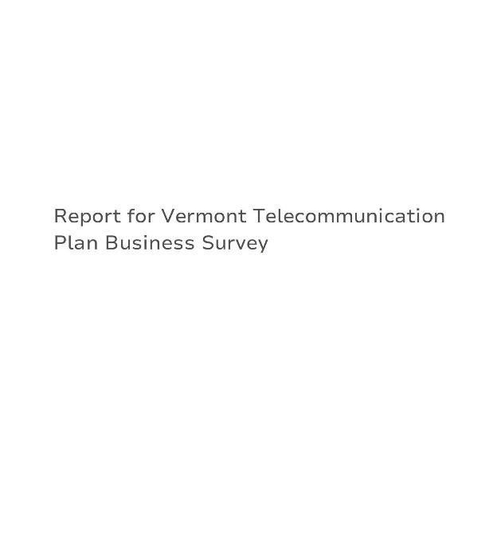

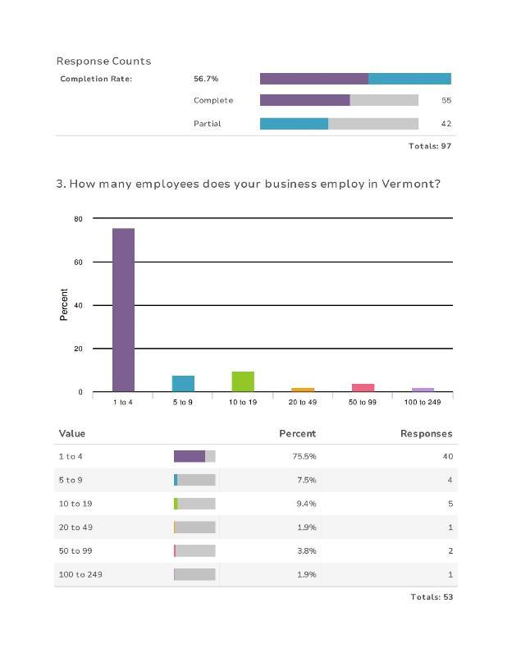

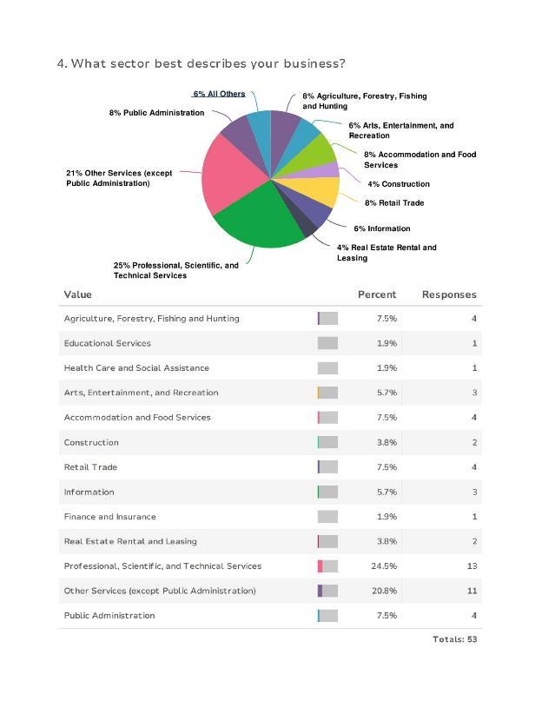

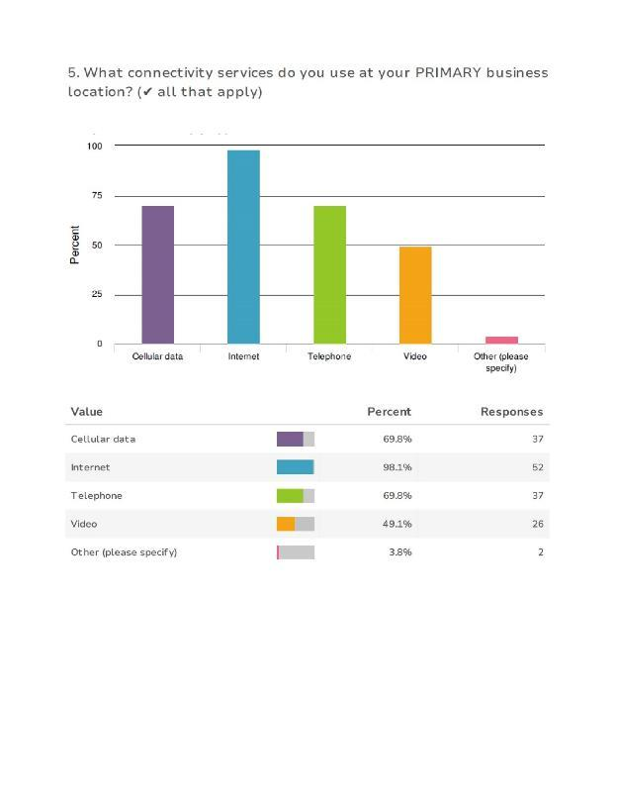

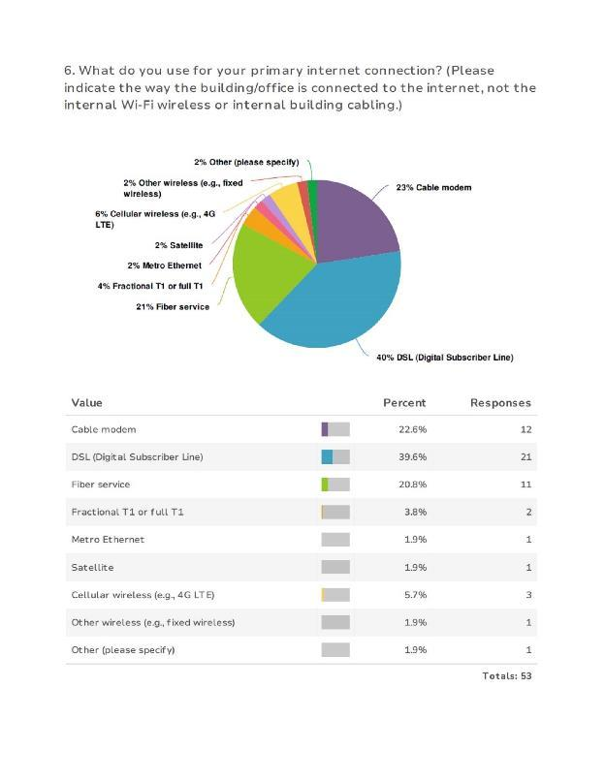

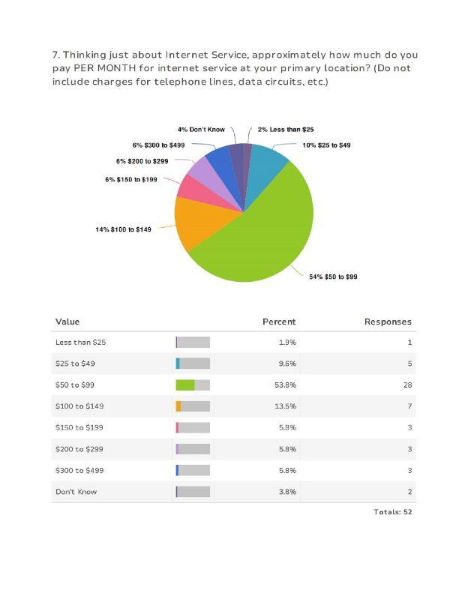

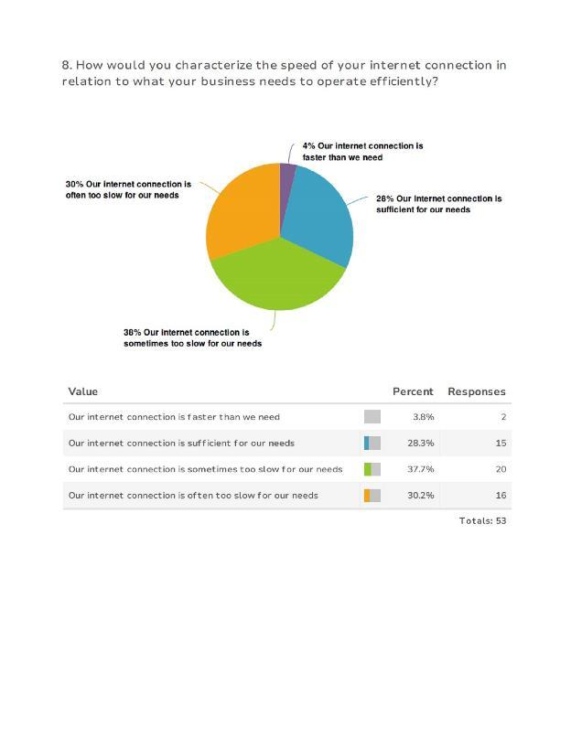

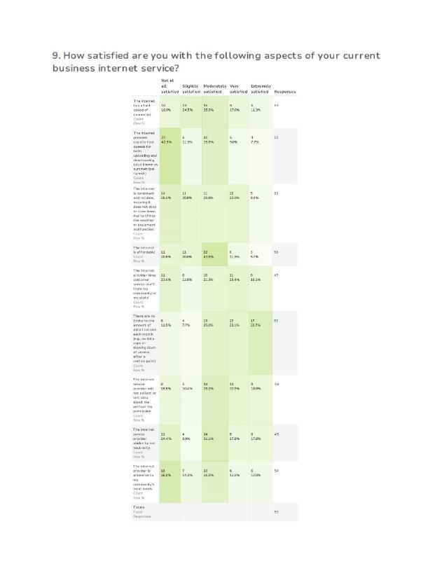

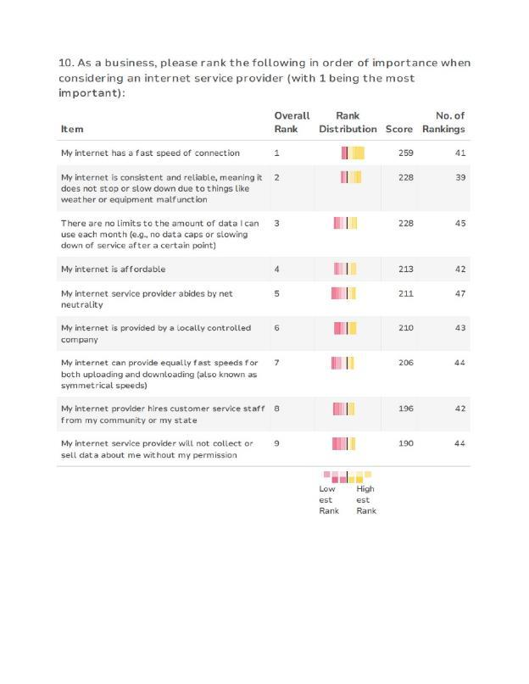

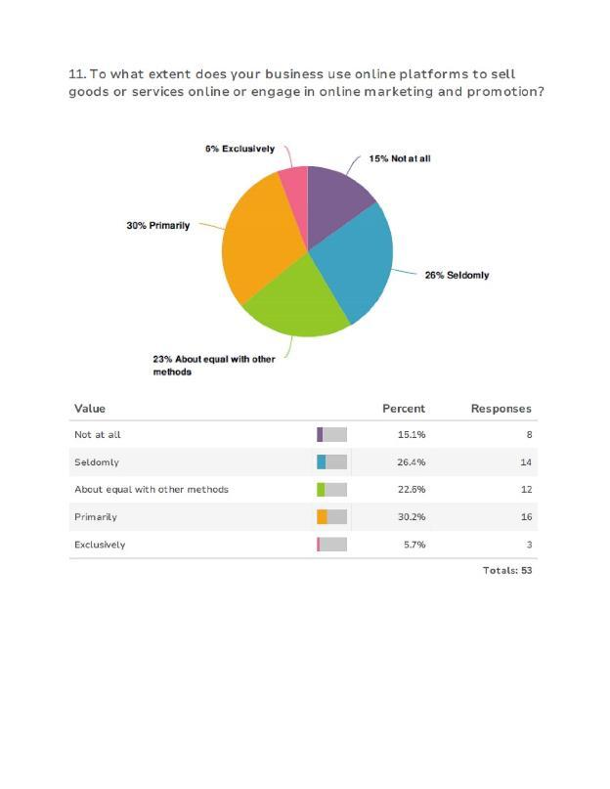

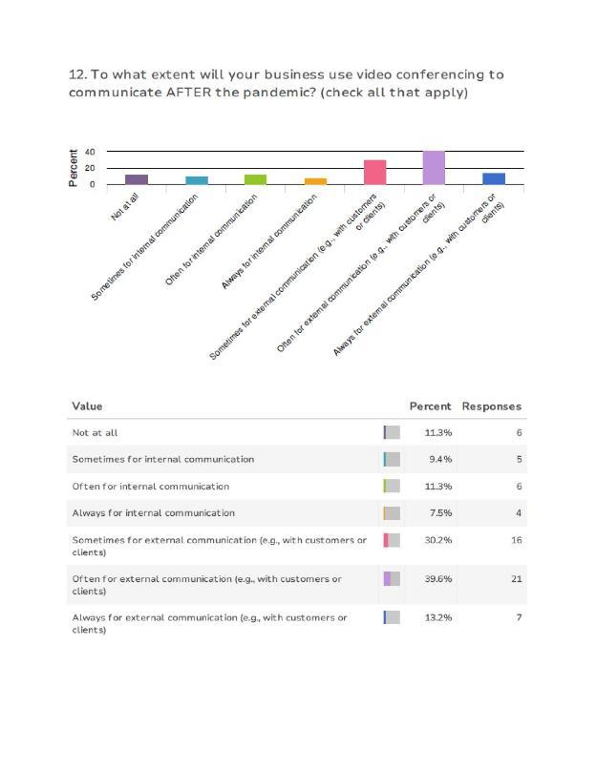

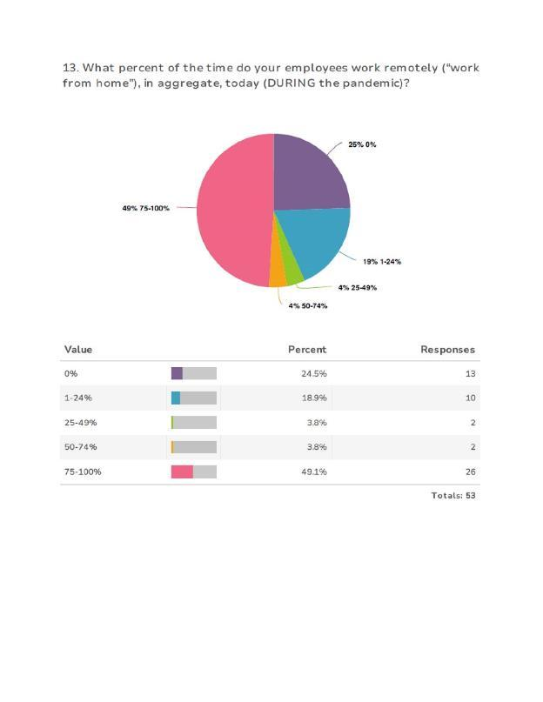

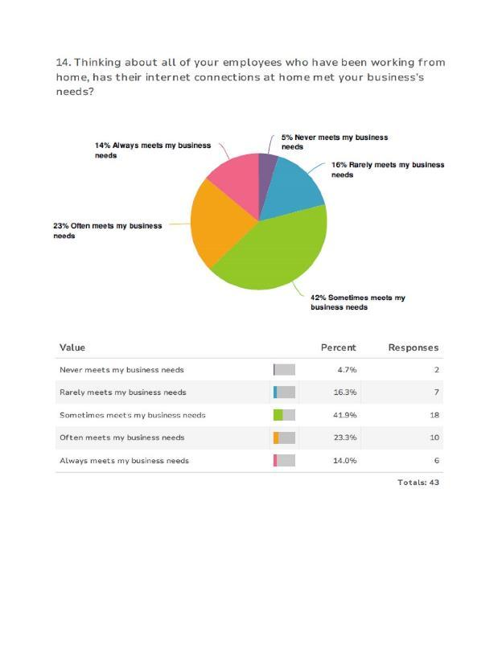

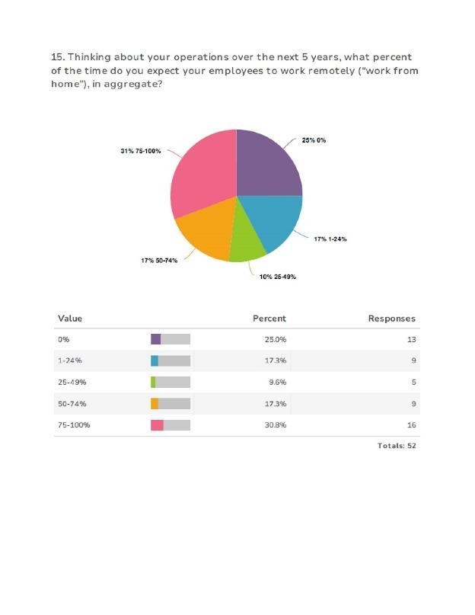

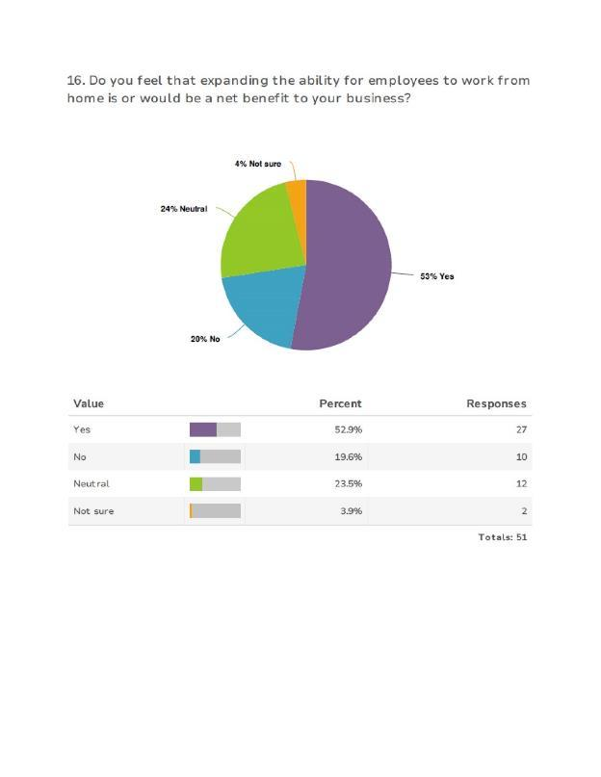

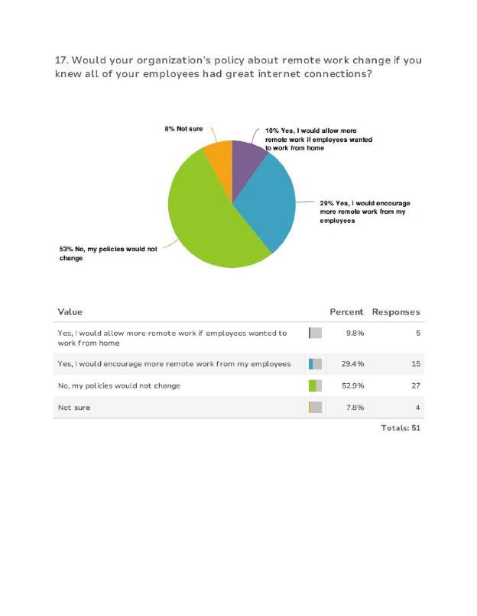

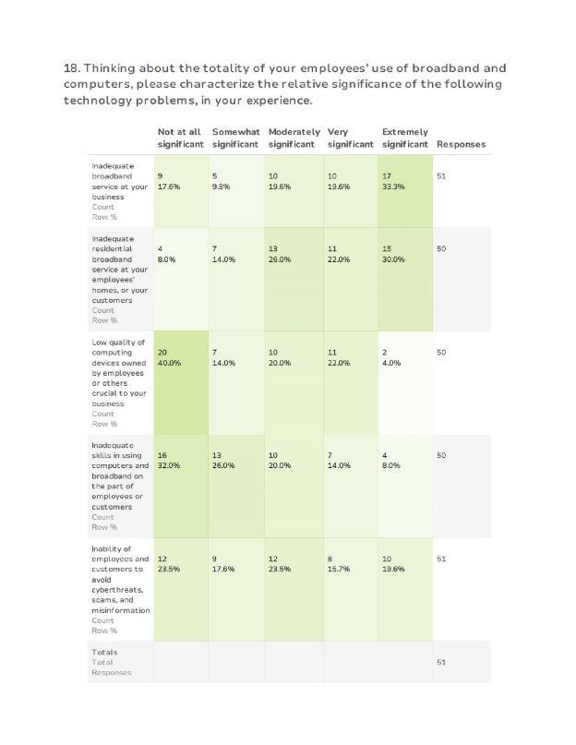

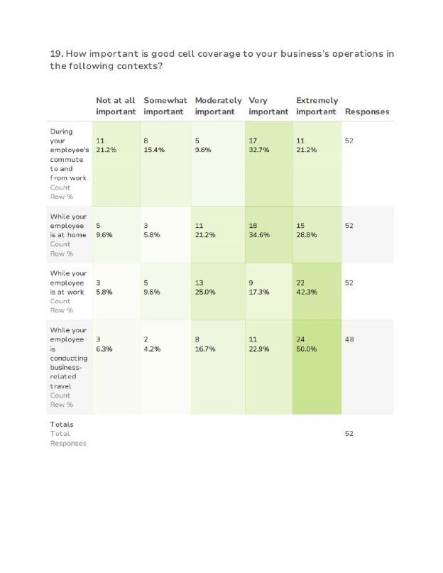

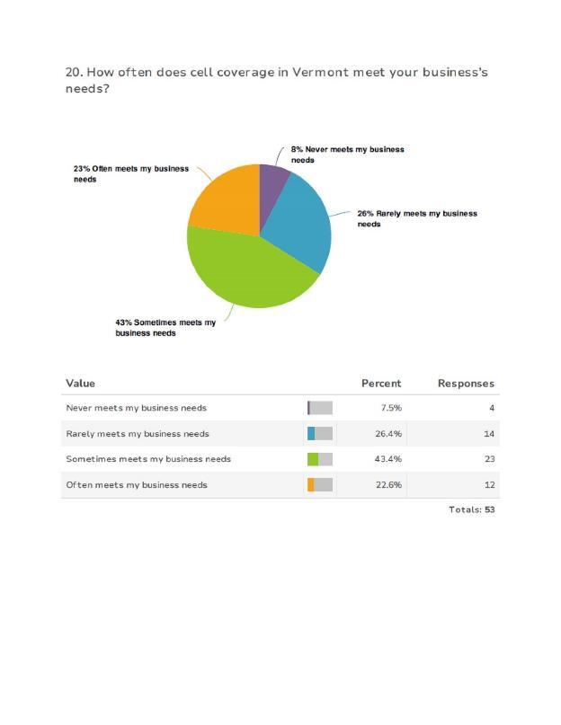

Appendix C: 2021 Municipal Leaders Survey
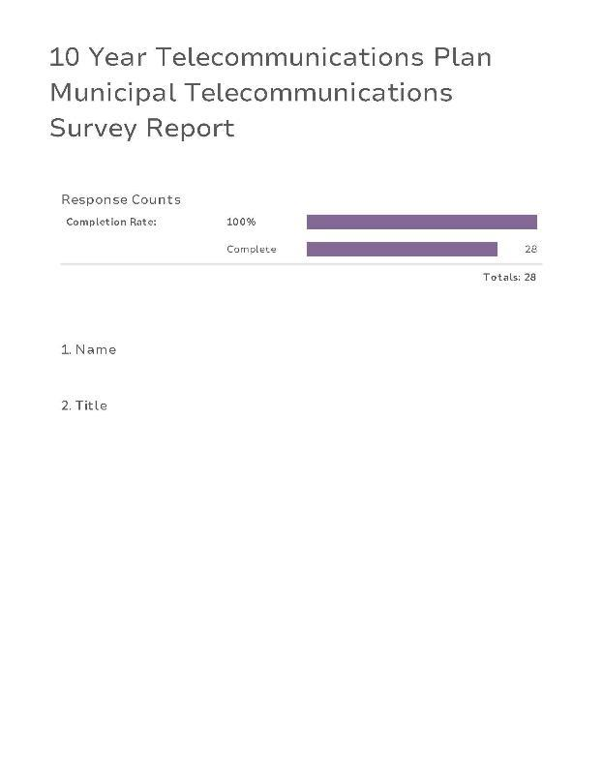
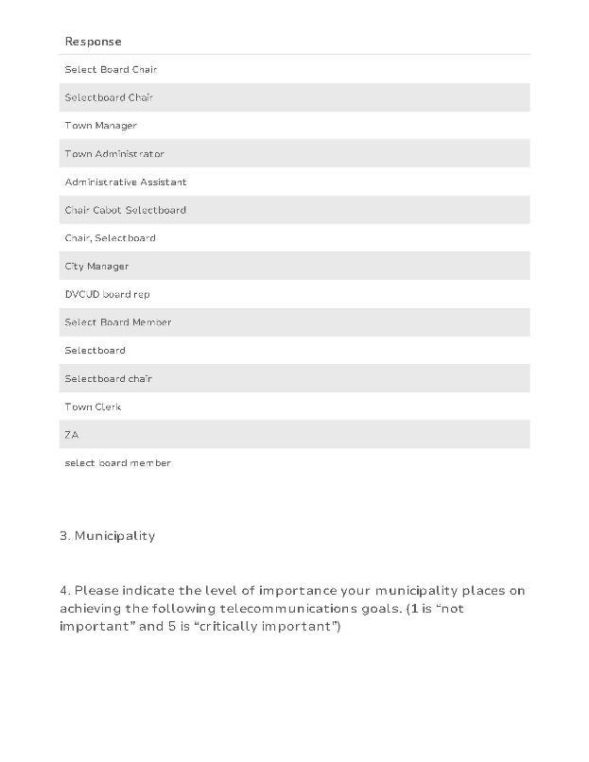
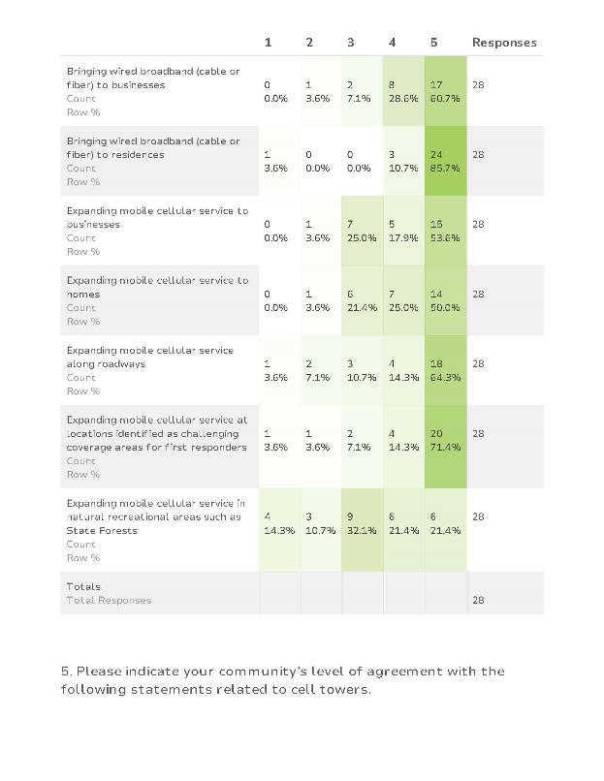
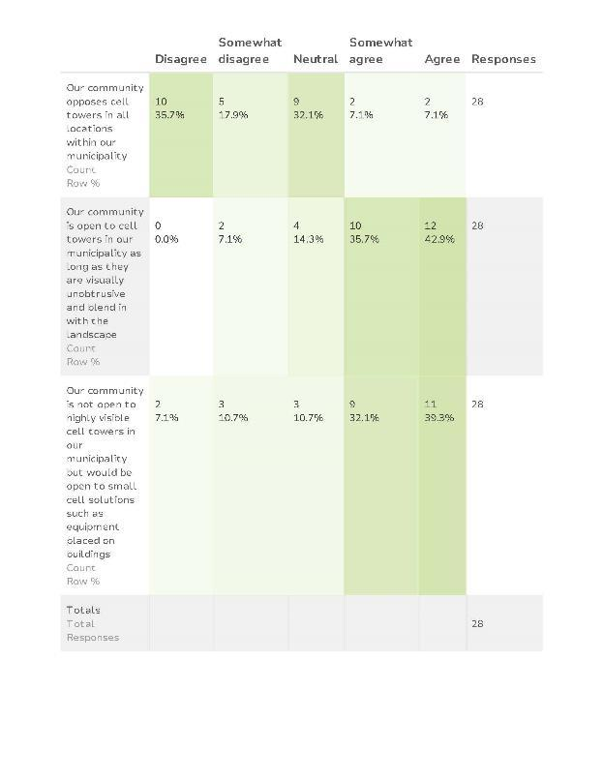
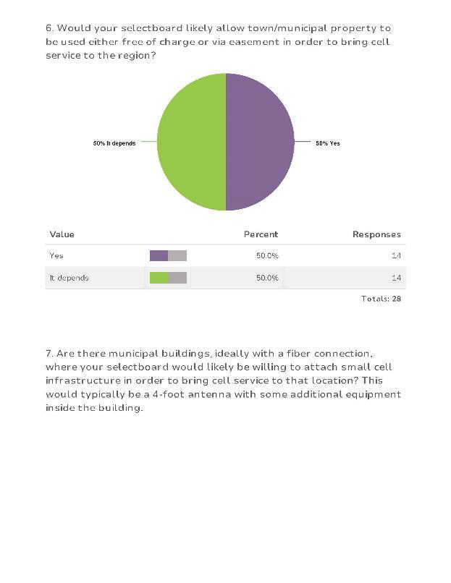
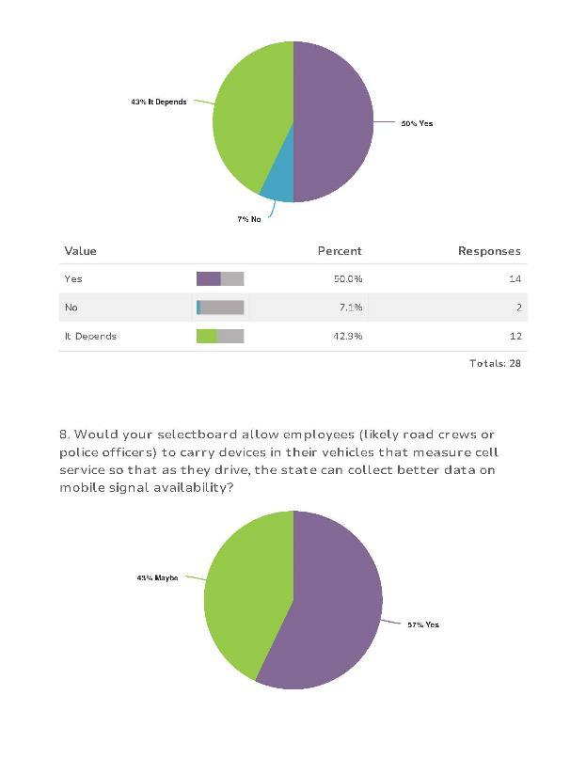
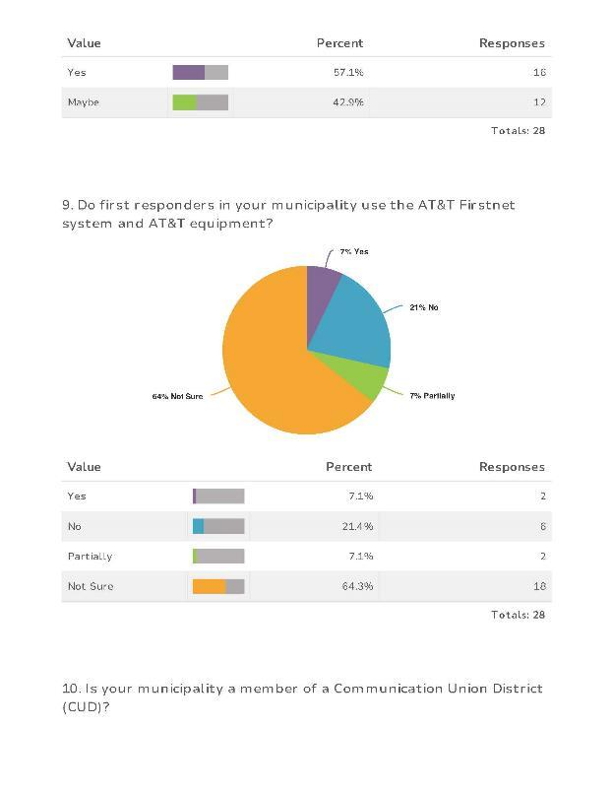
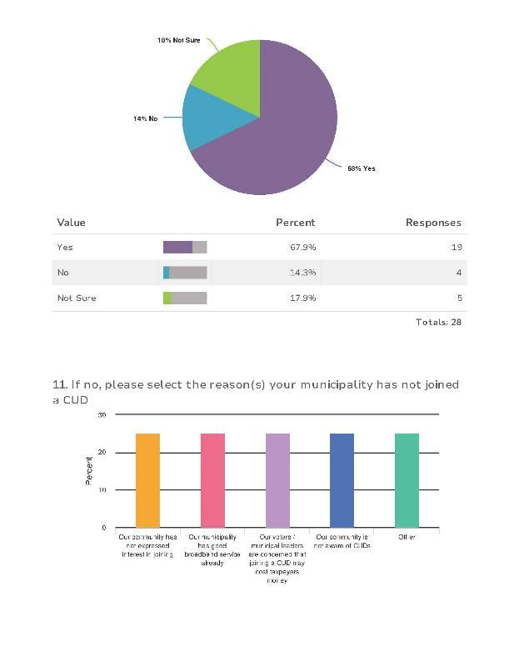
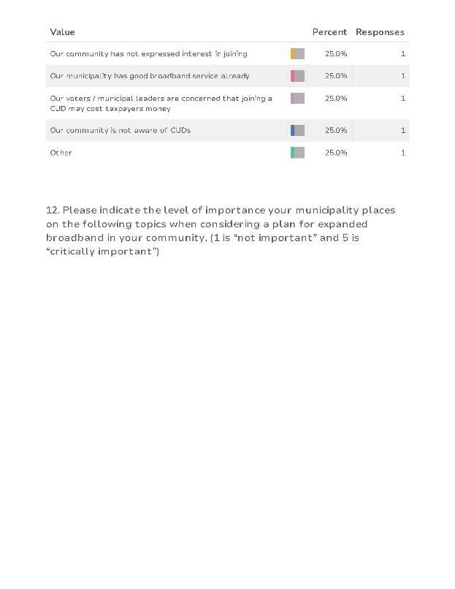
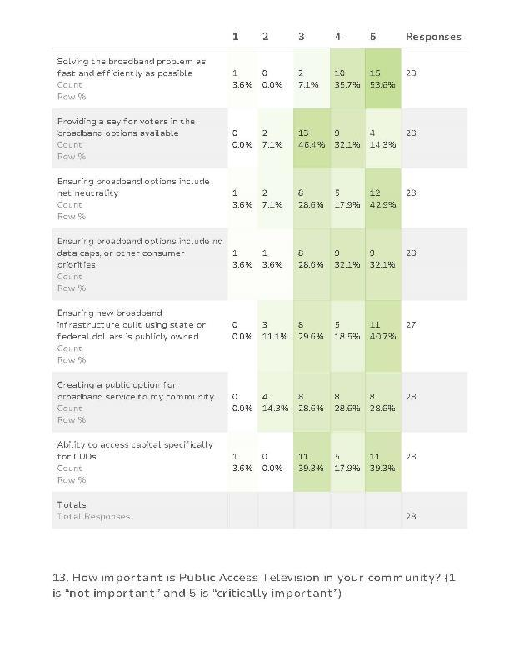
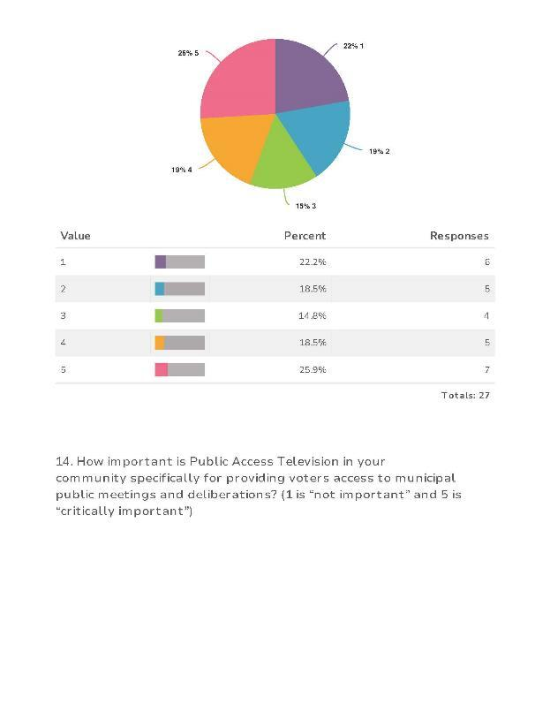
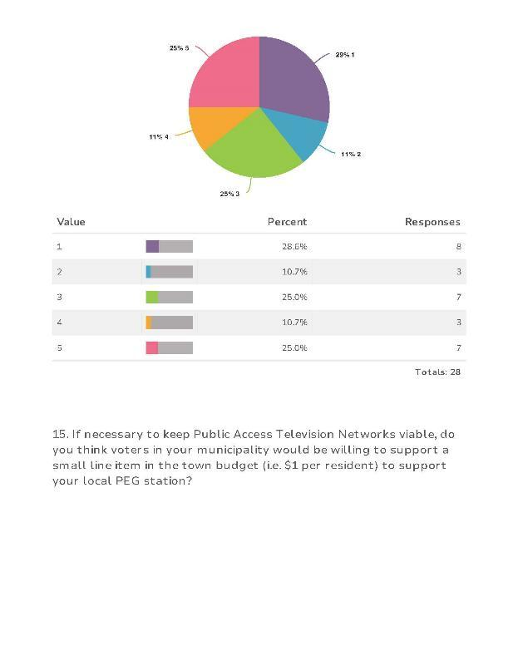
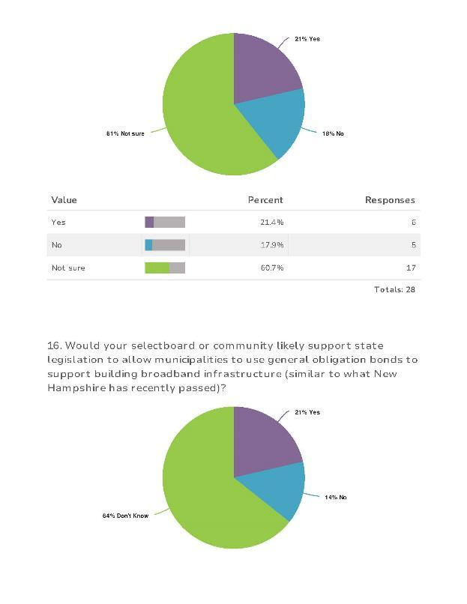

Appendix D: Stakeholder Input Provided for This Plan

State Agencies and Departments
- Agency of Commerce and Community Development: Kenneth Jones: Economic Analyst
- Agency of Education: Lisa Helme, State Coordinator of Education
- E-911: Barb Neal, Board Director
- Department of Libraries: Jason Broughton, State Librarian Joshua Muse, Library Consultant – Library Technology, Thomas McMurdo, Assistant State Librarian
- Agency of Digital Services – IT Shared Service: Frank Costantino, ERP Director
- Public Safety: Terry LaValley, Director of Radio Services
- Agency of Transportation: Costa Pappis, Policy and Planning Manager
- Department of Buildings and General Services: Marc O’Grady: Deputy Commissioner
- Department of Public Service: Robert Fish: Rural Broadband Technical Assistance Specialist
- Racial Equity Advisory Panel: Xusana Davis, Executive Director of Racial Equity
- Department of Disabilities, Aging, and Independent Living: Megan Tierney-Ward, Deputy Commissioner, Kate Parrish, Vocational Rehab Coordinator of Deaf and Hard of Hearing Services
- Department of Agriculture: Anson Tebbetts, Secretary of Agriculture, Food and Markets
- Center for Geographic Information: John Adams, Director
- Department of Housing and Community Development: Josh Hanford, Commissioner

Communications Union Districts
- ECFiber, FX Flinn
- NEK Community Broadband: Evan Carlson, Kristen Fountain, Christine Hallquist
- Southern Vermont CUD: Jeff Such, Sheila Kearns
- Otter Creek CUD, Bill Moore
- Deerfield Valley, Ann Manwaring
- Maple Broadband, Magna Dodge

Internet Service Providers
- Consolidated Communications: Erik Garr, President – Consumer-Small Business Unit
- Vermont Telephone Company: Sam Coleman, Network Engineer
- Vermont Telephone Company: Michel Guité, President
- AT&T: Owen Smith, President – Maine, New Hampshire, and Vermont
- ValleyNet, Carole Monroe and Stan Williams
- Waitsfield Champlain Valley Telecom / Green Mountain Access, Roger Nishi, President
- Starlink: Mary Evlins

Utilities
- Vermont Electric Power Company: Kerrick Johnson, Chief Innovation and Communications Officer, Dan Nelson, Vice President, Technology
- Vermont Public Power Supply Authority: Ken Nolan, General Manager
- Green Mountain Power: Liz Miller, VP, Sustainable Supply and Resilient Systems, Chief Legal Officer
- Vermont Electric Cooperative: Andrea Cohen, Manager Government Affairs and Member Relations

Healthcare Sector
- Bi-State Primary Care Association: Helen Labun, Director of Vermont Public Policy
- Vermont Program for Quality In Health Care, Inc.: Hillary Wolfley, Associate Director
- AARP: Philene Taormina, Director of Advocacy, AARP VT
- The University of Vermont Health Network: Todd Young, Network Director of Telehealth Services

Elected Officials
- Representative Timothy Briglin

Other Stakeholders
- Berkshire Telecommunications (author of PEG TV study): Peter Bluhm, Consultant
- Equal Access Broadband, Holly Groschner
- CCTV Center for Media and Democracy: Lauren-Glenn Davitian, Executive Director
- Vermont League of Cities and Towns: Ted Brady, Executive Director
- Vermont Principals Association: Jay Nichols, Executive Director
- Vermont Chamber of Commerce: Betsy Bishop, President
- Vermonters for a Clean Environment: Annette Smith, Executive Director
- Vermont Technical College: Patricia Moulton, President
- Vermont Council on Rural Development: Paul Costello, Executive Director
- Vermont Community Foundation, Dan Smith, Executive Director and Sarah Waring, VP for Grants and Community Investments

Note: Input and information from interviews performed by the project team during the preparation of Vermont’s Covid-19 Response Telecommunications Recovery Plan in fall 2020 was also used to inform this 10-Year Telecommunications Plan. For a full list of everyone interviewed for the Covid-19 Response Telecommunications Recovery Plan, please refer to that document, which can be found on the Vermont Public Service Department’s website.

Appendix E: Alignment of Plan to Statement of Work
The following summarizes the ways in which this 10-Year Telecommunications Plan satisfies the requirements set forth by the state in the agreed upon Statement of Work for this report (Attachment A, Contract # 41275)
- Ten year overview of expected future requirements for telecommunications services
- See Section 4, 10-Year Technology and Usage Trends

- Survey of Vermont residents and business
- See Section 2, Telecommunications Challenges and Needs in Vermont

- An assessment of the current state of telecommunications infrastructure.
- See the following sections:
- Section 1, Executive Summary
- Section 2, Telecommunications Challenges and Needs in Vermont
- Section 3, Identified Broadband Gaps in Vermont: Overview of Service Based on State Broadband Mapping and Testing

- An assessment, conducted in cooperation with the Agency of Digital Services (“ADS”) and Agency of Transportation (“AOT”) of State-owned and managed telecommunications systems and related infrastructure and an evaluation
- See the following sections:
    - Section 2, Telecommunications Challenges and Needs in Vermont
    - Section 5, Technology Assessment and Recommendation for Fiber for Unserved Areas
    - Section 6, Infrastructure Design and Costs for Unserved Areas
    - Section 13, Recommendation to Support PEG

- Assessment of opportunities for shared infrastructure
- See the following sections:
    - Section 7, Possible Structures for State Broadband Funding Programs to Address Unserved Areas
    - Section 11, Recommendations to Improve and Expand Mobile Service

- PEG television analysis
- See the following sections:
    - Section 2.2.2, Public Comment
    - Section 13, Recommendation to Support PEG

- Assessment of status, coverage, and capacity of telecommunications networks and services
- See the following sections:
- Section 2, Telecommunications Challenges and Needs in Vermont
- Section 3, Identified Broadband Gaps in Vermont: Overview of Service Based on State Broadband Mapping and Testing

- An analysis of alternative strategies to expand broadband and increase network resiliency
- See the following sections:
    - Section 5, Technology Assessment and Recommendation for Fiber for Unserved Areas
    - Section 6, Infrastructure Design and Costs for Unserved Areas
  - Section 7, Possible Structures for State Broadband Funding Programs to Address Unserved Areas
- Section 8, Recommended Resources and Support for State Program to Address Unserved Areas
- Section 9, Framework of Business Models and Negotiation Opportunities for CUDs

- Emergency communications initiatives and requirements
- See the following sections:
- Section 1, Executive Summary
- Section 2.4, Public Safety
- Section 12, Recommendation to Support Public Safety

- Analysis of regulatory and legal barriers facing state action
  - See Section 14, Legal Analysis

- Initiatives to advance state telecommunication policies and goals
- See the following sections:
- Section 1, Executive Summary
    - Section 5, Technology Assessment and Recommendation for Fiber for Unserved Areas
    - Section 6, Infrastructure Design and Costs for Unserved Areas
  - Section 7, Possible Structures for State Broadband Funding Programs to Address Unserved Areas
- Section 8, Recommended Resources and Support for State Program to Address Unserved Areas
- Section 9, Framework of Business Models and Negotiation Opportunities for CUDs
- Section 10, Addressing Demand-Side Broadband Challenges
  - Section 11, Recommendations to Improve and Expand Mobile Service
- Section 12, Recommendation to Support Public Safety
- Section 13, Recommendation to Support PEG
- Section 14, Legal Analysis

- The contractor’s team shall participate in weekly conference calls with the Department of Public Service staff.
The contractor’s team has participated in weekly conference calls as well as additional meetings with the Department of Public Service staff.
- Public Comment Draft and Final Draft of Report.
The contractor has worked closely with the Department of Public Service in pursuit of adherence to all relevant timelines and statutes.

Cost estimation is outlined in Section 6.
Appendix D identifies the stakeholders who provided input for this Plan. Appendices A – C are residential, business, and municipal leader survey results.
“Consolidated Communications' Enterprise@Home Connects Remote Home Office Locations With Reliable, Secure Technology,” Consolidated Communications, News Release, July 29, 2020, https://www.consolidated.com/about-us/news/article-detail/id/750/consolidated-communications-enterprisehome-connects-remote-home-office-locations-with-reliable-secure-technology
Department of Education stakeholder interview, April 5, 2021.
“Project 25,” APCO International, https://www.apcointl.org/spectrum-management/spectrum-management-resources/interoperability/p25/.
“Statewide Interoperability Planning: Statewide Communication Interoperability Plan,” Vermont Department of Public Safety’s Radio Technology Services, https://rts.vermont.gov/interoperability-planning#:~:text=Interoperable%20communications%20is%20a%20key,for%20interoperable%20emergency%20communications%20efforts; “Vermont Statewide Communication Interoperability Plan,” May 2020, https://rts.vermont.gov/sites/rts/files/documents/SCIP%202020%20Vermont%20FINAL.pdf.
Justin Trombly, “Planned FirstNet towers stumble this year, but officials confident in AT&T,” VTDigger, Dec. 28, 2020, https://vtdigger.org/2020/12/28/planned-firstnet-towers-stumble-this-year-but-officials-confident-in-att/.
“Statewide Communication Interoperability Plans,” Cybersecurity & Infrastructure Security Agency, https://www.cisa.gov/statewide-communication-interoperability-plans (accessed May 2021).
“Interoperability Continuum,” Department of Homeland Security, https://www.cisa.gov/sites/default/files/publications/interoperability_continuum_brochure_2.pdf (accessed May 2021).
“Vermont Statewide Communication Interoperability Plan,” May 2020, https://rts.vermont.gov/sites/rts/files/documents/SCIP%202020%20Vermont%20FINAL.pdf.
“FirstNet by the Numbers,” AT&T, Feb. 17, 2021, https://www.firstnet.com/content/dam/firstnet/white-papers/firstnet-by-the-numbers.pdf (accessed May 2021).
“FirstNet Partnership Kicks Off Fifth Year, Brings Initial 5G Investment to FirstNet,” FirstNet Authority, News Release, April 1, 2021, https://www.firstnet.gov/newsroom/blog/firstnet-partnership-kicks-fifth-year-brings-initial-5g-investment-firstnet (accessed May 2021).
Justin Trombly, “Planned FirstNet towers stumble this year, but officials confident in AT&T,” VTDigger, Dec. 28, 2020, https://vtdigger.org/2020/12/28/planned-firstnet-towers-stumble-this-year-but-officials-confident-in-att/.
Vermont General Assembly, 30 V.S.A. § 248a, Vermont Statutes Online, https://legislature.vermont.gov/statutes/section/30/005/00248a (accessed May 2021).
Valley News, “Special Report: VTel and its $116 million Vermont promise,” VTDigger, August 3, 2015, https://vtdigger.org/2015/08/03/vtel-and-its-116-million-vermont-promise/
“Mobile Wireless Drive Test,” State of Vermont Department of Public Service, https://publicservice.vermont.gov/content/mobile-wireless-drive-test (accessed May 2021).
“Wireless Communications Facilities – 248a Cases,” Vermont Public Utility Commission, https://puc.vermont.gov/sites/psbnew/files/doc_library/wireless-communications-facilities-section-248a_0.pdf
For more information on road type classifications, please refer to Vermont Statute 19 V.S.A. § 302.
This estimation includes RDOF locations.
RISI analysis; see Section 3.2.2 for methodology.
30 V.S.A § 3051
“More than 40 towns vote to join high-speed internet groups,” Associated Press, March 6, 2020, https://apnews.com/article/2a1aaa62984f0ffc7ce518b8accd15e9.
“Vermont Communications Union Districts,” State of Vermont Department of Public Service, https://publicservice.vermont.gov/content/vermont-communications-union-districts.
“Broadband Statistics Summary by Town as of December 31,2019,” State of Vermont Department of Public Service, Excel file, https://publicservice.vermont.gov/sites/dps/files/documents/Connectivity/BroadbandReports/2020/BroadbandStatistics_county_2020_02202020.xlsx (accessed May 2021).
“Market Analysis: Fastest Providers,” Ookla, https://www.speedtest.net/global-index/united-states?fixed#market-analysis (accessed May 2021).
Jon Brodkin, “Comcast reluctantly drops data-cap enforcement in 12 states for rest of 2021,” ArsTechnica, Feb. 19, 2021, https://arstechnica.com/tech-policy/2021/02/comcast-responds-to-pressure-cancels-data-cap-in-northeast-us-until-2022/
“We’re Giving Our Northeast Customers More Time,” Comcast, News Release, Feb. 18, 2021, https://corporate.comcast.com/stories/were-giving-our-northeast-customers-more-time (accessed May 2021).
“State Broadband Task Forces, Commissions or Authorities and Other Broadband Resources,” National Conference of State Legislatures (NCSL), June 2020, https://www.ncsl.org/research/telecommunications-and-information-technology/state-broadband-task-forces-commissions.aspx.
35-A.M.R.S.A. Ch 93, Advanced Technology Infrastructure, https://www.maine.gov/connectme/sites/maine.gov.connectme/files/inline-files/statute_2020.pdf.
“Grants,” ConnectMaine, https://www.maine.gov/connectme/grants (accessed May 2021).
“MassBroadband 123 Network Construction,” Massachusetts Broadband Institute, https://broadband.masstech.org/about-mbi/past-programs/massbroadband-123-network-construction (accessed May 2021).
“New Hampshire Senate Bill 457 (2020), LegiScan, https://legiscan.com/NH/text/SB457/2020 (accessed May 2021).
Sec. 1. 30-A MRSA §2203, sub-§9, 127th Maine Legislature, https://legislature.maine.gov/legis/bills/bills_127th/billtexts/HP063201.asp (accessed May 2021).
Jon Brodkin, “Comcast reluctantly drops data-cap enforcement in 12 states for rest of 2021: ISP grants reprieve in Northeast but still caps users in most of its US territory,” Ars Technica, Feb. 19, 2021, https://arstechnica.com/tech-policy/2021/02/comcast-responds-to-pressure-cancels-data-cap-in-northeast-us-until-2022/.
Phillip Dampier, “Spectrum Drops FCC Request to Allow It to Impose Data Caps in 2021; Was Likely to Be Rejected,” Stop the Cap, Jan. 19, 2021, https://stopthecap.com/2021/01/19/spectrum-drops-fcc-request-to-allow-it-to-impose-data-caps-in-2021-was-likely-to-be-rejected/.
Sascha Segan, “Testing Verizon 5G in Chicago: Speedy, But Watch Out for That Tree,” PCMag, May 17, 2019, www.pcmag.com/news/testing-verizon-5g-in-chicago-speedy-but-watch-out-for-that-tree.
Michael Sheetz, “What early users of SpaceX’s Starlink satellite internet think about the service, speed and more,” CNBC, April 15, 2021, https://www.cnbc.com/2021/04/15/spacexs-starlink-early-users-review-service-internet-speed-price.html
Amanda Gokee, “Lawmakers skeptical of Starlink solution for broadband problems,” VTDigger, March 7, 2021, https://vtdigger.org/2021/03/07/lawmakers-skeptical-of-starlink-solution-for-broadband-problems/.
Rob Toledo, “Report: The Average Household’s Internet Data Usage Has Jumped 38x in 10 Years,” DecisionData.org, April 17, 2020, https://decisiondata.org/news/report-the-average-households-internet-data-usage-has-jumped-38x-in-10-years/.
“U.S. Internet Usage and Global Leadership Are Expanding,” USTelecom, Nov. 27, 2017, https://www.ustelecom.org/wp-content/uploads/2018/12/USTelecom-Research-Brief-11.27.17.pdf.
Adam Ozimek, “The Future of Remote Work, “ Upwork, https://content-static.upwork.com/blog/uploads/sites/6/2020/05/26131624/Upwork_EconomistReport_FWR_052020.pdf.
“The Future of Remote Work.”
“The Future of Remote Work.”
Anne Wallace Allen “Lawmakers approve new move-to-Vermont incentive program,” VTDigger, May 27, 2019, https://vtdigger.org/2019/05/27/lawmakers-approve-new-move-vermont-incentive-program/.
Interview, Ken Jones, Agency of Commerce and Community Development, conducted October 16, 2020.
Mitch Wertlieb and Matthew F. Smith, “Limited Inventory, Many Out-of-state Buyers Keep Vermont Home Sales Unattainably Brisk,” Vermont Public Radio, March 29, 2021, https://www.vpr.org/post/limited-inventory-many-out-state-buyers-keep-vermont-home-sales-unattainably-brisk#stream/0.
“Medicare Telemedicine Healthcare Provider Fact Sheet,” Centers for Medicare and Medicaid Services, March 17, 2020, https://www.cms.gov/newsroom/fact-sheets/medicare-telemedicine-health-care-provider-fact-sheet; see also: “OCR Announces Notification of Enforcement Discretion for Telehealth Remote Communications During the COVID-19 Nationwide Public Health Emergency,” U.S. Department of Health and Human Services,” HHS, News Release, March 17, 2002, https://www.hhs.gov/about/news/2020/03/17/ocr-announces-notification-of-enforcement-discretion-for-telehealth-remote-communications-during-the-covid-19.html.
https://dvha.vermont.gov/sites/dvha/files/documents/News/DVHA%20Telemedicine%20%26%20Emergency%2 0Telephonic%20Coverage_Dental%20Providers%2004.10.2020.pdf.
https://dfr.vermont.gov/sites/finreg/files/doc_library/dfr-memo-covid19-telehealth-guidance.pdf.
Source: UVM Network of Health, eHealth summary, February 2021, courtesy of Todd Young.
https://vtrans.vermont.gov/planning/av-testing#_ftn2
https://www2.deloitte.com/us/en/insights/focus/future-of-mobility/role-of-telecommunications-in-new-mobility-ecosystem.html/#endnote-sup-9
https://www.cdc.gov/nchs/data/nhis/earlyrelease/wireless201705.pdf
https://www.pewresearch.org/internet/fact-sheet/mobile/
https://www.pewresearch.org/fact-tank/2021/03/17/cable-and-satellite-tv-use-has-dropped-dramatically-in-the-u-s-since-2015/#:~:text=Cable%20and%20satellite%20TV%20use%20has%20dropped%20dramatically%20in%20the%20U.S.%20since%202015&text=The%20share%20of%20Americans%20who,Center%20survey%20of%20U.S.%20adults.
https://ruralinnovation.us/blog/what-does-it-take-for-a-rural-town-to-get-high-speed-internet/
https://www.purdue.edu/newsroom/releases/2018/Q3/report-broadband-access-would-benefit-rural-areas,-state.html
https://www.fiberbroadband.org/blog/study-shows-home-values-up-3.1-with-access-to-fiber
Source: Data provided by the Department of Public Service via the Vermont Geodata portal.
“Edited Transcript: Q1 2021 Comcast Corp Earnings Call,” Comcast, April 29, 2021, https://www.cmcsa.com/static-files/a6156203-a308-4ed5-a8ba-65cb9d7d67ad
Both assuming a 35 percent take-rate.
Assuming three sectors, three 20 MHz CBRS channels, and typical oversubscription ratios.
Telcordia (Bellcore) GR-499-CORE. See, for example: “VoIP Availability and Reliability Model for the PacketCable™ Architecture Technical Report,” CableLabs, 2019.
Not including the access network from the last electronic component to the premises.
The network’s outside plant is both the most expensive and the longest-lasting portion. The architecture of the physical plant determines the network’s scalability for future uses and how the plant will need to be operated and maintained; the architecture is also the main determinant of the total cost of the deployment.
The take-rate affects the electronics and drop costs, but also may affect other parts of the network. A 35 percent take-rate is typical of environments where a new provider joins the telephone and cable provider in a service area.
A “hot swappable” line card can be removed and reinserted without the entire device being powered down or rebooted. The control cards in the router should maintain all configurations and push them to a replaced line card without the need for reconfirmation.
https://www.startup.digitalinclusion.org/
https://training.digitallearn.org/
https://vtdigger.org/2021/04/13/new-bill-would-create-fund-to-help-bipoc-vermonters-own-land/
https://vtdigger.org/2021/03/18/scott-calls-on-u-s-state-department-to-send-more-refugees-to-vermont/
https://www.prisonphonejustice.org/state/VT/
https://www.fcc.gov/public-safety/public-safety-and-homeland-security/policy-and-licensing-division/public-safety-spectrum Accessed May 2021
https://www.cisa.gov/sites/default/files/publications/List%20of%20Emergency%20Communications%20Financial%20Assistance%20Programs_DRAFT_04-14-2021_508.pdf
https://www.cisa.gov/sites/default/files/publications/FY%202021%20SAFECOM%20Guidance_Final_508.pdf
Wassenaar, Mike, and Davitian, Lauren-Glenn, “Quick question on public comment on VT Plan,” December 15, 2020, email.
https://legislature.vermont.gov/assets/Legislative-Reports/Report-2021-02-07.docx.pdf
More precisely, “[a]n open-access network refers to a horizontally layered network architecture in telecommunications, and the business model that separates the physical access to the network from the delivery of services. … In an [open access network], the owner or manager of the network does not supply services for the network; these services must be supplied by separate retail service providers.” Wikipedia, “Open-access network,” last mod. August 17, 2020, https://en.wikipedia.org/wiki/Open-access_network (accessed November 9, 2020).
“Open access” should not be confused with “open Internet,” the umbrella term used by the FCC to describe a set of principles also known as “network neutrality.” Network neutrality refers to an obligation of retail service providers to enable users to access Internet services and information provided by other entities on a neutral, nondiscriminatory basis.
See, e.g., Jordan Arnold and Jonathan Sallet, “If We Build It, Will They Come? Lessons From Open-Access, Middle-Mile Networks,” Benton Institute For Broadband and Society (December 2020), https://www.benton.org/sites/default/files/OAMM_networks,pdf
See 47 U.S.C. § 251(c)(3).
In the Matter of Review of the Section 251 Unbundling Obligations of Incumbent Local Exchange Carriers, ¶ 278, 18 FCC Rcd. 16978, 2003 WL 22175730 (rel. September 17, 2003).
In the Matter of Review of the Section 251 Unbundling Obligations of Incumbent Local Exchange Carriers, ¶ 2, 19 FCC Rcd. 20293, 2004 WL 2347593 (rel. October 18, 2004).
See In the Matter of Modernizing Unbundling and Resale Requirements in an Era of Next-Generation Networks and Services, WC Docket No. 19-308, Report and Order, FCC 20-152, released October 28, 2020.
In the Matter of Restoring Internet Freedom, WC Docket No. 17-108, Declaratory Ruling, Report and Order, FCC 17-166, released January 4, 2018.
23 C.F.R. § 710.403(d) and (e).
Restrictions may also appear in bond instruments, franchises, pole attachment agreements, and many other kinds of contracts.
“That private property ought to be subservient to public uses when necessity requires it, nevertheless, whenever any person’s property is taken for the use of the public, the owner ought to receive an equivalent in money.” Vermont Constitution, Ch. 1, art. 2.
Vermont Constitution Ch. I, art. 2 (“That private property ought to be subservient to public uses when necessity requires it, nevertheless, whenever any person’s property is taken for the use of the public, the owner ought to receive an equivalent in money.”).
See, e.g., 30 V.S.A. § 110.
30 V.S.A. § 112(4).
12 V.S.A. § 1040. Note, however, that Section 1040 does not affect “the authority of an entity authorized by law to use eminent domain for the following purposes: …public utilities, including entities engaged in the generation, transmission, or distribution of electric, gas, sewer and sewage treatment, or communication services.” Id.
The Mozilla Blog, March 19, 2021, https://blog.mozilla.org/blog/2021/03/19/reinstating-net-neutrality-in-the-us/, accessed 5/4/21.
Tim Wu, Network Neutrality, Broadband Discrimination, J. on Telecomm & High Tech L., Vol 2 2003,p. 141
In the Matter of Appropriate Framework for Broadband Access to the Internet over Wireline Facilities, CC Docket No. 02-33, Policy Statement, FCC 05-151, rel. September 23, 2005.
Comcast Corp. v. FCC, 600 F.3d 642 (D.C. Cir. 2010).
In the Matter of Preserving the Open Internet, GN Docket No. 09-191, Report and Order, FCC 10-201, rel. December 23, 2010.
Verizon Communications v. Federal Communications Commission, 740 F.3d 623 (D.C. Cir. 2014).
The FCC defines “broadband Internet access service” as: A mass-market retail service by wire or radio that provides the capability to transmit data to and receive data from all or substantially all Internet endpoints, including any capabilities that are incidental to and enable the operation of the communications service, but excluding dial-up Internet access service. In the Matter of Protecting and Promoting the Open Internet, Report and Order on Remand, Declaratory Ruling, and Order, 30 FCC Rcd. 5601 (F.C.C.), 2015 WL 1120110, (“Open Internet Order”), at ¶ 187; aff’d, United States Telecom Association v. FCC, 825 F.3d 674 (D.C. Cir. 2016).
Id.
In the Matter of Restoring Internet Freedom, WC Docket No. 17-108, Declaratory Ruling, Report and Order, and Order, FCC 17-166 (rel. Jan. 4, 2018)(“Restoring Internet Freedom Order”).
While removing all of the Open Internet Order’s rules governing the business practices of ISPs, the Restoring Internet Freedom Order retained transparency requirements that would theoretically allow consumers to understand the business practices of their ISP and oppose the practices with which they disagree: Properly tailored transparency disclosures provide valuable information to the Commission to enable it to meet its statutory obligation to observe the communications marketplace to monitor the introduction of new services and technologies, and to identify and eliminate potential marketplace barriers for the substantially reduces the possibility that ISPs will engage in harmful practices, and it incentivizes quick corrective measures by providers if problematic conduct is disclosures improve consumer confidence in ISPs’ practices while providing entrepreneurs and other small businesses the information they may need to innovate and improve products. Id., at ¶ 215.
Id., at ¶ 140.
Mozilla Corporation v. Federal Communications Commission, 940 F.3d 1, (D.C. Cir. 2019).
National Cable & Telecommunications Association v. Brand X Internet Services, 545 U.S. 967 (2005).
The court also accepted three other petitioner challenges, holding that the FCC’s failure to consider the impact of the Order on public safety, pole attachment regulation, and the federal Lifeline program necessitated a remand of the Order on those points. The FCC issued a remand Order in October 2020, for which a reconsideration petition is pending. (WC Docket No. 17-108.)
To date, seven states have adopted some form of net neutrality laws (California, Colorado, Maine, New Jersey, Oregon, Vermont, and Washington). Nine states have introduced net neutrality bills during the 2021 legislative session, according to the National Conference of State Legislatures.
Until President Biden appoints – and the Senate confirms – a replacement FCC commissioner, the FCC, led by Acting Chairwoman Jessica Rosenworcel, will continue to operate under a 2-2 stalemate between Democrat and Republican members.
American Cable Association et al. v. Becerra, No 2:18-cv-02684 (E.D. Cal.)
See Casey Lide, “State Net Neutrality Laws May Lead to Federal Legislation,” The National Law Review, March 1, 2021.
State of Vermont Executive Department, Executive Order No. 2-18.
Act 169 (2018).
American Cable Association et al. v. Scott, No. 2:18-cv-00167-CR, Stipulation Regarding Temporary Stay of Litigation and Injunction Barring Enforcement of Executive Order No. 2-18 and Act 169, (D. Vt.)
American Cable Association et al. v. Scott, Order Regarding Temporary Stay of Litigation and Injunction Barring Enforcement of Executive Order No. 2-18 and Act 169, filed May 3, 2021.
South Dakota v. Dole, 483 U.S. 203 (1987).
Congressional Research Service, “The Federal Government’s Authority to Impose Conditions on Grant Funds,” March 23, 2017; see South Dakota v. Dole, 483 U.S. 203, 211 (1987).
See, e.g., Minnesota (HF1885, SF946); Missouri (HB321); New Mexico (SB360); North Carolina (SB517); Ohio (SB8); Oklahoma (HB1123); Oregon (HB2654); Vermont (H.360); West Virginia (HB2002); and Wyoming (HB14).
See, e.g., Ala. Code § 37-16-4; Ariz. Code § 10-2151; Colorado R.S. § 40-15-601 et seq; MS Code § 77-17-11; SC.Code § 58-9-3000 et seq.; Tex. Util. Code § 181.048; VA Code § 55.1-306.1
See, e.g., Complaint, Grano v. Rappahannock Electric Cooperative, CA No. 3:20-cv-65 (W.D.Va. filed October 28, 2020), https://www.inversecondemnation.com/files/filed-petition.pdf; see also
Grice, 184 Vt. At 149, 956 A.2d at 574-75.
Grice, 184 Vt. At 149-50, 956 A.2d at 575.
This section addresses the obligations to provide telephone and broadband service. Although not addressed in this section, similar types of obligations to serve may, in certain circumstances, also arise for cable TV operators.
See, e.g., Sherry Lichtenberg, “Carrier of Last Resort: Anachronism or Necessity?,” National Regulatory Research Institute (2016), FA85B978-00A3-862C-5E8D-9E10816FA7DB (naruc.org).
Id.
Id.
Id.
Communications Act of 1934, 47 U.S.C. § 151.
Telecommunications Act of 1996, 47 U.S.C. § 254.
Sherry Lichtenberg, “Carrier of Last Resort: Anachronism or Necessity?”
47 C.F.R. Part 54.
47 U.S.C. § 214(e).
47 C.F.R. § 54.201.
Id.
See Rural Digital Opportunity Fund Phase I Auction, Public Notice, DA 20-1422 (Dec. 7, 2020).
47 C.F.R. § 54.101.
See, e.g., 30 V.S.A. § 227c; PUC Rule 7.500.
PUC Rule 7.505.
PUC Rule 7.505.
30 V.S.A. § 227c(a).
PUC Rule 7.506.
PUC Rule 7.505.
See, Investigation into New England Telephone and Telegraph Company’s tariff filing re: Open Network Architecture, PUC Docket No. 5713 (Order dated 2/4/1999).
Id at pg. 77.
PUC Docket No. 5713 (Order dated 2/4/1999) at pg. 122.
See, e.g., 30 V.S.A. § 227d.
See, e.g. Rural Digital Opportunity Fund (“RDOF”) Phase I.
https://publicservice.vermont.gov/sites/dps/files/documents/VT%20Emergency%20Telecom%20Plan_Final_Dec%202020.pdf

